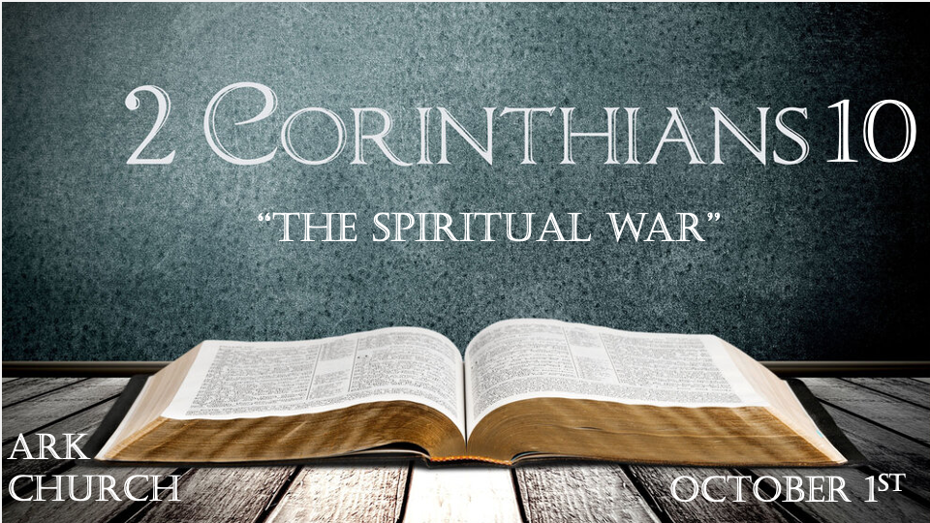
The theme of this letter is comfort. All the previous Chapters were to prepare us for the final four Chapters.
You are being equipped to win the war.

*Warfare in the Spiritual realm has its differences and similarities to the natural.

*2 Corinthians 10:1 Now I, Paul, myself am pleading with you by the meekness and gentleness of Christ—who in presence am lowly among you, but being absent am bold toward you. 2 But I beg you that when I am present I may not be bold with that confidence by which I intend to be bold against some, who think of us as if we walked according to the flesh. 3 For though we walk in the flesh, we do not war according to the flesh. 4 For the weapons of our warfare are not carnal but mighty in God for pulling down strongholds, 5 casting down arguments and every high thing that exalts itself against the knowledge of God, bringing every thought into captivity to the obedience of Christ, 6 and being ready to punish all disobedience when your obedience is fulfilled.

V:1-2 What to do when in struggle/conflict with other believers.

Find your boldness in dealing with others in the Holy Spirit and, in Truth, not overtly physical responses.

Insights: In a Christian environment of robust and domineering leadership, whether parents or pastors, the tendency is to depend more on human oversight and guidance.

Suppose you grow up in a Christian environment of humility and love. They tend to lean more on God.

V:3 Understanding the realities of warfare.

The Christian is born into a cosmic war. Ephesians 6:12
Maturing in the Word of God and His Spirit will enhance our challenges with our flesh.

V:4 What are carnal or human weapons?

Manipulation is using emotions, friendship, education, or anything to persuade others. We never manipulate someone to The Truth; we guide them to it.

Perception: My observation is this, and they say this is my perception. Christians must understand the power of perception but deal with truth.

The carnal weapons of MP(Manipulation and perception) create strangleholds or the Bible term strongholds.

V: 4-5 The 21st-century battle is with reality. We are to fight against ANYTHING that sets itself up against the knowledge of God.

We are bringing our minds, thoughts, and human insights that attack God into captivity and washing them with truth from God’s Word.

V:6 Being ready to punish what?

Disobedience has a two-pronged approach—the attack on Truth and accepting the smallest amount of compromise. Replacing truth with love is a compromise. Love is a powerful weapon!

*All Christians belong to Jesus, but not all act as they do.

*2 Corinthians 10:7 Do you look at things according to the outward appearance? If anyone is convinced in himself that he is Christ’s, let him again consider this in himself, that just as he is Christ’s, even so we are Christ’s. 8 For even if I should boast somewhat more about our authority, which the Lord gave us for edification and not for your destruction, I shall not be ashamed— 9 lest I seem to terrify you by letters. 10 “For his letters,” they say, “are weighty and powerful, but his bodily presence is weak, and his speech contemptible.” 11 Let such a person consider this, that what we are in word by letters when we are absent, such we will also be in deed when we are present.

V:7-9 Outward appearances and their deception.

Authority, position, and education were never meant for destruction or the tearing down of others.
Don’t confuse the person with the stronghold as we tear down strongholds. Our battles not against flesh but against principalities, against powers, against the rulers of the darkness of this age, against spiritual hosts of wickedness in the heavenly places. Ephesians 6:12

V:10-11 Our words, emails, texts, and media posts must represent who we are in Christ.

Duplicity is the death of our spirit.

*Measure what really counts and know whose approval you need.

*2 Corinthians 10:12 For we dare not class ourselves or compare ourselves with those who commend themselves. But they, measuring themselves by themselves, and comparing themselves among themselves, are not wise. 13 We, however, will not boast beyond measure, but within the limits of the sphere which God appointed us—a sphere which especially includes you. 14 For we are not overextending ourselves (as though our authority did not extend to you), for it was to you that we came with the gospel of Christ; 15 not boasting of things beyond measure, that is, in other men’s labors, but having hope, that as your faith is increased, we shall be greatly enlarged by you in our sphere, 16 to preach the gospel in the regions beyond you, and not to boast in another man’s sphere of accomplishment.
17 But “he who glories, let him glory in the LORD.” 18 For not he who commends himself is approved, but whom the Lord commends.

V:12-16 How to measure spiritual ministry?

Use Jesus as the measure. Anything else is not wise.

- Quantity is never the proper spiritual measurement. Quality of spirit is a better measurement.
- Jesus measured all seven churches in Revelation differently than they measured themselves and offered them each a different solution. The answer for each church was based on their problem.
- External activities are easier to calculate than internal transformation. Learn to measure the transformation.

V:17-18 Two Key questions.

*Is God glorified by my life? If so, how?

*Is God smiling about your transformation? Is God placing a growth mark on the door of your life?

