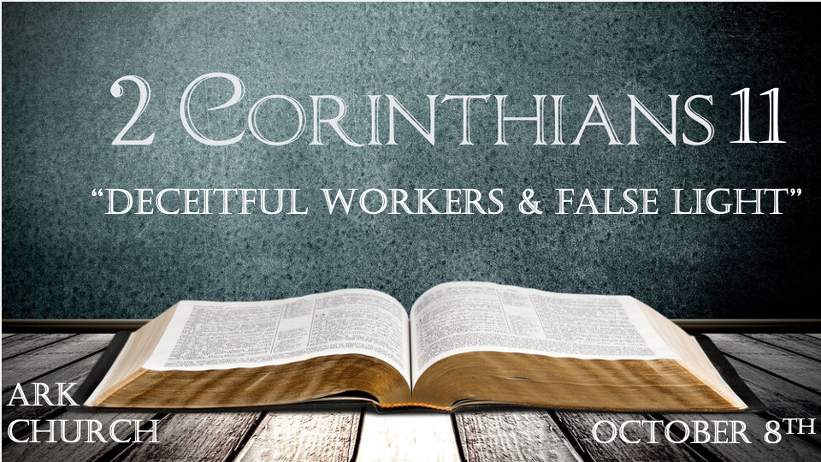
*2 Timothy 3:16 All Scripture is given by inspiration of God, and is profitable for doctrine, for reproof, for correction, for instruction in righteousness, 17 that the man of God may be complete, thoroughly equipped for every good work.

*2 Timothy 3:13 But evil men and impostors will grow worse and worse, deceiving and being deceived.

*The Simplicity of Love when it is in Christ. (What to know when love gets confusing.)

*2 Corinthians 11:1 Oh, that you would bear with me in a little folly—and indeed you do bear with me. 2 For I am jealous for you with godly jealousy. For I have betrothed you to one husband, that I may present you as a chaste virgin to Christ. 3 But I fear, lest somehow, as the serpent deceived Eve by his craftiness, so your minds may be corrupted from the simplicity that is in Christ. 4 For if he who comes preaches another Jesus whom we have not preached, or if you receive a different spirit which you have not received, or a different gospel which you have not accepted—you may well put up with it!

V:1-2 The idiom of a father's love.
A father's love is jealous over his children and has a right to protect them.

Paul sees the Corinth Church as a daughter he is preparing for marriage to Jesus.

*Proverbs 28:1 The wicked flee when no one pursues, But the righteous are bold as a lion.

V:3-4 The enemy's goal. To corrupt your mind from the simplicity that is in Christ.
Simplicity is the single-mindedness of heart and devotion. A divided heart leads to a defiled life and a destroyed relationship.
The Deceit of the Devil is to twist God's Words and intent.
- He questions God's Word. Did God say?
- He denies God's Word. You will not surely die.
- He substitutes his own lie. You shall be like God.

In verses two and three, the title for Jesus is used as "Christ." He is the Messiah-–-Savior.

To reveal Jesus with limited characteristics is to be unwilling or willing to be a deceitful worker in the kingdom.

*Can you pass the True or False test of God's Word?

*2 Corinthians 11:5 For I consider that I am not at all inferior to the most eminent apostles. 6 Even though I am untrained in speech, yet I am not in knowledge. But we have been thoroughly manifested among you in all things.
7 Did I commit sin in humbling myself that you might be exalted, because I preached the gospel of God to you free of charge? 8 I robbed other churches, taking wages from them to minister to you. 9 And when I was present with you, and in need, I was a burden to no one, for what I lacked the brethren who came from Macedonia supplied. And in everything I kept myself from being burdensome to you, and so I will keep myself. 10 As the truth of Christ is in me, no one shall stop me from this boasting in the regions of Achaia. 11 Why? Because I do not love you? God knows!
12 But what I do, I will also continue to do, that I may cut off the opportunity from those who desire an opportunity to be regarded just as we are in the things of which they boast. 13 For such are false apostles, deceitful workers, transforming themselves into apostles of Christ. 14 And no wonder! For Satan himself transforms himself into an angel of light. 15 Therefore it is no great thing if his ministers also transform themselves into ministers of righteousness, whose end will be according to their works.

V:5-11 Believers should strive to be honest and transparent. (True)
Honesty is the one gift every Christian should give.

Transparency is essential. Sadly, the openness you display can be used by mean people. Be open anyway.

V:12-15 The false light that transforms. (False)
Three times, Paul will use some form of the word to transform. It means to disguise to masquerade.

Critical areas of Satan's use of deception is to confuse believers are social issues, environmental issues, and world peace.
False light distorts the souls.

Light is never passive; it's always an agent to enhance seeing. Satan's false light allows others to see sin as normal and perversion as a standard, and his light defines a sick society as enlightenment.

If we don't fight falsehood in the public squares in the church house, it will force you to fight at your doorstep.

*The Kingdom of God never plays defense!

*Matthew 11:12 From the days of John the Baptist until now, the kingdom of heaven has been forcefully advancing, and forceful men lay hold of it.

*If you're in bondage, you've been devoured or had things stolen and even beaten. You may question yourself, wondering if you are living wisely.

*2 Corinthians 10:16 I say again, let no one think me a fool. If otherwise, at least receive me as a fool, that I also may boast a little. 17 What I speak, I speak not according to the Lord, but as it were, foolishly, in this confidence of boasting. 18 Seeing that many boast according to the flesh, I also will boast. 19 For you put up with fools gladly, since you yourselves are wise! 20 For you put up with it if one brings you into bondage, if one devours you, if one takes from you, if one exalts himself, if one strikes you on the face. 21 To our shame I say that we were too weak for that! But in whatever anyone is bold—I speak foolishly—I am bold also.
22 Are they Hebrews? So am I. Are they Israelites? So am I. Are they the seed of Abraham? So am I. 23 Are they ministers of Christ?—I speak as a fool—I am more: in labors more abundant, in stripes above measure, in prisons more frequently, in deaths often. 24 From the Jews five times I received forty stripes minus one. 25 Three times I was beaten with rods; once I was stoned; three times I was shipwrecked; a night and a day I have been in the deep; 26 in journeys often, in perils of waters, in perils of robbers, in perils of my own countrymen, in perils of the Gentiles, in perils in the city, in perils in the wilderness, in perils in the sea, in perils among false brethren; 27 in weariness and toil, in sleeplessness often, in hunger and thirst, in fastings often, in cold and nakedness— 28 besides the other things, what comes upon me daily: my deep concern for all the churches. 29 Who is weak, and I am not weak? Who is made to stumble, and I do not burn with indignation?

30 If I must boast, I will boast in the things which concern my infirmity. 31 The God and Father of our Lord Jesus Christ, who is blessed forever, knows that I am not lying. 32 In Damascus the governor, under Aretas the king, was guarding the city of the Damascenes with a garrison, desiring to arrest me; 33 but I was let down in a basket through a window in the wall, and escaped from his hands.

V:16-21 Thinking themselves wise, they became fools.
When people judge using their eyes, it is often wrongly perceived as foolishness, and Christianity is often misunderstood.

V:22-29 Everything you've been through can be used. How?
The Five identities are Hebrew, Israeli, seed of Abraham, Ministers of Christ, Labors in the kingdom.
Interestingly, Paul is beaten five times with stripes.
Three times, Paul was hit with rods and once was stoned
Three times, Paul shipwrecked.

In the often category, Paul was in peril by Jews, Gentiles, in cities, in the wilderness, in weariness, in sleeplessness, in hunger and thirst, in fasting, in the cold, and in nakedness.

Paul's deep concern was for the Church.

V:30-33 Infirmity and persecution do play a role in our lives.
Don't let the spirit of discouragement come upon you!

All of this is here to say you can make it through these times.

I want to be encouraged when I come to church. Absolutely, but don't allow the desire for encouragement to deceive you into false security.

Security is only in Christ Jesus and not in this world. If you want positive passion and excitement, come to Wednesday's service.

