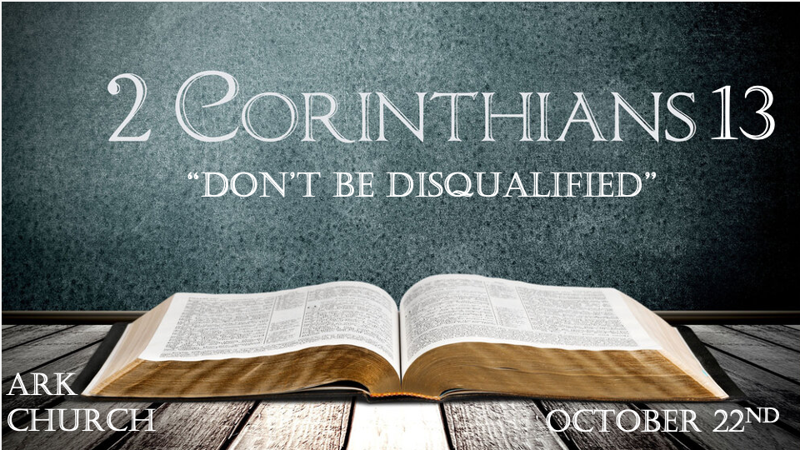

*How to establish truth through witnesses and live by the power of God.

*2 Corinthians 13:1 This will be the third time I am coming to you. "By the mouth of two or three witnesses every word shall be established." 2 I have told you before, and foretell as if I were present the second time, and now being absent I write to those who have sinned before, and to all the rest, that if I come again I will not spare— 3 since you seek a proof of Christ speaking in me, who is not weak toward you, but mighty in you. 4 For though He was crucified in weakness, yet He lives by the power of God. For we also are weak in Him, but we shall live with Him by the power of God toward you.

V:1-2 Truth must be established, and falsehood, sin, and bearing false witness must stop.
Truth is undeniable. It surpasses culture, time, and race. Truth is truth, even if no one believes it. Falsehood is still false even if everyone believes it.

Jesus even used two witnesses to verify everything that He said was true. (John 8:18)

V:3-4 To the Christians who are always seeking proof, Paul has a stern warning for you.
You should develop a seeker's heart and hungry soul when needing proof of truth.
Then, learning the Word of God, you will develop a strong heart and a satisfied soul.

What does it mean to live by Jesus' power?
- You are not living by the power of the approval of peers or culture
- Your satisfaction comes from an eternal view, not a temporal one. 2 Cor. 4
- You are comforted by your obedience more than your popularity.

*Do nothing against the truth if you don't want to be disqualified.

*2 Corinthians 13:5 Examine yourselves as to whether you are in the faith. Test yourselves. Do you not know yourselves, that Jesus Christ is in you?—unless indeed you are disqualified. 6 But I trust that you will know that we are not disqualified.
7 Now I pray to God that you do no evil, not that we should appear approved, but that you should do what is honorable, though we may seem disqualified. 8 For we can do nothing against the truth, but for the truth. 9 For we are glad when we are weak and you are strong. And this also we pray, that you may be made complete. 10 Therefore I write these things being absent, lest being present I should use sharpness, according to the authority which the Lord has given me for edification and not for destruction.

Insights for V:5-7 What seems to be is often not what is the truth.

*Psalm 139:23 Search me, O God, and know my heart; Try me, and know my anxieties; 24 And see if there is any wicked way in me, and lead me in the way everlasting.
V:5 Self-deception is the greatest falsehood we can live in. Truth is the great liberator of humanity.

V:6 Disqualified, what does it mean? Counterfeits: some translations use the word reprobates/degenerates.
Paul wants you to know they have stood the test of time and Character. Have we done so?

V:7 We are to do no evil. Are you discouraged by a lack of a holy standard? This letter isn't trying to get us to do something we are incapable of doing. Righteousness is only through Jesus.

Here's a weird twist. Living a surrendered life will disqualify you in many non-believers' eyes. They will exclude you as a weak person who uses Christianity as a crutch.

V:8-10 A Christian is glad when another Christian grows in truth and doesn't need them as much. Maturity in Christ is a beautiful thing.
V:8 You can do nothing against the truth. You can only put yourself in the position to be judged by it.
The call is to do something for truth by standing with it.

V:9 Be glad when you see others becoming strong in their faith in the truth of God's Word. Discipleship is helping people mature in Christ.
Christian growth is impossible in isolation. Iron must sharpen Iron for the skills of a believer to be honed. (One bee won't make it. One sheep won't ever make a flock.)
Ephesians 4:10-16 The whole body joined and knit together by what every joint supplies, according to the effective working by which every part does its share, causes growth of the body for the edifying of itself in love.

V:10 Important rule about sternness of truth. Truth is always for edification and not for destruction.

*The final ingredients to become a person that dispenses comfort.

*2 Corinthians 13:11 Finally, brethren, farewell. Become complete. Be of good comfort, be of one mind, live in peace; and the God of love and peace will be with you.
12 Greet one another with a holy kiss.
13 All the saints greet you.
14 The grace of the Lord Jesus Christ, and the love of God, and the communion of the Holy Spirit be with you all. Amen.

V:11 Become complete! How do we dispense good comfort?
- How can you be a good comfort to others? A relationship with Jesus and He is the goal of your life.
Jesus makes us complete. We were spiritually dead, and Christ in us brings us to life.

- A dead person is absent of spirit. They are dead spiritually and have no spiritual power.
Let this mind that is in Christ Jesus be in you. One mind is to think Biblically like Jesus.

- Let the peace of Christ be yours. Leave in peace with others.
Let the love of God rule your heart.

V:12-14 A cultural norm and more.
Holy kiss, yes, it was a kiss on the cheek, but more than that, it was a connection with what is holy in one another. A Tender, divine affection for the souls of others is priceless.

Three ending exhortations to an entire relationship with God. The Grace of Jesus, the Love of God, and communion (Koinonia) of the Holy Spirit.

