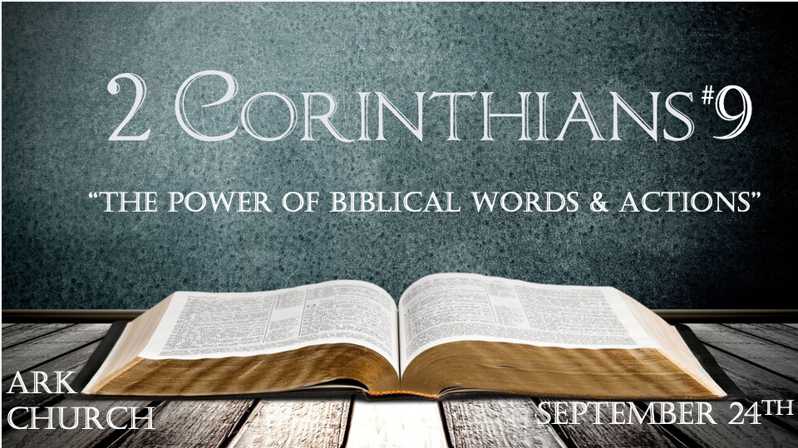
The theme of this letter is comfort. The back story is about being offended. Talking about money and giving covers both feeling uncomfortable and the possibility of being offended. (Don’t put this on the screen.)

*Giving is not a good test of the sincerity of your love for others or God.

*2 Corinthians 9:1 Now concerning the ministering to the saints, it is superfluous for me to write to you; 2 for I know your willingness, about which I boast of you to the Macedonians, that Achaia was ready a year ago; and your zeal has stirred up the majority. 3 Yet I have sent the brethren, lest our boasting of you should be in vain in this respect, that, as I said, you may be ready; 4 lest if some Macedonians come with me and find you unprepared, we (not to mention you!) should be ashamed of this confident boasting. 5 Therefore I thought it necessary to exhort the brethren to go to you ahead of time, and prepare your generous gift beforehand, which you had previously promised, that it may be ready as a matter of generosity and not as a grudging obligation.

V:1-5 Being prepared ahead of time to give is often a test of obedience.

*Philippians 2:8 And being found in appearance as a man, He humbled Himself and became obedient to the point of death, even the death of the cross.

A Christian who understands their source or the ability to give or bless comes from God. They are a mature Christian.

Giving says I don’t view my obligation with reluctance. I love my opportunities.

The desire to be abounding/fruitful in everything is the overriding principle.

The prosperity gospel is not scriptural, but abounding in everything is.

*The death of the spirit of poverty is through hilarious generosity & righteousness.

*2 Corinthians 9:6 But this I say: He who sows sparingly will also reap sparingly, and he who sows bountifully will also reap bountifully. 7 So let each one give as he purposes in his heart, not grudgingly or of necessity; for God loves a cheerful giver. 8 And God is able to make all grace abound toward you, that you, always having all sufficiency in all things, may have an abundance for every good work. 9 As it is written:
“He has dispersed abroad,
He has given to the poor;
His righteousness endures forever.”

V:6 The power of an idiom. Understanding an idiom should not take the application to an extreme degree. (In Song of Solomon, he compares his love for his wife to his horse.) Song of Solomon 1:9

Sowing and giving are not the same thing. They do share certain principles.

When sowing, I still retain my ownership. Adam sowed his seed, and Eve bore him two sons. The sons are Adam’s and Eve’s. If I plant orange seeds in my field, the tree still belongs to me.

Giving should include a relinquishing of ownership. When we give to someone without surrendering our rights, it is considered a loan.

V:7 Giving begrudgingly steals your blessings. Develop your principles about giving based on scripture.
- Immature followers of Jesus have experience it is more blessed to give than to receive. Acts.20:35

- Chapter 8 taught us to Choose to give out what you have, not what you don’t have.

- The hilarious giver knows the power of being a vessel for God to others. The dividends are often eternal.

V:8 When God gives, it abounds and teaches us how sufficient God is.

- Biblical living is not Socialism.

- God attaches grace and righteousness to giving. They shouldn’t be separated.

V:9 God disperses His provision, love, faith, and knowledge to the world, especially to the poor.

*Have you ever experienced an indescribable gift?

*2 Corinthians 9:10 Now may He who supplies seed to the sower, and bread for food, supply and multiply the seed you have sown and increase the fruits of your righteousness, 11 while you are enriched in everything for all liberality, which causes thanksgiving through us to God. 12 For the administration of this service not only supplies the needs of the saints, but also is abounding through many thanksgivings to God, 13 while, through the proof of this ministry, they glorify God for the obedience of your confession to the gospel of Christ, and for your liberal sharing with them and all men, 14 and by their prayer for you, who long for you because of the exceeding grace of God in you. 15 Thanks be to God for His indescribable gift!

V:10 The seed represents God’s power to create. The seed is attached to God’s righteousness, increasing in our lives.
When done right, our giving will place you in the right standing with God and others.

V:11-15 The increase of the fruits of your righteousness is connected to abounding in everything.
A harvest in faith, speech, knowledge, diligence, love, and grace to give.

When giving is appropriately done, needs are met, and God is glorified.

The letter to the Church in Corinth is building to a new level. Get these basics down because there is an ongoing war, and you must know how to win.

Wartime provision
We are in Wartime, yet experiencing the comfort of God in the midst of it all. (Next week, chapter 10, winning the War)

