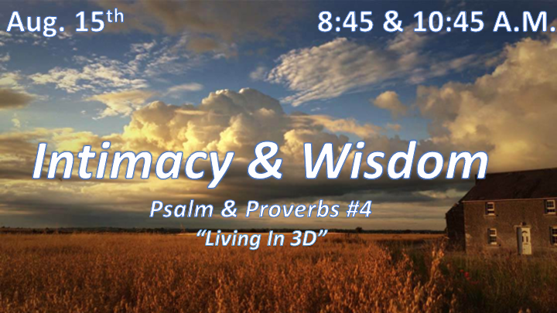

*Psalm 11:3 If the foundations are destroyed, what can the righteous do?

*Proverbs 2:1 My son, if you accept my words and store up my commands within you,
2 turning your ear to wisdom and applying your heart to understanding—
3 indeed, if you call out for insight and cry aloud for understanding,
4 and if you look for it as for silver and search for it as for hidden treasure,
5 then you will understand the fear of the LORD and find the knowledge of God.

6 For the LORD gives wisdom; from his mouth come knowledge and understanding.
7 He holds success in store for the upright, he is a shield to those whose walk is blameless,
8 for he guards the course of the just and protects the way of his faithful ones.
9 Then you will understand what is right and just and fair—every good path.
10 For wisdom will enter your heart, and knowledge will be pleasant to your soul.
11 Discretion will protect you, and understanding will guard you.

* Take your one-dimensional Christian life and start living in 3D.

- V:1-5 A Christian good foundation has a heart for God and His Word.
- Beyond hearing God’s Word we must understand (Matthew 13:23), and accept them. (Mark 4:20) The Third ingredient is retaining the Word through persevering. (Luke 8:15)

- *Discover the treasure of God’s Word.

- V:6-11 God gives wisdom, knowledge, understanding, protection and a good path.
- What is pleasant to the soul will always be rooted in God’s Wisdom and Word.
- *V:11 Discretion will protect you. Discretion is the ability to act or plan based on godly judgement and authority.

- *Psalm 37:4 Delight in the LORD, and he will give you the desires of your heart.

This year’s Olympics didn’t just showcase the world’s most elite athletes … it set 3D printing upfront and center:
3D-printed running shoes (one runner even got the gold while sporting them!).
3D-printed cycling helmets and bikes. The podiums that Olympic champions accepted their medals on were 3D printed.
We even now build houses with 3D printing.

*Proverbs 2:12 Wisdom will save you from the ways of wicked men, from men whose words are perverse,
13 who have left the straight paths to walk in dark ways,
14 who delight in doing wrong and rejoice in the perverseness of evil,
15 whose paths are crooked and who are devious in their ways.

*The Perversion of Delight.

- V:12-13 Perverse words lead to dark paths.

- V:14-15 “The Perversion.”
- Isaiah 5:20 The prophecy of an upside-down way of life.

- 12 scriptural warnings against perversion. Proverbs 4:24, 6:14, 11:3, 12:8, 15:4, 17:20, 19:3, 28:6, Psalm 101:4, Ezekiel 9:9, Matthew 17:17, and 1st Timothy 6:5

*Proverbs 3:5 (KJV) Trust in the LORD with all thine heart; and lean not unto thine own understanding.
6 In all thy ways acknowledge him, and he shall direct thy paths.
7 Be not wise in thine own eyes: fear the LORD, and depart from evil.

*The Secret of Living as a 3D Christian.

- Mature Christians “Discover” the treasure of God’s Word.

- Sanctified Christians have “Discretion” that work as a covering over them.

- Victorious Christians have the secret of “Delighting” in the Lord and He will give you the desires of your heart.

