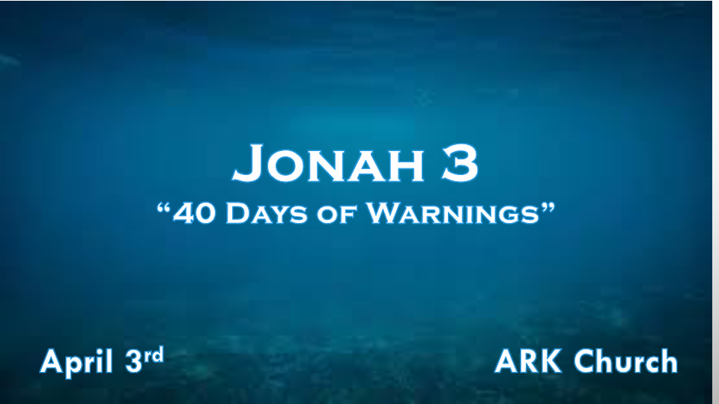

*The Word of the Lord Goes Out During Times of Warnings.

*Jonah 3:1 Now the word of the LORD came to Jonah the second time, saying, 2 “Arise, go to Nineveh, that great city, and preach to it the message that I tell you.” 3 So Jonah arose and went to Nineveh, according to the word of the LORD. Now Nineveh was an exceedingly great city, a three-day journey in extent. 4 And Jonah began to enter the city on the first day’s walk. Then he cried out and said, “Yet forty days, and Nineveh shall be overthrown!”

- V:1-2 God never blindsides humanity.
God’s Word comes to Jonah a second time
Again, God’s instructions are to go to the capital and warn them of destruction.

By faith, Noah was divinely warned. Hebrews 11:7
I Cor. 10:11 All these happened to them as examples in the wilderness and Old Testament. God’s patterns are so we will learn how God deals with His people from the past. (the O.T. shows us God’s warnings.)

- V:3 The warning went to Nineveh according to the word of the Lord.
Jonah did not add to or take away from the warning.
*John 3:36 He who believes in the Son has everlasting life, and he who does not believe the Son shall not see life, but the wrath of God abides on him.”

- Learn the Biblical pattern of God’s past warnings.
1st Example: Destruction of the Northern Kingdom in 721 B.C. is a pattern.

2nd Example is Babylonian captivity.
First came the breach of 605 B.C. The walls of Jerusalem are destroyed, and Daniel and his friends are taken captive.
The second wave came when Babylon replaced the King of Israel, and more captives were taken.
The third wave was the total destruction of the temple in 586 B.C.

- V:4 The Number 40 represents a period of waiting and completion of God’s purpose. His purpose this time is to overthrow Nineveh.
*Genesis 19:25 & Amos 4:11 This same word to overthrow is used to describe the destruction of Sodom and Gomorrah.
Noah’s flood lasted 40 days and nights.
Elijah in 1 Kings 19:8, strength from the food the angel provided Elijah went 40 days and nights till he reached Horeb.
Ezekiel laid on his right side for 40 days for the iniquity of the house of Judah. Ezekiel 4:6
3 Kings reigned for 40 years: Saul, David, and Solomon
Goliath taunted Israel for 40 days. I Samuel 17:16

*The Ingredients to the Path of Life.

*Jonah 3:5 So the people of Nineveh believed God, proclaimed a fast, and put on sackcloth, from the greatest to the least of them. 6 Then word came to the king of Nineveh; and he arose from his throne and laid aside his robe, covered himself with sackcloth and sat in ashes. 7 And he caused it to be proclaimed and published throughout Nineveh by the decree of the king and his nobles, saying,
Let neither man nor beast, herd nor flock, taste anything; do not let them eat, or drink water. 8 But let man and beast be covered with sackcloth, and cry mightily to God; yes, let every one turn from his evil way and from the violence that is in his hands. 9 Who can tell if God will turn and relent, and turn away from His fierce anger, so that we may not perish?

- Repentance is an action word.
It’s more than being sorry.
If repentance is anything, it’s not business as usual.
Fasting, dressing in humility (Spiritually), and depriving yourself of the flesh are good steps to awaken your spirit.

- A proclamation from leaders and obedience from all showed sincerity.
How did God get a capital and a king’s attention?
An eclipse
A man spit out from a large fish. (Assyria’s God was the fish god)

- Crying or changing our actions, God is not obligated to deliver us. (Choices have consequences)
They turned from their evil, wicked ways.
They call out to the true God
They understood a judgment of death was upon them.

*God’s Desire is that None Should Perish

*Jonah 3:10 Then God saw their works, that they turned from their evil way; and God relented from the disaster that He had said He would bring upon them, and He did not do it.

God sees all; He knows our motives and our hearts.

Question? Do you know your heart and motives?

