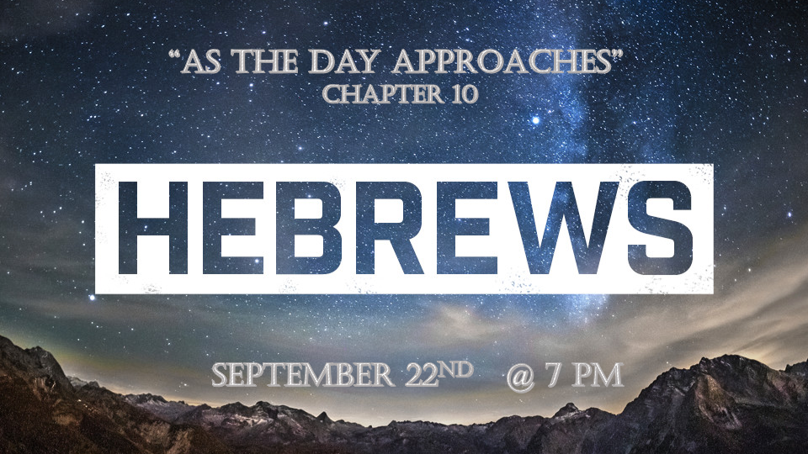

Prophetic Update:
- *Suddenly like labor pains, things changed. I Thess. 5:3, Luke 21:34, Acts 2:2

- *Wolves will be among the flock. (False prophets, apostles, and undiscerning Church leaders such as Pastors and Denominational leaders) Matt. 7:15 (False prophets) Acts 20:29-30 (Distortion of Truth)

*Hebrews10:1 The law is only a shadow of the good things that are coming—not the realities themselves. For this reason it can never, by the same sacrifices repeated endlessly year after year, make perfect those who draw near to worship. 2 Otherwise, would they not have stopped being offered? For the worshipers would have been cleansed once for all, and would no longer have felt guilty for their sins. 3 But those sacrifices are an annual reminder of sins. 4 It is impossible for the blood of bulls and goats to take away sins.
5 Therefore, when Christ came into the world, he said: "Sacrifice and offering you did not desire, but a body you prepared for me;
6 with burnt offerings and sin offerings you were not pleased.
7 Then I said, 'Here I am—it is written about me in the scroll—I have come to do your will, my God.' "
8 First he said, "Sacrifices and offerings, burnt offerings and sin offerings you did not desire, nor were you pleased with them"—though they were offered in accordance with the law. 9 Then he said, "Here I am, I have come to do your will." He sets aside the first to establish the second. 10 And by that will, we have been made holy through the sacrifice of the body of Jesus Christ once for all.

*The Shadow of things to come.

- V:1-4 To the Jew the yearly sacrifice was a reminder. Their ritual could not take away sin. This was to point them to their need for a Savior.

- V:5-10 The Messiah’s sacrifice which all other sacrifices pointed to was once and for all.

*Hebrews10:11 Day after day every priest stands and performs his religious duties; again and again, he offers the same sacrifices, which can never take away sins. 12 But when this priest had offered for all time one sacrifice for sins, he sat down at the right hand of God, 13 and since that time he waits for his enemies to be made his footstool. 14 For by one sacrifice he has made perfect forever those who are being made holy.
15 The Holy Spirit also testifies to us about this. First he says:
16 "This is the covenant I will make with them after that time, says the Lord. I will put my laws in their hearts, and I will write them on their minds."
17 Then he adds: "Their sins and lawless acts I will remember no more."
18 And where these have been forgiven, sacrifice for sin is no longer necessary.
*Insights into the sacrifice of our Messiah.

- V:11 O. T. sacrifices could only cover sin. Jesus sacrifice takes away sin.

- V:12 Priest could never sit in the tabernacle for the work was never done. Jesus does sit at the right hand of the father because it was complete.

- V:13-18 The day is looming when all of Jesus’ enemies will be under his feet. The day is forthcoming when our holiness will be complete.
- As the day is imminent the desire to have God’s Word in my heart grows.
- Sacrifice on God’s part is complete. Our opportunity is to accept what’s been done once for all.

*Hebrews 10:19 Therefore, brothers and sisters, since we have confidence to enter the Most Holy Place by the blood of Jesus, 20 by a new and living way opened for us through the curtain, that is, his body, 21 and since we have a great priest over the house of God, 22 let us draw near to God with a sincere heart and with the full assurance that faith brings, having our hearts sprinkled to cleanse us from a guilty conscience and having our bodies washed with pure water. 23 Let us hold unswervingly to the hope we profess, for he who promised is faithful. 24 And let us consider how we may spur one another on toward love and good deeds, 25 not giving up meeting together, as some are in the habit of doing, but encouraging one another—and all the more as you see the Day approaching.

*The Shadow of the past is gone and the day is approaching.

- V:19 What was reserved for only the High Priest is now our privilege to give us a holy boldness as we see the day is forthcoming.

- V:20-22 The Shadow of the future is casting on us revealing our freedom in Christ. It also gives us the advantage of sincerity in a deceptive world. It assures us in a frayed society that the future is in God’s hands. The future shadow is calling to a sanctified conscience in an impure culture. Show picture of tree shadows

- V:23-25 Believers must not isolate. They must draw near to God, and to one another as we see the Day drawing near. Is V:25 fulfilled in the 2020 pandemic?

