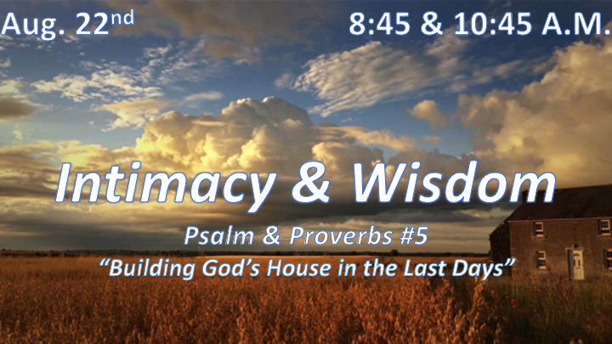

*What’s the hardest struggle for the Christian as the world becomes more wicked?

*Psalm 11:1 In the LORD I take refuge. How then can you say to me: "Flee like a bird to your mountain.
2 For look, the wicked bend their bows; they set their arrows against the strings to shoot from the shadows at the upright in heart.
3 When the foundations are being destroyed, what can the righteous do?"
4 The LORD is in his holy temple; the LORD is on his heavenly throne. He observes everyone on earth; his eyes examine them.
5 The LORD examines the righteous, but the wicked, those who love violence, he hates with a passion.
6 On the wicked he will rain fiery coals and burning sulfur; a scorching wind will be their lot.
7 For the LORD is righteous, he loves justice; the upright will see his face.

*The Testing of the Righteous.

- V:1 Christians trust in the Lord (Proverbs 3:5), not in their escape plan.

- V:2-3 The unrighteous are shooting the believer’s foundational issues while destroying the holy.

- V:4-7 The final exams have started and soon the day of wrath will begin. What will sustain you until His return?

*Prophetic insights continue through Psalm Chapters 12-14.

The godly in the midst of godless
*Psalm12:1 Help, LORD, for no one is faithful anymore; those who are loyal have vanished from the human race.

The anguish people will experience during the tribulation
*Psalm 13:1 How long, LORD? Will you forget me forever? How long will you hide your face from me?

The depraved attitudes in the last days.
*Psalm 14:1 The fool says in his heart, "There is no God." They are corrupt, their deeds are vile; there is no one who does good.

How to fight the good fight of faith?

*Psalm 127:1 Unless the LORD builds the house, the builders' labor in vain. Unless the LORD watches over the city, the guards stand watch in vain.
2 In vain you rise early and stay up late, toiling for food to eat—for he grants sleep to those he loves.
3 Children are a heritage from the LORD, offspring a reward from him.
4 Like arrows in the hands of a warrior are children born in one's youth.
5 Blessed is the man whose quiver is full of them. They will not be put to shame when they contend with their opponents in court.

*Wisdom within the intimacy of God’s Word for the Last Days.

- V:1-2 Partner with God, everything done without Him is done in vain.
- An Ineffective effort to shape life without God.

- Hollow protection tries to guard something God is not protecting.

- An unproductive effort is striving to have the best without God’s blessing of rest.

- V:3-5 Our true hope is our children.
- Protecting our hope for the future by educating them at home.

- Blessed is the man who understands his greatest responsibility is being a protector of the family.

