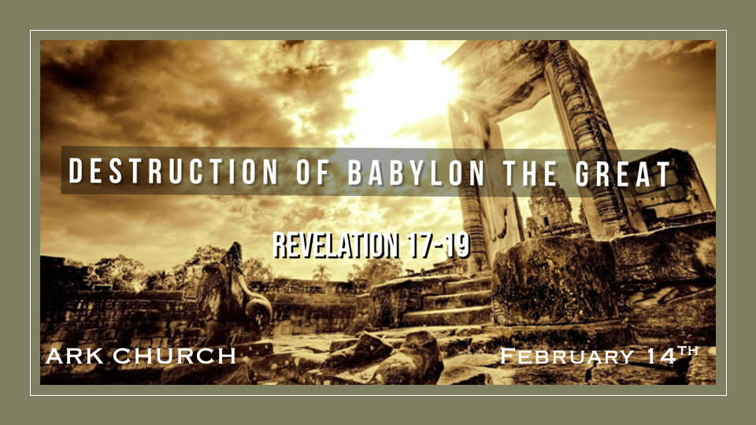
The statue of Peter before and after the lightning strike.
- It’s in Pope Francis's home-town
- It happened on his birthday in Dec. 2023
- The Halo is destroyed, representing holiness.
- The Keys are destroyed, signifying authority.

*The Mystery of Babylon The Great

*Revelation 16:19 Now the great city was divided into three parts, and the cities of the nations fell. And great Babylon was remembered before God, to give her the cup of the wine of the fierceness of His wrath.

*Revelation 17:1 Then one of the seven angels who had the seven bowls came and talked with me, saying to me, “Come, I will show you the judgment of the great harlot who sits on many waters, 2 with whom the kings of the earth committed fornication, and the inhabitants of the earth were made drunk with the wine of her fornication.”
3 So he carried me away in the Spirit into the wilderness. And I saw a woman sitting on a scarlet beast which was full of names of blasphemy, having seven heads and ten horns. 4 The woman was arrayed in purple and scarlet, and adorned with gold and precious stones and pearls, having in her hand a golden cup full of abominations and the filthiness of her fornication. 5 And on her forehead a name was written: MYSTERY, BABYLON THE GREAT, THE MOTHER OF HARLOTS AND OF THE ABOMINATIONS OF THE EARTH.

- Babylon the Great is remembered before God to give her the cup of the fierceness of His wrath.
Babylon is a location, a spirit, and a system, much like our understanding of the anti-Christ.
Babylon sits on many waters, and the kings of the earth commit fornication with Babylon.

- The Great Harlot sits on many waters. To commit fornication with the Kings of the earth means she must have been pure at some point, a virgin or committed to God. Besides Israel, what other nation declares its commitment to God? Answer: USA

The chronological order of “The Mystery” starts in Chapter 13, which is the description of the Beast, and then Chapter 14, which is the calling and three proclamations.

The Sequence

*Revelation 14:6 Then I saw another angel flying in the midst of heaven, having the everlasting gospel to preach to those who dwell on the earth—to every nation, tribe, tongue, and people— 7 saying with a loud voice, “Fear God and give glory to Him, for the hour of His judgment has come; and worship Him who made heaven and earth, the sea and springs of water.”
8 And another angel followed, saying, “Babylon is fallen, is fallen, that great city, because she has made all nations drink of the wine of the wrath of her fornication.”
9 Then a third angel followed them, saying with a loud voice, “If anyone worships the beast and his image, and receives his mark on his forehead or on his hand, 10 he himself shall also drink of the wine of the wrath of God, which is poured out full strength into the cup of His indignation. He shall be tormented with fire and brimstone in the presence of the holy angels and in the presence of the Lamb. 11 And the smoke of their torment ascends forever and ever; and they have no rest day or night, who worship the beast and his image, and whoever receives the mark of his name.”

1st Proclamation: “Fear God and give glory to Him for the hour of His judgment has come.
*The angel announcing the hour of judgment is upon the earth, the last hour of repentance before the tribulation.

2nd Proclamation: “Babylon is fallen, is fallen, that great city, because she has made all nations drink of the wine of the wrath of her fornication.”
*The 2nd announcement is the fall of Babylon the Great; it happens in a one-hour period, too. Rev. 18:10

3rd Proclamation: “If anyone worships the beast and his image, and receives his mark, the wrath of God is poured out upon them.

*The “Mystery” is Bigger than Babylon.

*Revelation 17:7 But the angel said to me, “Why did you marvel? I will tell you the mystery of the woman and of the beast that carries her, which has the seven heads and the ten horns. 8 The beast that you saw was, and is not, and will ascend out of the bottomless pit and go to perdition. And those who dwell on the earth will marvel, whose names are not written in the Book of Life from the foundation of the world, when they see the beast that was, and is not, and yet is.
9 “Here is the mind which has wisdom: The seven heads are seven mountains on which the woman sits. 10 There are also seven kings. Five have fallen, one is, and the other has not yet come. And when he comes, he must continue a short time. 11 The beast that was, and is not, is himself also the eighth, and is of the seven, and is going to perdition.
12 “The ten horns which you saw are ten kings who have received no kingdom as yet, but they receive authority for one hour as kings with the beast. 13 These are of one mind, and they will give their power and authority to the beast. 14 These will make war with the Lamb, and the Lamb will overcome them, for He is Lord of lords and King of kings; and those who are with Him are called, chosen, and faithful.”
15 Then he said to me, “The waters which you saw, where the harlot sits, are peoples, multitudes, nations, and tongues. 16 And the ten horns which you saw on the beast, these will hate the harlot, make her desolate and naked, eat her flesh and burn her with fire. 17 For God has put it into their hearts to fulfill His purpose, to be of one mind, and to give their kingdom to the beast, until the words of God are fulfilled. 18 And the woman whom you saw is that great city which reigns over the kings of the earth.”

- The angel asked, “Why did you marvel?”
When all this takes place, we should have been able to put the pieces together.

- *Who are all the characters in Revelation 17? Babylon, the woman, and the beast.

The Beast: There are also seven kings. Five have fallen, one is, and the other has not yet come. And when he comes, he must continue a short time. 11 The beast that was, and is not, is himself also the eighth, and is of the seven, and is going to perdition.

*Five Kings have fallen: Egypt, Assyria, Babylon, Medes/Persians, and Greece Empire.

*One is: At the time of the writing of Revelation, the kingdom was Rome.

*Another is to come for a short time: USA?

The Beast is the eighth King/Kingdom and is of the seven.

He is of the seven, which could mean there is a common thread that he is a part of.

- V:12 The ten kings have no kingdom but will receive their authority in one hour.

- V:15-18 The judgment of the great harlot (Babylon) who sits on many waters, and they are peoples, multitudes, nations, and tongues.

One hour Babylon is destroyed

One hour is the angel warning that the time has come.

One hour, ten kings without kingdoms will receive authority and then give it to the anti-Christ.

