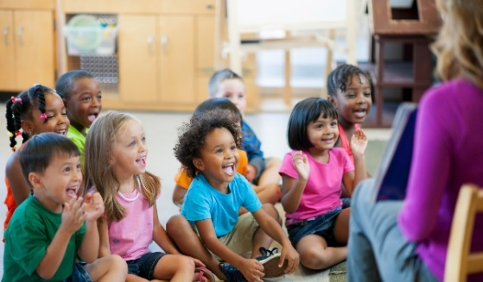- Homeschooling – Yes You Can! -
Find out how!
Your kids, Your Values, Your Choice
Homeschooling is the ultimate School Choice. It gives parents the freedom to personalize their children’s
education in ways that will best meet their unique needs and help them realize their full potential.
Parents are well-qualified; they are the best teachers for their own children.
You are invited to join us and learn how to homeschool your children.
Where: The ARK Church Redlands
Center for Home Schools
Young Hall
1307 E. Citrus Ave.
Redlands CA 92374
When: Thursday evening, June 25, 6:30-8:30 PM
RSVP (909) 793-2996 or churchoffice@arknaz.com

Come learn from the best!
Rebecca Kocsis, General Manager, Christian Home Educator’s
Association of California (CHEA)
Denise Soto, State Coordinator, California School Choice 2022. Denise is a very
experienced homeschooler and the ultimate resource on the “hows” of
homeschooling for California children.
Rebecca Friedrichs is a 28-year teacher and author of “Standing Up to Goliath,”
the truth about why public-school unions are a danger to quality education in
the government run schools.

For more information visit https://www.californiaschoolchoice.org
