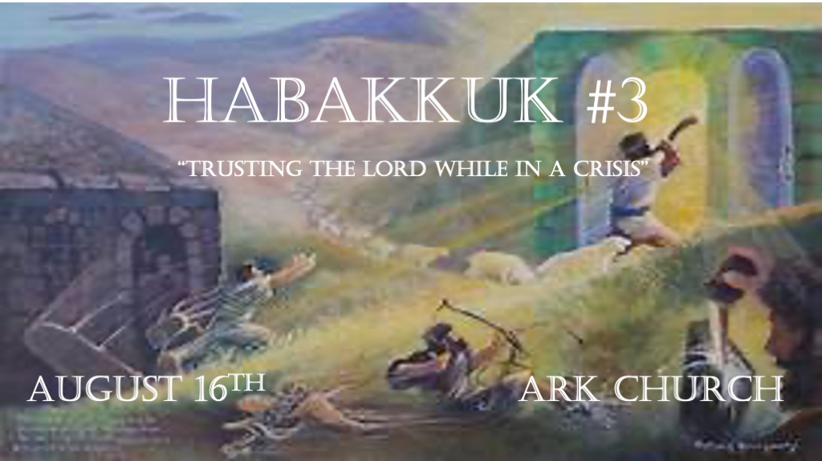
*Habakkuk means One Who Embraces or clings. The Prophet clings firmly to God regardless of what is happening in his culture in 607 B.C.

*Habakkuk gave no prophetic addressed directly to Israel. His dialogue is with God about the future.

*Key Verse Habakkuk 2:3 (NIV) For the revelation awaits an appointed time; it speaks of the end and will not prove false. Though it linger, wait for it; it will certainly come and will not delay.

*The Prayer for Showers of Mercy.
*Habakkuk 3:1 I 1 A prayer of Habakkuk the prophet, on Shigionoth.
2 O LORD, I have heard Your speech and was afraid; O LORD, revive Your work in the midst of the years!
In the midst of the years make it known; In wrath remember mercy.

V:1 A prayer within worship?

The same essence is in what we see written in the Psalms 400 years earlier.

V:2 Important request: When wrath is justified, let’s pray for mercy!

Prayers for mercy must be a part of this pre-wrath time before the rapture. (prayer for the righteous)

Under what circumstances should we pray for mercy for the unrighteous?

*Past faithfulness and knowledge of the future are used to renew us in the present.
*Habakkuk3:3 God came from Teman, The Holy One from Mount Paran.

His glory covered the heavens, and the earth was full of His praise. 4 His brightness was like the light; He had rays flashing from His hand, and there His power was hidden. 5 Before Him went pestilence, and fever followed at His feet. 6 He stood and measured the earth; He looked and startled the nations. And the everlasting mountains were scattered, the perpetual hills bowed. His ways are everlasting. 7 I saw the tents of Cushan in affliction; The curtains of the land of Midian trembled. 8 O LORD, were You displeased with the rivers, was Your anger against the rivers, was Your wrath against the sea, that You rode on Your horses, Your chariots of salvation? 9 Your bow was made quite ready; Oaths were sworn over Your arrows.

You divided the earth with rivers. 10 The mountains saw You and trembled; The overflowing of the water passed by. The deep uttered its voice, and lifted its hands on high. 11 The sun and moon stood still in their habitation; At the light of Your arrows they went, at the shining of Your glittering spear. 12 You marched through the land in indignation; You trampled the nations in anger.
13 You went forth for the salvation of Your people, for salvation with Your Anointed. You struck the head from the house of the wicked, by laying bare from foundation to neck.
14 You thrust through with his own arrows the head of his villages. They came out like a whirlwind to scatter me; Their rejoicing was like feasting on the poor in secret. 15 You walked through the sea with Your horses, through the heap of great waters. 16 When I heard, my body trembled; My lips quivered at the voice; Rottenness entered my bones; And I trembled in myself, that I might rest in the day of trouble. When he comes up to the people, he will invade them with his troops.

V:3-9 Without the knowledge of God’s faithfulness. Christians do not have an anchor or stability.

God’s faithfulness in creation. Speculation is Habakkuk recalling God’s faithfulness as Moses recorded it.
- In the new heaven, there will be no sun. God is light! Did God share His light with the present universe?
- Everlasting mountains are not secure if God wants them removed.
- V:9 Part one. The bow that will be shot forth the future is ready. The certainty of what is coming is sworn, for the arrows of what’s been reserved for the future will be shot out of God’s will.

V:9-13 A vision of Jesus' second coming or God’s faithfulness is remembered. (Possibly both)

V:9 Part two. The dividing of the earth with rivers. The river Jordan Biblically separates the world from the East and the West. Remember, Jerusalem is the center geographically in Biblical times.

V:10-11 The quotes seem to be from Psalms and Joshua. The question is, will it happen again?
- The mountain trembles are from Psalms 46:2-3.
- The sun and the moon standing still is from Joshua 10:12-15

V:12-13 The vision has elements of Babylonian destruction and something beyond them.

V:14-16 Habakkuk senses his sinfulness and needs peace as he is in the presence of the Mighty God. His prayer should be ours. May we rest (be at peace with God) in the day of trouble.

*Every area of life is in a crisis, Yet I will rejoice in the Lord.
*Habakkuk 3:17 Though the fig tree may not blossom, nor fruit be on the vines; Though the labor of the olive may fail,
and the fields yield no food; Though the flock may be cut off from the fold, and there be no herd in the stalls—18 Yet I will rejoice in the LORD, I will joy in the God of my salvation. 19 The LORD God is my strength; He will make my feet like deer’s feet, and He will make me walk on my high hills.
To the Chief Musician. With my stringed instruments.

V:17-18 Crisis that challenges our faith will come.

Israel will be dispersed, and the land will be desolate, but this won’t happen for almost 700 years from Habakkuk’s writings.

The timetable has always been in God’s hands. This truth is vital as we walk through the pre-tribulation events.

V:19 The Lord is our strength, and we should sing it.

Benjamin Franklin — who was not a Christian, though he had great respect for the Bible — used Habakkuk to confound a group of sophisticated, cultured despisers of the Bible. When he was in Paris, he heard this group mocking the Bible and mocking Franklin for his admiration of it. One evening he came among them and said that he had a manuscript containing an ancient poem, was quite impressed by the poem, and wanted to read it to them. When he read Habakkuk 3:17-19, his listeners received it with praise and admiration — “What a magnificent poem!” they said and wanted to know where they could get copies. Franklin told them to just look in Habakkuk Chapter 3.

May the Lord make your feet swift like the deer, and may you experience new obedience.

