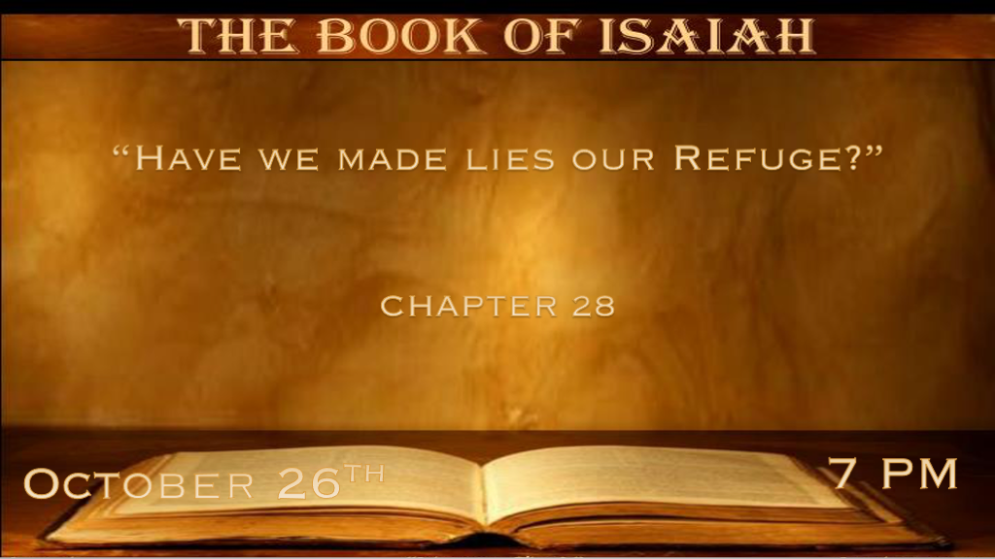

*Warning there is a priesthood and prophets that lie to themselves and others.

*Isaiah 28:1 Woe to the crown of pride, to the drunkards of Ephraim, whose glorious beauty is a fading flower which is at the head of the verdant valleys, to those who are overcome with wine! 2 Behold, the Lord has a mighty and strong one, like a tempest of hail and a destroying storm, like a flood of mighty waters overflowing, who will bring them down to the earth with His hand. 3 The crown of pride, the drunkards of Ephraim, will be trampled underfoot; 4 And the glorious beauty is a fading flower which is at the head of the verdant valley,
like the first fruit before the summer, which an observer sees; He eats it up while it is still in his hand. 5 In that day the LORD of hosts will be for a crown of glory and a diadem of beauty to the remnant of His people, 6 for a spirit of justice to him who sits in judgment, and for strength to those who turn back the battle at the gate. 7 But they also have erred through wine, and through intoxicating drink are out of the way; The priest and the prophet have erred through intoxicating drink, they are swallowed up by wine, they are out of the way through intoxicating drink; they err in vision, they stumble in judgment. 8 For all tables are full of vomit and filth; No place is clean.

- V:1-3 The spiritual leaders are intoxicated. God’s hand is invisible to them.
- *Literally they drank too much.
- *Spiritually they were intoxicated by their lies.
- *Pride they thought too highly of themselves.

- V:4-6 Spiritual and physical judgment was coming.
These verses deal with that day and a futuristic day when this will be Israel’s and the world’s judgment.

- V:7-8 Their error was in their view or vision of the future.
This parallels us today. The statement no place is clean is pun intended sobering.

* How do we protect ourselves from the lie?

*Isaiah 28:9 “Whom will he teach knowledge? And whom will he make to understand the message? Those just weaned from milk? Those just drawn from the breasts? 10 For precept must be upon precept, precept upon precept,
line upon line, line upon line, here a little, there a little.” 11 For with stammering lips and another tongue he will speak to this people, 12 to whom He said, “This is the rest with which you may cause the weary to rest,” and, “This is the refreshing”; Yet they would not hear. 13 But the word of the LORD was to them, “Precept upon precept, precept upon precept, line upon line, line upon line, here a little, there a little,” that they might go and fall backward, and be broken and snared and caught.
14 Therefore hear the word of the LORD, you scornful men, who rule this people who are in Jerusalem, 15 because you have said, “We have made a covenant with death, and with Sheol, we are in agreement. When the overflowing scourge passes through, It will not come to us, for we have made lies our refuge, and under falsehood, we have hidden ourselves.”

- V:9 If spiritual leaders are not listening to God, and living in the lies of society who will lead?
Clearly, God doesn’t expect the new followers of God to be responsible to teach.

- V:10-13 The Word of God anticipates every situation.
Some scholars say too much emphasis is placed on precept upon precept, line upon line, and here a little, there a little.

*God’s word is perfectly designed!

*The major doctrines of the faith are throughout the whole Bible.

*No one chapter contains all the deeper truths of God’s word on Salvation, judgment, or heaven.

- V:14-15 Wicked people make agreements with death and the devil. They trusted in their lies as a place of refuge for themselves.
This kind of evil is upon the world once again. Israel will make a covenant with the antichrist in the future.

*There is only one place to hide before destruction comes upon the earth.

*Isaiah 28:16 In Therefore thus says the Lord GOD: “Behold, I lay in Zion a stone for a foundation, a tried stone, a precious cornerstone, a sure foundation; Whoever believes will not act hastily. 17 Also I will make justice the measuring line, and righteousness the plummet; The hail will sweep away the refuge of lies, and the waters will overflow the hiding place. 18 Your covenant with death will be annulled, and your agreement with Sheol will not stand; When the overflowing scourge passes through, then you will be trampled down by it. 19 As often as it goes out it will take you; For morning by morning it will pass over, and by day and by night; It will be a terror just to understand the report.”
20 For the bed is too short to stretch out on, and the covering so narrow that one cannot wrap himself in it. 21 For the LORD will rise up as at Mount Perazim, He will be angry as in the Valley of Gibeon—That He may do His work, His awesome work, and bring to pass His act, His unusual act. 22 Now therefore, do not be mockers, lest your bonds be made strong; For I have heard from the Lord GOD of hosts, a destruction determined even upon the whole earth.

- V:16-18 Jesus is our refuge. He is our foundation and he will sweep away the lies in our lives and bring us to truth and stability. 1 Peter 2:6-7 verse 16 is quoted by Peter.
Their evil covenant will be annulled and agreement with hell will not protect them.

- V:19-22 Understanding the report that comes from God will be a horror in itself.
Verse 22 is futuristic implying the judgment that is coming to this world.

*The last days' parable about learning from the wisdom of God’s ways.

*Isaiah 28:23 Give ear and hear my voice, listen and hear my speech. 24 Does the plowman keep plowing all day to sow? Does he keep turning his soil and breaking the clods? 25 When he has leveled its surface, does he not sow the black cummin and scatter the cummin, plant the wheat in rows, the barley in the appointed place, and the spelt in its place? 26 For He instructs him in right judgment, his God teaches him. 27 For the black cummin is not threshed with a threshing sledge, nor is a cartwheel rolled over the cummin; But the black cummin is beaten out with a stick, and the cummin with a rod. 28 Bread flour must be ground; Therefore he does not thresh it forever, break it with his cartwheel, or crush it with his horsemen. 29 This also comes from the LORD of hosts, who is wonderful in counsel and excellent in guidance.

- Are you listening to God, if so how?
It only takes a simple message to turn from deception. The message of truth is planted in your heart.

- Are you relying on your knowledge and the world’s remedies?
Black Cumin was used for healing to cure all things.
Some were buried with it believing it would protect them in the afterlife.
Historians say Cleopatra used its oil for beauty and health.
Islam prophet Muhammed said it was the universal cure.

- It’s the Lord of Host's counsel and guidance that will get us through.

