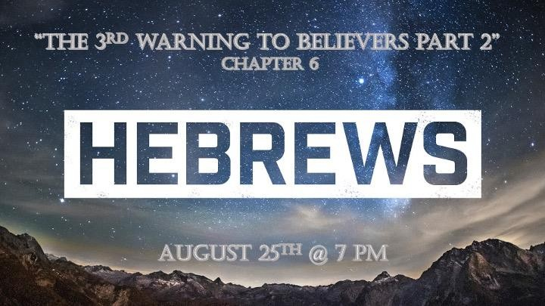

The Danger of Drifting Away (Ch. 2:1-4)
- The Danger of Disobedience (Doubting) (Ch. 3:7 – 4:13)
- The Danger of Deformity (Immaturity) (Ch. 5:11 – 6:20)
- The Danger of Willful Sin (Apostasy) (Ch. 10:26 – 31)
- The Danger of Denying (Indifference) (Ch. 12:15 – 29)

VERSES. 1-3

The foundation, the Old Covenant, had 6 features that are pointed out in verses 1-2. These are…

- Repentance from Dead Works - In the OT all the way unto John the Baptist, men knew only that they had to repent and turn to God.
- Faith toward God – The OT taught repentance from dead works and faith toward God. The
NT teaches repentance in faith towards the Lord Jesus. (Acts 4:12)
- Instruction about Washings - The Greek word in this case is baptismos, which should be
translated “washings” as it is everywhere else. (Ezekiel 36:25)

Laying on of Hands (Leviticus 3:8)
- Resurrection of the Dead (Job 19:26; Daniel 12:2; John 11:25-26; I Corinthians 15)
- Eternal Judgment – We can learn little more from the Old Testament about the final judgment than what is given in Ecclesiastes 12:14

The point of Hebrews 6:1-3 is simply that the unbelieving Jews should let go completely of the immature, elementary shadows and symbols of the Old Covenant and take hold of the mature and perfect reality of the New. (I John 2:12-14)

  - 1D – one dimensional – (adjective) having or relating to a single dimension; lacking depth; superficial.
    - “Little Children” – your sins are forgiven for HIS sake. Also, you have known the
Father – basic salvation

  - 2D – two dimensional = (adjective) having or appearing to have length and breadth but no depth; "a two-dimensional object"; lacking depth or substance; superficial.

    - “Young Men” – you have overcome the wicked one. You are strong and the Word of God abides in you. “Spiritual momentum”

  - 3D – three dimensional = (adjective) having or appearing to have length, breadth, and depth; a three-dimensional object".
    - “Fathers” – You have known Him from the beginning – Spiritual maturity

VERSE 3 – “I will go on and teach you what you need to know if God permits me.”

VERSES 4-6 – Five Great Advantages of this audiences of Hebrew Christians…

- They had been enlightened - mentally aware of something
- They had tasted of the heavenly gift – Those who were exposed to those who had truly experienced true salvation.
- They had partaken of the Holy Spirit – The Greek word has to with association, not possession.
- The had tasted the Word of God –tasted (sampled) of God’s Word. (Jeremiah 15:16)
- They had tasted the Power of the age to come – The powers of the kingdom demonstrated by Jesus in His earthly ministry and still did not believe.

VERSES 7-8 – To enhance the blessing of maturity and the ultimate destruction of that which is barren, the writer provides an illustration from nature. Much effort or work must be placed into the earth in order for it to produce. This is also true in the heart of man if they are to produce perfection (maturity). That upon which no effort is expended becomes worthless (John 15). There are two kinds of fields, one maturing unto blessing and the other degenerating unto cursing.

VERSES 9-12 – The writer is persuaded that his readers possess better qualities and the “things that accompany salvation”. However, he pronounces the fearful punishment upon those who would trample the Son of God under foot and would count the blood of Christ as unholy. He is describing what would happen to them if they did so. The writer is desirous that, as they were diligent in the past, so now in the present they might grow and mature in order to know the full assurance of their eternal life. They must not become slothful or “sluggish” (Greek.). They had already become “sluggish” in their hearing in (“dull”- KJV in 5:11)

VERSES 13-20 – The greatest encouragement to faith and patience is the confidence that God’s promises are trustworthy, in the example of Abraham. Both God’s authority and His integrity were at stake. Remember Abraham died not having received the promises of this Abrahamic Covenant, but it was fulfilled in the ministry of Christ Himself. However, the miracle of Isaac’s birth and subsequent encounter at Mt. Moriah reaffirmed God’s promise to Abraham.

God’s covenant to Abraham was based on two immutable (unchangeable) elements. FIRST, God’s promise was based upon His own unchanging work. He cannot lie; he will not allow His word to fail (Numbers 23:19). SECOND, our hope is sure and steadfast as a well-placed, unbending anchor. Our anchor is not located in the deepest seas, but in the sanctuary of the highest heaven. Our forerunner, Jesus is far different from the OT priests. The OT high priest could represent and intercede for the people within the sanctuary, the Holy of Holies; but he

could NOT take the people into it. As our forerunner, Jesus has opened the way before us that eventually we might enter in with HIM!!!! (Ephesians 3:11-12; Hebrews 4:14-16).

