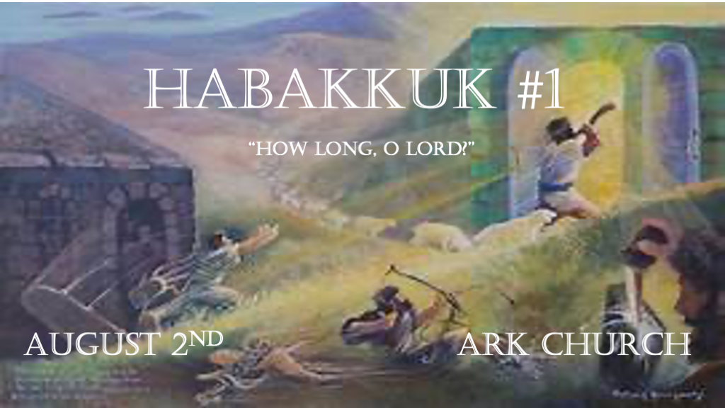
*Habakkuk means One Who Embraces or clings.
The Prophet clings firmly to God regardless of what happens to his nation. 607 B.C.

*The Burden of a Falling Nation.
*Habakkuk 1:1 The burden which the prophet Habakkuk saw.
2 O LORD, how long shall I cry, and You will not hear? Even cry out to You, “Violence!” and You will not save.
3 Why do You show me iniquity and cause me to see trouble? For plundering and violence are before me; There is strife, and contention arises. 4 Therefore the law is powerless, and justice never goes forth. For the wicked surround the righteous; Therefore perverse judgment proceeds.

V:1-3 A firm faith must wrestle with tough questions.

To avoid the hard questions of life will leave you vulnerable to deception.

Don’t be intimated by what you don’t know. Being willing to learn all that you don’t know. (Acts 17:11)

Violence against the young or innocent is always troubling to the soul. If it stops being so, the soul has died.

Dealing with generational iniquity will always bring strife because of those who deny it. It should humble us when we see it in us. It should cause us to pray and call out to God when we see the sins of others.

V:4 The signs of a fallen nation.

Laws are powerless.

Justice is lost and weighted by falsehood.

The wicked have the righteous boxed in through their control of society, but the righteous have a redeemer.

Perverse judgments are the norm.

*Look and watch and be amazed by what God is doing and will do.
*Habakkuk 1:5 “Look among the nations and watch—Be utterly astounded! For I will work a work in your days which you would not believe, though it were told you. 6 For indeed I am raising up the Chaldeans, a bitter and hasty nation which marches through the breadth of the earth, to possess dwelling places that are not theirs. 7 They are terrible and dreadful; Their judgment and their dignity proceed from themselves. 8 Their horses also are swifter than leopards and more fierce than evening wolves. Their chargers charge ahead; Their cavalry comes from afar; they fly as the eagle that hastens to eat. 9 “They all come for violence;
Their faces are set like the east wind. They gather captives like sand. 10 They scoff at kings, and princes are scorned by them.
They deride every stronghold, for they heap up earthen mounds and seize it. 11 Then his mind changes, and he transgresses;
He commits offense, ascribing this power to his god.”

V:5-7 The Parallel for today’s world.
God used the Babylonians/Chaldeans as a hostile and thoughtless nation. Possessing Israel’s land and the people's lives was the cost of rejecting God.

Examine the enemies of the USA. Many candidates could fill in the description in these verses.
God is challenging us to look at the nations.
Once, we were called to look at the nations to bring leadership, help, and salvation to them. Now we look at them to see who is bringing judgment to us.

V:7-9 Their nations are built for warfare and have several characteristics.

V:7 They have conviction and are horrifying and alarming.

V:8 Swift and aggressive and prepared for battle.

V:9 They are coming for violence. Jerusalem and the temple weren’t just conquered; they were destroyed.

V:10-11 They ascribe their power to their god.
They mock or toy with strongholds or nations, then change their minds and transgress.

You don’t make a treaty with them. The end time empire will be like the Roman empire, not Babylonian or Greece. They will use the iron rod to destroy others.

*How to face the times of crisis and judgment.
*Habakkuk 1:12 Are You not from everlasting, O LORD my God, my Holy One? We shall not die. O LORD, You have appointed them for judgment; O Rock, You have marked them for correction. 13 You are of purer eyes than to behold evil,
and cannot look on wickedness. Why do You look on those who deal treacherously and hold Your tongue when the wicked devours a person more righteous than he? 14 Why do You make men like fish of the sea, like creeping things that have no ruler over them? 15 They take up all of them with a hook, they catch them in their net, and gather them in their dragnet. Therefore they rejoice and are glad. 16 Therefore they sacrifice to their net, and burn incense to their dragnet; Because by them their share is sumptuous and their food plentiful. 17 Shall they therefore empty their net, and continue to slay nations without pity?

V:12 Marked for correction.
What marks a nation for God’s correction?

Only one path will derail God’s Wrath. Repentance it’s the Nineveh path of mercy.

V:13-15 Human dilemma when trying to understand God’s judgment.
V:13 Habakkuk could not understand how a holy God could use a more wicked nation than Israel to judge Israel.

Human reasoning is flawed. God knows things we can only speculate. Babylonian would prepare a magi that would one day honor the Messiah.

V:14-15 God’s people (Israel) were easily captured as fish caught in a net. Lesson: humanity is no match for God’s plan. Let God be God.

V:16-17 The slaying of nations brings a futuristic aspect to this chapter.
There is a wickedness beyond Babylon.

The wickedness of the Anti-Christ who is true lawlessness and his spirit is in the world.

