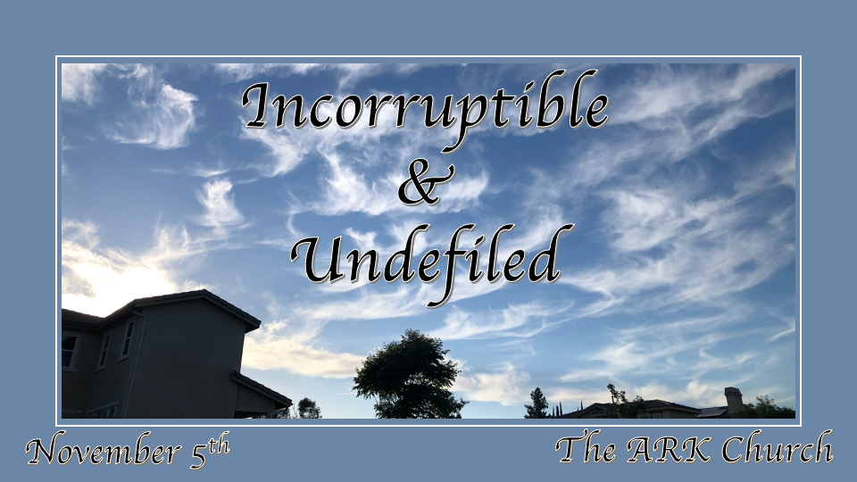
*A Eternal Mindset is a Vital Christian Perspective.

*I Peter 1:4 to an inheritance incorruptible and undefiled and that does not fade away, reserved in heaven for you, 5 who are kept by the power of God through faith for salvation ready to be revealed in the last time.

*How Much Do You Know About Heaven? (Video)

Insights I Peter 1:4 *An inheritance is more than a destination of heaven.
Things to know about the place called heaven.

- John 14:2-3 Let’s talk real estate. How much does inflation corrupt the price of real estate? Free housing!

Let’s discuss breakfast, lunch, and dinner. How much of your time comes with thinking about food? A banqueting table is prepared for us. Grocery bills and eating-out expenses are zero!

- *Revelation 19:6 And I heard, as it were, the voice of a great multitude, as the sound of many waters and as the sound of mighty thunderings, saying, “Alleluia! For the Lord God Omnipotent reigns! 7 Let us be glad and rejoice and give Him glory, for the marriage of the Lamb has come, and His wife has made herself ready.” 8 And to her it was granted to be arrayed in fine linen, clean and bright, for the fine linen is the righteous acts of the saints.

Our future inheritance is being spelled out! Fine Linen, clean and bright, is part of our inheritance. What’s the clothing budget cost? Nothing!

Did this happen before? Yes, in the wilderness, heaven came on earth.

- Philippians 3:20 For our citizenship is in heaven, from which we also eagerly wait for the Savior, the Lord Jesus Christ, 21 who will transform our lowly body that it may be conformed to His glorious body, according to the working by which He is able even to subdue all things to Himself.

The physical ingredient of our inheritance is unique. The Total makeover with the optimum body is designed never needing a doctor visit or a dentist. The glorified body upgrade includes being an eternal heir. (1 Cor. 15:53-54)

More insights I Peter 1:4 *The Incorruptible creation and environment.

A house never needs repair or repainted, and remodeling is done without cost.
Our food won’t rot or decay in heaven and will have great variety. No MSG is added to the food.
Clothing that doesn’t wear out. By the way, Israel saw the clothing aspect in the forty years in the wilderness.
Our body is indestructible, with perfect digestion and no time spent in the restroom.

- *Revelation 21:4 And God will wipe away every tear from their eyes; there shall be no more death, nor sorrow, nor crying. There shall be no more pain, for the former things have passed away.”
No sorrow, death, or crying, plus no pain meds are needed in heaven. What brought all those things to this world is sin.

A character, integrity, and a moral level humans can only dream about will be incorruptible and immortal.

- *I Peter 1:23 having been born again, not of corruptible seed but incorruptible, through the word of God which lives and abides forever
The Incorruptible process starts right now!

I believe in a young world and creation, as the Bible teaches.
*Romans 5:12 Therefore, just as through one man sin entered the world, and death through sin, and thus death spread to all men, because all sinned.

I Cor. 15:21 For since by man came death, by Man also came the resurrection of the dead. 22 For as in Adam all die, even so in Christ all shall be made alive.

More insights 1 Peter 1:4 *No defilement is possible in the new heaven.

Biblical Definition of undefiled: free from stain or blemish. Synonyms: immaculate pure. (used of persons or behaviors) having no faults; sinless.

- *Psalm 119:1 says, “Blessed are the undefiled.”
The defilement comes from the soiling, corruption, and pollution of the soul with unbridled sin. It is abandonment from God in unbelief, rebellion, self-righteousness, pride, self-indulgence, and indifference to the way of righteousness.

- *James 3:17 But the wisdom that is from above is first pure (undefiled), then peaceable, gentle, willing to yield, full of mercy and good fruits, without partiality and without hypocrisy. 18 Now the fruit of righteousness is sown in peace by those who make peace.

Greater things are yet to come, and greater things are yet to be done!

*1 Corinthians 2:9 But, as it is written, “What no eye has seen, nor ear heard, nor the heart of man imagined, what God has prepared for those who love him”—

