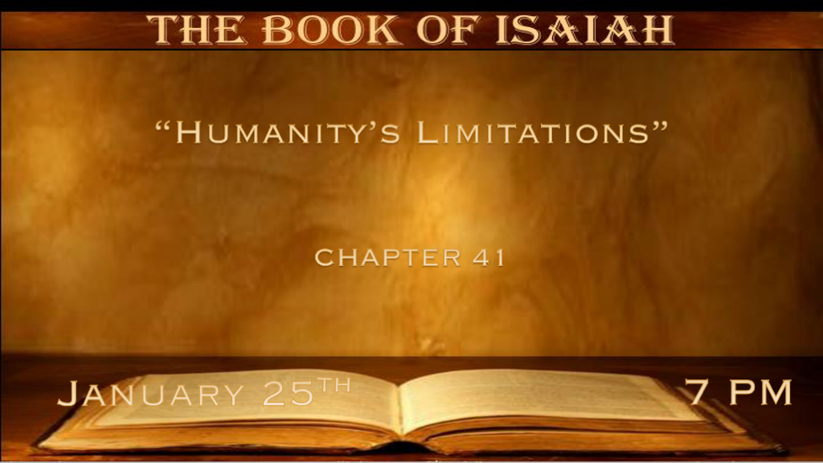

*\*Are you a friend of God?*

*\*Isaiah 41:1 “Keep silence before Me, O coastlands, and let the people renew their strength! Let them come near, then let them speak;*

*Let us come near together for judgment. 2 “Who raised up one from the east? Who in righteousness called him to His feet? Who gave the nations before him, and made him rule over kings? Who gave them as the dust to his sword, as driven stubble to his bow? 3 Who pursued them, and passed safely by the way that he had not gone with his feet? 4 Who has performed and done it, calling the generations from the beginning? ‘I, the LORD, am the first; And with the last I am He.’ ” 5 The coastlands saw it and feared, the ends of the earth were afraid; They drew near and came. 6 Everyone helped his neighbor, and said to his brother, “Be of good courage!” 7 So the craftsman encouraged the goldsmith; He who smooths with the hammer inspired him who strikes the anvil, saying, “It is ready for the soldering”; Then he fastened it with pegs, that it might not totter. 8 “But you, Israel, are My servant, Jacob whom I have chosen, the descendants of Abraham My friend. 9 You whom I have taken from the ends of the earth, and called from its farthest regions, and said to you, ‘you are My servant, I have chosen you and have not cast you away: 10 Fear not, for I am with you; Be not dismayed, for I am your God. I will strengthen you, yes, I will help you, I will uphold you with My righteous right hand.’*

1. V:1-3 **A 170-year prophecy.** The one raised from the east will be the deliverer of Israel we will learn his name in Chapter 45 it’s Cyrus.

**Tucked inside this prophecy of Cyrus.** God is speaking to the World about a future world that comes together for judgment.

1. V:3-8 **God’s choices** of who and how He raises people up.
2. One of the great “I AM” statements. I am the first and the last. Rev. 1:8 & 22:13
3. **Cyrus** leader of the Mede/Persian lets Israel go back to their homeland after exactly 70 years of captivity.
4. **Jacob** is transformed into Israel. God weaves a testimony with His power.
5. V:8-9 **Abraham** my friend. Part of being a friend of God is the insight into the future.
6. Daniel was called His beloved and it is Daniel who receives end-time revelation.
7. John the Apostle is also called His beloved and He receives the book of revelation
8. V:9-10 **As friends of God** we don’t have to fear the future**.**

**V:9 Is God’s promise to Israel** I will gather you and not cast you away.

**V:10** I will strengthen you.

*\*“Fear Not,” because there are many good reasons to have faith.*

*\*Isaiah 40:11 “Behold, all those who were incensed against you shall be ashamed and disgraced; They shall be as nothing, and those who strive with you shall perish. 12 You shall seek them and not find them—Those who contended with you. Those who war against you shall be as nothing, as a nonexistent thing. 13 For I, the LORD your God, will hold your right hand, saying to you, ‘Fear not, I will help you.’ 14 “Fear not, you worm Jacob, You men of Israel! I will help you,” says the LORD and your Redeemer, the Holy One of Israel. 15 “Behold, I will make you into a new threshing sledge with sharp teeth; You shall thresh the mountains and beat them small, and make the hills like chaff. 16 You shall winnow them, the wind shall carry them away, and the whirlwind shall scatter them; You shall rejoice in the LORD, and glory in the Holy One of Israel.*

*17 “The poor and needy seek water, but there is none, their tongues fail for thirst. I, the LORD, will hear them; I, the God of Israel, will not forsake them. 18 I will open rivers in desolate heights and fountains in the midst of the valleys; I will make the wilderness a pool of water,*

*And the dry land springs of water. 19 I will plant in the wilderness the cedar and the acacia tree, the myrtle and the oil tree; I will set in the desert the cypress tree and the pine and the box tree together, 20 That they may see and know, and consider and understand together,*

*that the hand of the LORD has done this, and the Holy One of Israel has created it.*

1. V:11-13 **Again, fear not,** God will make war against those who make war against us.

**The world is incensed against the Christians.** They are the ones that will face shame and disgrace.

1. V:14-16 **A special “Fear Not”** to Israel. Why?

**The Lord is the Redeemer!** The Holy One of Israel.

**The 1st coming** was as Redeemer and His **2nd coming** is as the avenger of blood.

1. V:17-20 **Daily needs** limit humanity but in reality, they allow God to reveal His care.

**The God who provides** just as He did in the wilderness.

*\*God does call out evil and declares all that He will do.*

*\*Isaiah 41:21 “Present your case,” says the LORD. “Bring forth your strong reasons,” says the King of Jacob. 22 “Let them bring forth and show us what will happen; Let them show the former things, what they were, that we may consider them, and know the latter end of them;*

*Or declare to us things to come. 23 Show the things that are to come hereafter, that we may know that you are gods; Yes, do good or do evil, that we may be dismayed and see it together. 24 Indeed you are nothing, and your work is nothing; He who chooses you is an abomination. 25 “I have raised up one from the north, and he shall come; From the rising of the sun he shall call on My name; And he shall come against princes as though mortar, as the potter treads clay. 26 Who has declared from the beginning, that we may know? And former times, that we may say, ‘He is righteous’? Surely there is no one who shows, surely there is no one who declares, surely there is no one who hears your words. 27 The first time I said to Zion, ‘Look, there they are!’ And I will give to Jerusalem one who brings good tidings. 28 For I looked, and there was no man; I looked among them, but there was no counselor, who, when I asked of them, could answer a word. 29 Indeed they are all worthless; Their works are nothing; Their molded images are wind and confusion.*

1. V:21-24 **God challenges evil.** See the limitations of evil.
2. They have no case to present before God.
3. They don’t know the future. They can only know what God has declared.
4. Evil beings, devils, and demons are limited and so are enlightened humans.

**An abomination choose evil** and it shows their lack of any real understanding. They are nothing.

1. V:25-26  **God declares** what He has done and what’s going to happen with exactness.

**God is 100% correct and so are His true prophets.**

1. V:27 **God’s love for Jerusalem.**

**God promises** to give to Jerusalem good tidings. Two truths are being implied; Jesus the King will reign from Jerusalem. Jerusalem has a future beyond this world.

1. V:28-29 **All of humanity is limited.**

Apart from God, all our works will add up to nothing.

The work of evil is confusion. The Work of God always shows the Way, the Truth, and the Life.