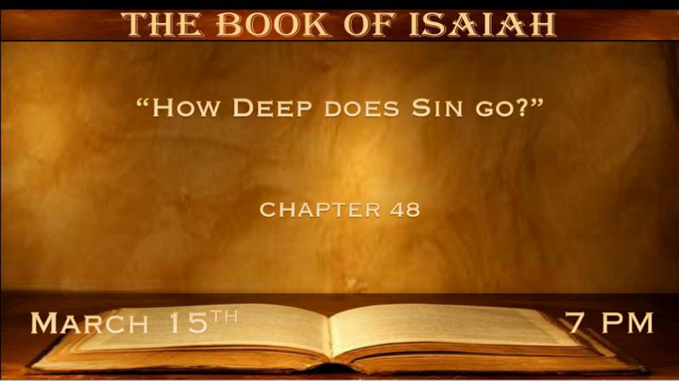

*The Lord Sees the Hardness of Hearts and our deception.

*Isaiah 48:1 “Hear this, O house of Jacob, who are called by the name of Israel, and have come forth from the wellsprings of Judah;
Who swear by the name of the LORD, and make mention of the God of Israel, but not in truth or in righteousness; 2 For they call themselves after the holy city, and lean on the God of Israel; The LORD of hosts is His name:
3 “I have declared the former things from the beginning; They went forth from My mouth, and I caused them to hear it. Suddenly I did them, and they came to pass. 4 Because I knew that you were obstinate, and your neck was an iron sinew, and your brow bronze,
5 Even from the beginning I have declared it to you; Before it came to pass I proclaimed it to you, lest you should say, ‘My idol has done them, and my carved image and my molded image have commanded them.’ 6 “You have heard; See all this. And will you not declare it?
I have made you hear new things from this time, even hidden things, and you did not know them. 7 They are created now and not from the beginning; And before this day you have not heard them, lest you should say, ‘Of course I knew them.’ 8 Surely you did not hear,
surely you did not know; Surely from long ago your ear was not opened. For I knew that you would deal very treacherously, and were called a transgressor from the womb. 9 “For My name’s sake I will defer My anger, and for My praise I will restrain it from you, so that I do not cut you off. 10 Behold, I have refined you, but not as silver; I have tested you in the furnace of affliction. 11 For My own sake, for My own sake, I will do it; For how should My name be profaned? And I will not give My glory to another.

- V:1-2 Our sins are deep generational sins.
- O house of Jacob you are Israel in name only means. Israel: God prevails or is Governed by God.
Sin’s deception is still ruling the heart.

- Tribal connection to Judah is not a compliment.
Judah is known for his cruelty and immorality Genesis 37 & 38.

Sinners find comfort in their sins by mentioning God and even sharing some things about God. Self-deception is a deeper-level sin.

- V:3-5 When God reveals His power and we choose to live attached to our sinful lifestyle.
Stubbornness/stiff neck people are still enjoying their ways of sin. The cost of sin hasn’t caught up to them.

- V:6-8 Hearing what God declares before it happens and not acknowledging God did so is sin.
This is the sin of stiff neck Christians. The rejection of God’s prophetic word is a grave sin against those that call themselves Christian and act like Jacob (deceived)

- V:9-11 Examine the things that are in your life. Is God trying to get your attention?

The distracted life: This life is extremely deceived. They look at others and believe they are doing fine.
- How much time do your iPhone, social media, and noise (Music, TV, etc.) get in your day?
- How many things need to happen in a day for you to feel content?
V:9 God restrains His anger because He loves you.

The detached life: They are attached to others but not to family, Church, or God. They feel the emptiness even at a crowded party.
V:10 God is turning up the heat. The refining process allows us to learn only the Holy Spirit will make you feel complete.

The demonic life: Blame most of their afflictions or problems in life are from God. When they may be from the evil influences they allow to control them.
V:11 God is denouncing everything in your life that is stealing His Glory. He won’t share His glory with the devil and anyone or anything.

*The Lie: Sin makes me undeserving. The Truth: God delivers us from sin.

*Isaiah 48:12 “Listen to Me, O Jacob, and Israel, My called: I am He, I am the First, I am also the Last. 13 Indeed My hand has laid the foundation of the earth, and My right hand has stretched out the heavens; When I call to them, They stand up together. 14 “All of you, assemble yourselves, and hear! Who among them has declared these things? The LORD loves him; He shall do His pleasure on Babylon, and His arm shall be against the Chaldeans. 15 I, even I, have spoken; Yes, I have called him, I have brought him, and his way will prosper. 16 “Come near to Me, hear this: I have not spoken in secret from the beginning; From the time that it was, I was there. And now the Lord GOD and His Spirit have sent Me.” 17 Thus says the LORD, your Redeemer, The Holy One of Israel: “I am the LORD your God, Who teaches you to profit, Who leads you by the way you should go. 18 Oh, that you had heeded My commandments! Then your peace would have been like a river, and your righteousness like the waves of the sea. 19 Your descendants also would have been like the sand, and the offspring of your body like the grains of sand; His name would not have been cut off nor destroyed from before Me.”
20 Go forth from Babylon! Flee from the Chaldeans! With a voice of singing, Declare, proclaim this, Utter it to the end of the earth; Say, “The LORD has redeemed His servant Jacob!” 21 And they did not thirst when He led them through the deserts; He caused the waters to flow from the rock for them; He also split the rock, and the waters gushed out. 22 “There is no peace,” says the LORD, “for the wicked.”

- V:12 God is calling to the undeserving (all of us) to hear His voice.
Through reading the Word of God

The Preaching of the Word of God

His voice is in Christian worship.

- V:13-15 The Creator who made us and everything in heaven and under it loves us.
Who is speaking? Jesus is speaking. This portion of Isaiah mirrors John Chapter one.

- V:16-17 I have not spoken in secret. Who was sent? Jesus and His love leads us in the way we should go.

*John 14:6 Jesus said to him, “I am the way, the truth, and the life. No one comes to the Father except through Me.

V:16 Reveals Elohim The Father, The Son, and The Holy Spirit.

- V:18-22 The peace is from one source.

The wicked may seem like they prosper for a time, but they cannot have peace.

*Isaiah 48:18 Oh, that you had heeded My commandments! Then your peace would have been like a river,
And your righteousness like the waves of the sea.

