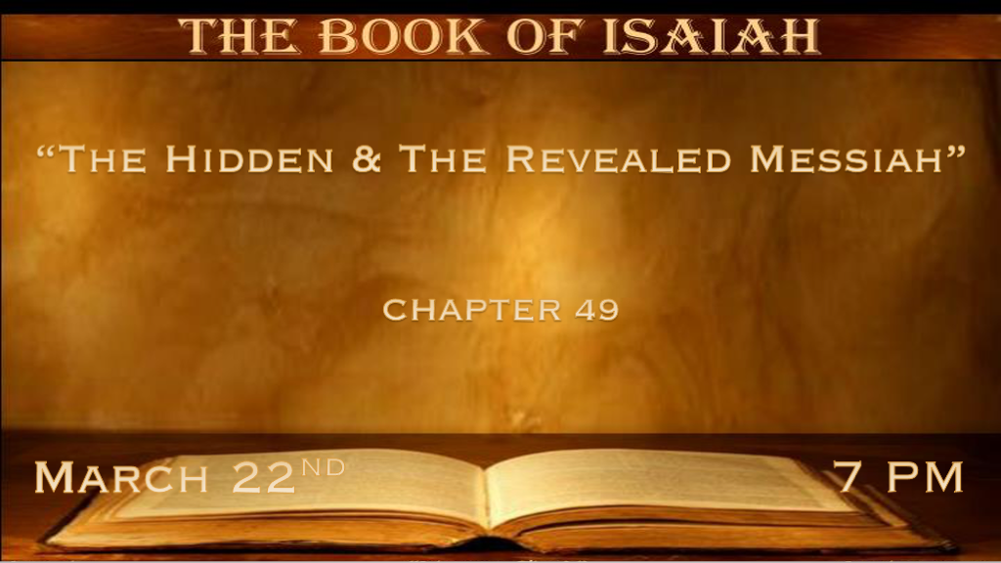

*The Shadow of God’s Hand Has Hid Me (Jesus)

*Isaiah 49:1 “Listen, O coastlands, to Me, and take heed, you peoples from afar! The LORD has called Me from the womb; From the matrix of My mother He has made mention of My name. 2 And He has made My mouth like a sharp sword; In the shadow of His hand He has hidden Me, And made Me a polished shaft; In His quiver He has hidden Me.” 3 “And He said to me, You are My servant, O Israel, in whom I will be glorified.’ 4 Then I said, ‘I have labored in vain, I have spent my strength for nothing and in vain; Yet surely my just reward is with the LORD, and my work with my God.’ ” 5 “And now the LORD says, who formed Me from the womb to be His Servant, to bring Jacob back to Him, so that Israel is gathered to Him (For I shall be glorious in the eyes of the LORD, and My God shall be My strength),
6 Indeed He says, ‘It is too small a thing that You should be My Servant To raise up the tribes of Jacob, and to restore the preserved ones of Israel; I will also give You as a light to the Gentiles, that You should be My salvation to the ends of the earth.’ ”

- V:1 Another Warning to the coastlands.
The distant lands of the Gentile need to heed or listen to the truth. This could represent the day we are living in.
*The Matrix of the womb. The environment from which something new is developed. Luke 1:31

- V:2-3 The Hidden Sword of God.
*Jesus is the Word and the Word is a Sword and the weapon of our warfare. Revelation 19:15

- V:4-6 Jesus 1st advent mission. The Gentile portion of the mission is part of the shadow.
Clearly the prophetic mission of Jesus was to come as a servant to His Father to give light to the world. Gentiles are a major part of Jesus' prophetic mission to bring salvation to the end of the world.
V:4 The NKJV doesn’t believe Jesus is speaking. It is Jesus but it shows the sadness of God about the stubbornness of the nation Israel as it is referred to as Jacob.

*Is This A Prophecy Concerning The United States & The UK?

*Isaiah 49:7 Thus says the LORD, The Redeemer of Israel, their Holy One, to Him whom man despises, to Him whom the nation abhors, to the Servant of rulers: “Kings shall see and arise, princes also shall worship, because of the LORD who is faithful, The Holy One of Israel; And He has chosen You.” 8 Thus says the LORD: “In an acceptable time I have heard You, and in the day of salvation I have helped You; I will preserve You and give You as a covenant to the people, to restore the earth, to cause them to inherit the desolate heritages; 9 That You may say to the prisoners, ‘Go forth,’ to those who are in darkness, ‘Show yourselves.’ “They shall feed along the roads, and their pastures shall be on all desolate heights. 10 They shall neither hunger nor thirst, neither heat nor sun shall strike them; For He who has mercy on them will lead them, even by the springs of water He will guide them. 11 I will make each of My mountains a road, and My highways shall be elevated. 12 Surely these shall come from afar; Look! Those from the north and the west, and these from the land of Sinim.” 13 Sing, O heavens! Be joyful, O earth! And break out in singing, O mountains! For the LORD has comforted His people, and will have mercy on His afflicted.

- This Chapter names the who of the target audience in verse one the people in the coastlands.
No future discovery of humanity can take an all-knowing God by surprise.

Many older commentaries do not grasp this prophetic sequence.

- V:7-8 Prophecy about God hearing at an acceptable time. Is this the Covenant that John Winthrop made in 1631 that the Colonies signed to start in this new world?
A New World with godly people desiring a new start where God’s principles would reign.

Why is the 1619 project trying to erase this important link in America’s history?

- V:9-13 Who are the people of the Land of Sinim?
The land of sin but especially in two directions North and West.

V:8 God will make all mountains a highway. He removes every barrier for Israel to become what it is.

A people for a season who brought comfort to Israel God’s people. They brought singing to the heavens and the earth. You decided who in the world could this prophecy be talking about.

*God Again Reveals and Proclaims His Love for Israel.

*Isaiah 49:14 But Zion said, “The LORD has forsaken me, and my Lord has forgotten me.” 15 “Can a woman forget her nursing child, and not have compassion on the son of her womb? Surely they may forget, yet I will not forget you. 16 See, I have inscribed you on the palms of My hands; Your walls are continually before Me. 17 Your sons shall make haste; Your destroyers and those who laid you waste shall go away from you. 18 Lift up your eyes, look around and see; All these gather together and come to you. As I live,” says the LORD, “You shall surely clothe yourselves with them all as an ornament, and bind them on you as a bride does. 19 “For your waste and desolate places, and the land of your destruction, will even now be too small for the inhabitants; And those who swallowed you up will be far away.
20 The children you will have, after you have lost the others, will say again in your ears, ‘The place is too small for me; Give me a place where I may dwell.’ 21 Then you will say in your heart, ‘Who has begotten these for me, Since I have lost my children and am desolate,
a captive, and wandering to and fro? And who has brought these up? There I was, left alone; But these, where were they?’ ” 22 Thus says the Lord GOD: “Behold, I will lift My hand in an oath to the nations, and set up My standard for the peoples; They shall bring your sons in their arms, and your daughters shall be carried on their shoulders; 23 Kings shall be your foster fathers, and their queens your nursing mothers; They shall bow down to you with their faces to the earth, and lick up the dust of your feet. Then you will know that I am the LORD, for they shall not be ashamed who wait for Me.”
24 Shall the prey be taken from the mighty, or the captives of the righteous be delivered? 25 But thus says the LORD: “Even the captives of the mighty shall be taken away, and the prey of the terrible be delivered; For I will contend with him who contends with you, and I will save your children. 26 I will feed those who oppress you with their own flesh, and they shall be drunk with their own blood as with sweet wine. All flesh shall know that I, the LORD, am your Savior, and your Redeemer, the Mighty One of Jacob.”

- V:14-17 God remembers all His promises.
The cycle of comfort and affliction is ancient history and is the current situation in Israel.

Great promise the destroyers and affliction will go away.

- V:18-23 What God does for Israel is also an oath and standard of His promises to the World.

The Walls that are forever before God is a reference to Jerusalem. In V:18 As the Bride does, Wow!

The promise to Israel was partially fulfilled when they returned from Babylon.

V:23 Kings shall be your foster fathers. I believe will be a millennial fulfillment.

- V:24-26 The claim over sinners is taken away.
The redeemer purchases us. Deliverance and the captives are set free this is speaking about Israel's final deliverance through Jesus, the Mighty One of Jacob.

