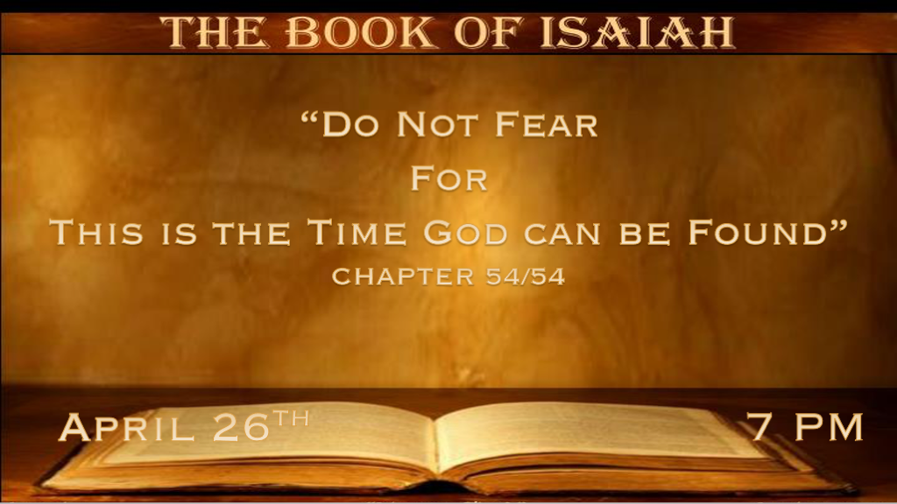

*Enlarge your tent!

*Isaiah 54:1 “Sing, O barren, You who have not borne! Break forth into singing, and cry aloud, you who have not labored with child! For more are the children of the desolate than the children of the married woman,” says the LORD. 2 “Enlarge the place of your tent, and let them stretch out the curtains of your dwellings; Do not spare; Lengthen your cords, and strengthen your stakes. 3 For you shall expand to the right and to the left, and your descendants will inherit the nations, and make the desolate cities inhabited. 4 “Do not fear, for you will not be ashamed;
Neither be disgraced, for you will not be put to shame; For you will forget the shame of your youth, and will not remember the reproach of your widowhood anymore. 5 For your Maker is your husband, the LORD of hosts is His name; And your Redeemer is the Holy One of Israel; He is called the God of the whole earth. 6 For the LORD has called you like a woman forsaken and grieved in spirit, like a youthful wife when you were refused,” Says your God. 7 “For a mere moment I have forsaken you, but with great mercies I will gather you. 8 With a little wrath I hid My face from you for a moment; But with everlasting kindness I will have mercy on you,” Says the LORD, your Redeemer. 9 “For this is like the waters of Noah to Me; For as I have sworn that the waters of Noah would no longer cover the earth, so have I sworn that I would not be angry with you, nor rebuke you. 10 For the mountains shall depart and the hills be removed, but My kindness shall not depart from you, Nor shall My covenant of peace be removed,” Says the LORD, who has mercy on you.

- V:1 The shame of barrenness has an immense spiritual connotation to all humanity.
Why being barren spiritually should bring a spirit of brokenness. God's call is to be fruitful.
The Holy Spirit is the avenue to fruitfulness.

- V:2-6 We are all Sarahs and Abrahams.
To expand your tent is to be stretched spiritually.
Spread out and stop relying on your flesh comfort zone.
Have you made decisions recently that said to your fear, “You won’t stop me?”

- V:7-10 The truth about God’s consequences for our sin, lack of faith, and disobedience.
- A forsaken gathering.
- A little Wrath from God and everlasting kindness are signs of the end.
- Physical upheaval is like in Noah’s day, but the covenant of peace will prevail.

*Precious foundations and a favorite promise
*Isaiah 54:11 Behold, “O you afflicted one, tossed with tempest, and not comforted, Behold, I will lay your stones with colorful gems, and lay your foundations with sapphires. 12 I will make your pinnacles of rubies, your gates of crystal, and all your walls of precious stones. 13 All your children shall be taught by the LORD, and great shall be the peace of your children. 14 In righteousness you shall be established; You shall be far from oppression, for you shall not fear; and from terror, for it shall not come near you. 15 Indeed they shall surely assemble, but not because of Me. Whoever assembles against you shall fall for your sake. 16 “Behold, I have created the blacksmith who blows the coals in the fire, who brings forth an instrument for his work; And I have created the spoiler to destroy. 17 No weapon formed against you shall prosper,
and every tongue which rises against you in judgment you shall condemn. This is the heritage of the servants of the LORD, and their righteousness is from Me,” Says the LORD.

- V:11-13 Many falsely believe God doesn’t care.
These scriptures reveal The God who cares and lays a precious foundation of stones.
God will teach the people of God and our children, and a GREAT peace will come to our children.

- V:14-17 Covenant language: No fear, those who come against us shall fall.
Foundational living is always through God’s righteousness.
No weapon formed against me shall prosper.

*Now is the time to learn from God while He may be found.

Isaiah 55:1 “Ho! Everyone who thirsts, Come to the waters; and you who have no money, come, buy and eat. Yes, come, buy wine and milk
without money and without price. 2 Why do you spend money for what is not bread, and your wages for what does not satisfy? Listen carefully to Me, and eat what is good, And let your soul delight itself in abundance. 3 Incline your ear, and come to Me. Hear, and your soul shall live; and I will make an everlasting covenant with you—The sure mercies of David. 4 Indeed I have given him as a witness to the people, a leader and commander for the people. 5 Surely you shall call a nation you do not know, and nations who do not know you shall run to you, because of the LORD your God, and the Holy One of Israel; For He has glorified you.” 6 Seek the LORD while He may be found,
Call upon Him while He is near. 7 Let the wicked forsake his way, and the unrighteous man his thoughts; Let him return to the LORD, And He will have mercy on him; And to our God, for He will abundantly pardon. 8 “For My thoughts are not your thoughts, Nor are your ways My ways,” says the LORD. 9 “For as the heavens are higher than the earth, So are My ways higher than your ways, and My thoughts than your thoughts. 10 “For as the rain comes down, and the snow from heaven, and do not return there, but water the earth, and make it bring forth and bud, that it may give seed to the sower and bread to the eater, 11 So shall My word be that goes forth from My mouth; It shall not return to Me void, But it shall accomplish what I please, and it shall prosper in the thing for which I sent it. 12 “For you shall go out with joy, and be led out with peace; The mountains and the hills shall break forth into singing before you, and all the trees of the field shall clap their hands.
13 Instead of the thorn shall come up the cypress tree, and instead of the brier shall come up the myrtle tree; And it shall be to the LORD for a name, for an everlasting sign that shall not be cut off.”

- *V:1-5 More covenant language! Important life instructions in verse 3.
Mephibosheth eats and drinks at the king's table.

We need to hear from God! It’s good to trust your Pastor and respect your elders, but the soul lives when we trust God.

Eat what is good! An intake of cultural, sinful, lustful, and evil things means you are not protecting your senses. (The everlasting covenant is the best promise from God.)

The Church doesn’t understand the power of God’s promises. Israel will one day understand these promises, which will be their path to salvation.

- *V:6-7 God’s invitation is an abundance of pardon.

- *The warning: There will be a time when it’s hard to find God.

- *V:8-9 We need to stop with our thoughts and ways and learn God’s.

- *V:10-11 The allegory of nature and the application to God’s Word not returning void.

- *V:12-13 The fulfillment of God’s promises will have Israel, us, and nature singing His praise.

