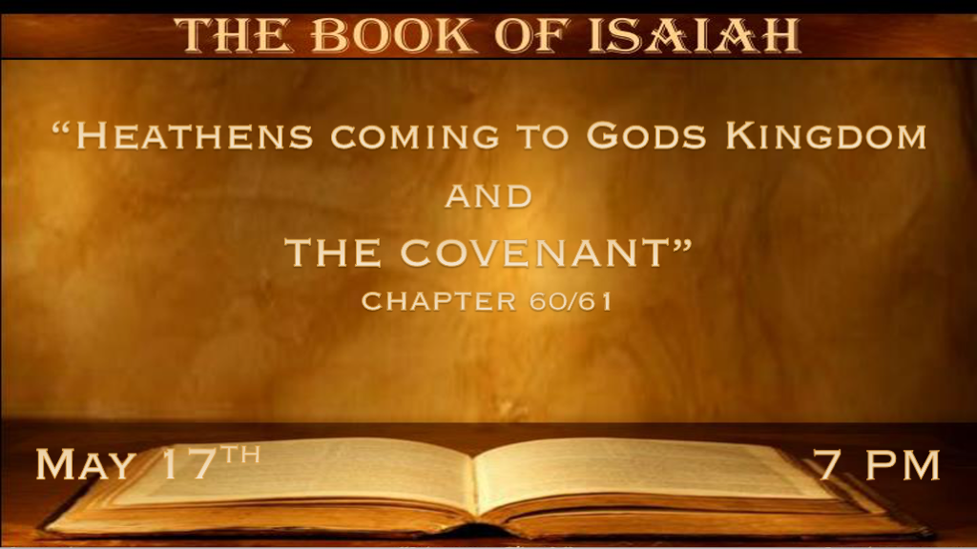

*Gentiles and the World will look to Jesus, but when?

*Isaiah 60:1 Arise, shine;
For your light has come! And the glory of the LORD is risen upon you. 2 For behold, the darkness shall cover the earth, and deep darkness the people; But the LORD will arise over you, and His glory will be seen upon you. 3 The Gentiles shall come to your light, and kings to the brightness of your rising. 4 “Lift up your eyes all around, and see: They all gather together, they come to you; Your sons shall come from afar, and your daughters shall be nursed at your side. 5 Then you shall see and become radiant, and your heart shall swell with joy; Because the abundance of the sea shall be turned to you, the wealth of the Gentiles shall come to you. 6 The multitude of camels shall cover your land, the dromedaries of Midian and Ephah; All those from Sheba shall come; They shall bring gold and incense, and they shall proclaim the praises of the LORD. 7 All the flocks of Kedar shall be gathered together to you, the rams of Nebaioth shall minister to you; They shall ascend with acceptance on My altar,
And I will glorify the house of My glory. 8 “Who are these who fly like a cloud, and like doves to their roosts? 9 Surely the coastlands shall wait for Me; And the ships of Tarshish will come first, to bring your sons from afar, their silver and their gold with them, to the name of the LORD your God, and to the Holy One of Israel, because He has glorified you. 10 “The sons of foreigners shall build up your walls, and their kings shall minister to you; For in My wrath I struck you, but in My favor I have had mercy on you.

V:1-10 Light means it is time to rise and shine. The blessing upon Israel will be like no other time on earth.

- Notice what shall cover the earth; it’s the darkness.
Don’t become focused on the darkness. Let the light do what? Guide you to Jesus and His Word.
This illumination is not earthly light! It’s the light of resurrection.

- That is a great promise. The Gentiles, it’s not may but shall come to the Light of Jesus.
The kings are drawn to the light. The light has a double meaning suggesting the millennial reign.
Israel won’t be united until the second coming. Those that are following the Light are united and come together.

- The separate mention of Israel and Gentiles says replacement theology is Not accurate.
Replacement theology believes the church replaces Israel. When what is happening is there are two destinies.
The theology was an obvious outcome of having no nation of Israel since 70 A.D., that’s 1,878 years.

- V:5-7 The wealth of Gentiles coming to Israel again points more likely to millennial reign.
This picture of wealth symbolizes how much we will glorify God for His faithfulness to His Word and Israel.

- V:8-10 The gold and silver are given in the name of the Lord, also as a symbol of God’s favor.

*The Contrast of God’s Kingdom and the Old Paradigm of Life.
*Isaiah 60:11 Therefore your gates shall be open continually; They shall not be shut day or night, that men may bring to you the wealth of the Gentiles, and their kings in procession. 12 For the nation and kingdom which will not serve you shall perish, and those nations shall be utterly ruined. 13 “The glory of Lebanon shall come to you, the cypress, the pine, and the box tree together, to beautify the place of My sanctuary; And I will make the place of My feet glorious. 14 Also the sons of those who afflicted you shall come bowing to you, and all those who despised you shall fall prostrate at the soles of your feet; And they shall call you The City of the LORD,
Zion of the Holy One of Israel. 15 “Whereas you have been forsaken and hated, so that no one went through you, I will make you an eternal excellence, a joy of many generations. 16 You shall drink the milk of the Gentiles, and milk the breast of kings; You shall know that I, the LORD, am your Savior and your Redeemer, the Mighty One of Jacob. 17 “Instead of bronze I will bring gold, instead of iron I will bring silver,
Instead of wood, bronze, and instead of stones, iron. I will also make your officers peace, and your magistrates righteousness. 18 Violence shall no longer be heard in your land, neither wasting nor destruction within your borders; But you shall call your walls Salvation, and your gates Praise. 19 “The sun shall no longer be your light by day, nor for brightness shall the moon give light to you; But the LORD will be to you an everlasting light, And your God your glory. 20 Your sun shall no longer go down, nor shall your moon withdraw itself; For the LORD will be your everlasting light, and the days of your mourning shall be ended. 21 Also your people shall all be righteous; They shall inherit the land forever, the branch of My planting, the work of My hands, that I may be glorified. 22 A little one shall become a thousand, and a small one a strong nation. I, the LORD, will hasten it in its time.”

- V:11-14 Open gates are a sign of peace and safety.
The City of the Lord has a slight change as it’s representing Jesus instead of the City of God because this is The reign of Christ.

- V:15-18 Greater than exchanging bronze for gold is the transformation of people into the righteous.
Gates that are called praise and walls called Salvation instead of death and bloodshed described in Chapter 59:6-8

- V:19-22 The natural order of a day will be replaced with the heavenly.
No need for the sun because of the glory and light of Jesus.
The thousand years will correct what sin destroyed as God fulfills Israel’s covenant.

*Jesus declares in Luke that He fulfills this prophecy but not entirely.

Isaiah 61:1 “The Spirit of the Lord GOD is upon Me, because the LORD has anointed Me to preach good tidings to the poor; He has sent Me to heal the brokenhearted, to proclaim liberty to the captives, and the opening of the prison to those who are bound; 2 To proclaim the acceptable year of the LORD, and the day of vengeance of our God; To comfort all who mourn, 3 To console those who mourn in Zion, to give them beauty for ashes, the oil of joy for mourning, the garment of praise for the spirit of heaviness; That they may be called trees of righteousness, the planting of the LORD, that He may be glorified.” 4 And they shall rebuild the old ruins, they shall raise up the former desolations, and they shall repair the ruined cities, The desolations of many generations. 5 Strangers shall stand and feed your flocks, and the sons of the foreigner shall be your plowmen and your vinedressers. 6 But you shall be named the priests of the LORD, they shall call you the servants of our God. You shall eat the riches of the Gentiles, and in their glory you shall boast. 7 Instead of your shame you shall have double honor, and instead of confusion they shall rejoice in their portion. Therefore in their land they shall possess double; Everlasting joy shall be theirs. 8 “For I, the LORD, love justice; I hate robbery for burnt offering; I will direct their work in truth, and will make with them an everlasting covenant. 9 Their descendants shall be known among the Gentiles, and their offspring among the people. All who see them shall acknowledge them, that they are the posterity whom the LORD has blessed.” 10 I will greatly rejoice in the LORD, my soul shall be joyful in my God; For He has clothed me with the garments of salvation, He has covered me with the robe of righteousness, as a bridegroom decks himself with ornaments, and as a bride adorns herself with her jewels. 11 For as the earth brings forth its bud, as the garden causes the things that are sown in it to spring forth, so the Lord GOD will cause righteousness and praise to spring forth before all the nations.

- V:-1-4 The jubilee and the day of vengeance.
*Luke 4:17 And He was handed the book of the prophet Isaiah. And when He had opened the book, He found the place where it was written:
18 “The Spirit of the LORD is upon Me, because He has anointed Me to preach the gospel to the poor; He has sent Me to heal the brokenhearted, to proclaim liberty to the captives and recovery of sight to the blind, to set at liberty those who are oppressed;
19 To proclaim the acceptable year of the LORD.”
20 Then He closed the book, and gave it back to the attendant and sat down. And the eyes of all who were in the synagogue were fixed on Him. 21 And He began to say to them, “Today this Scripture is fulfilled in your hearing.”

Jesus changes a comma in Isaiah to a period in Luke. Because Jesus fulfilled the 1st part of the prophecy, and the second is still in our future.
The comma is a grammar pause. That pause between the year of favor and the day of vengeance has existed for two thousand years.

- V:5-8 In V:8, God directs the work of truth. Why?

God’s covenant with humanity is that you can count on God and His Word for truth.
When all other sources of information become deceitful, the Word of God will still anchor you.

- V:9-11 In the future (Millennial age), All generations and people will know of the covenant of God. They will also learn the names of the faithful of Israel.

The transformation of the earth and the fulfillment of God’s Word will be known in the millennial by all nations, and God will be exalted.

