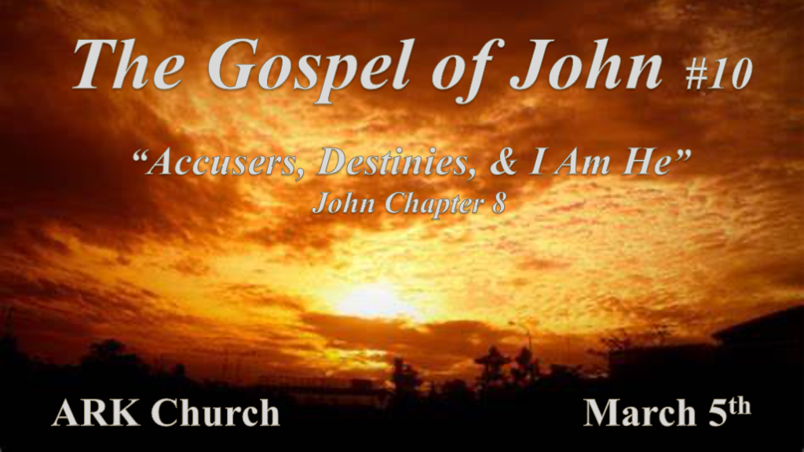

*Accusers often have a misconception of God’s morality & Justice.

*John 7:53 And everyone went to his own house. *John 8:1 But Jesus went to the Mount of Olives.
2 Now early in the morning He came again into the temple, and all the people came to Him; and He sat down and taught them. 3 Then the scribes and Pharisees brought to Him a woman caught in adultery. And when they had set her in the midst, 4 they said to Him, “Teacher, this woman was caught in adultery, in the very act. 5 Now Moses, in the law, commanded us that such should be stoned. But what do You say?”
6 This they said, testing Him, that they might have something of which to accuse Him. But Jesus stooped down and wrote on the ground with His finger, as though He did not hear. 7 So when they continued asking Him, He raised Himself up and said to them, “He who is without sin among you, let him throw a stone at her first.” 8 And again He stooped down and wrote on the ground. 9 Then those who heard it, being convicted by their conscience, went out one by one, beginning with the oldest even to the last. And Jesus was left alone, and the woman standing in the midst. 10 When Jesus had raised Himself up and saw no one but the woman, He said to her, “Woman, where are those accusers of yours? Has no one condemned you?”
11 She said, “No one, Lord.” And Jesus said to her, “Neither do I condemn you; go and sin no more.”

- V:1-6 The accusers use their fingers to point out the sinfulness of others, while God uses His to write about a Son who sets sinners free.
Deut. 9:10 The Lord gave me the two tablets of stone written by the finger of God; and on them were all the words which the Lord had spoken with you at the mountain from the midst of the fire on the day of the assembly.
Exodus 24:12 I have written for their instructions.
Exodus 31:18 God gave Moses two tablets of stone that God had written with His finger.
Exodus 34:1 Cut out two stones and I will write on them the words that were on the two tablets you shattered.
Daniel 5:24-28 God writes on the Babylonian wall that their time was up.
Exodus 8:16-19 The sand turns to gnats and the magicians could not reproduce it. They said this plague is the finger of God.
Luke 11:20 But if I cast out demons by the finger of God, then the kingdom of God has come upon you.

- V:6-11 The accusers always have a hidden agenda. What was the Pharisees' agenda?
V:6 They wanted to have some kind of accusation against Jesus. If you find yourself on the side of being an accuser you must ask yourself why should I take this position? The answer may astound you.

The accuser or prosecutor is always Satan in the Bible. Satan ordains himself to lay charges against humanity demanding punishment.

*Revelation 12:10 Then I heard a loud voice saying in heaven, “Now salvation, and strength, and the kingdom of our God, and the power of His Christ have come, for the accuser of our brethren, who accused them before our God day and night, has been cast down.

*The secret to understanding your destiny.

*John 8:12 Then Jesus spoke to them again, saying, “I am the light of the world. He who follows Me shall not walk in darkness, but have the light of life.” 13 The Pharisees therefore said to Him, “You bear witness of Yourself; Your witness is not true.” 14 Jesus answered and said to them, “Even if I bear witness of Myself, My witness is true, for I know where I came from and where I am going; but you do not know where I come from and where I am going. 15 You judge according to the flesh; I judge no one. 16 And yet if I do judge, My judgment is true; for I am not alone, but I am with the Father who sent Me. 17 It is also written in your law that the testimony of two men is true. 18 I am One who bears witness of Myself, and the Father who sent Me bears witness of Me.” 19 Then they said to Him, “Where is Your Father?” Jesus answered, “You know neither Me nor My Father. If you had known Me, you would have known My Father also.” 20 These words Jesus spoke in the treasury, as He taught in the temple; and no one laid hands on Him, for His hour had not yet come. 21 Then Jesus said to them again, “I am going away, and you will seek Me, and will die in your sin. Where I go you cannot come.” 22 So the Jews said, “Will He kill Himself, because He says, ‘Where I go you cannot come’?”
23 And He said to them, “You are from beneath; I am from above. You are of this world; I am not of this world. 24 Therefore I said to you that you will die in your sins; for if you do not believe that I am He, you will die in your sins.” 25 Then they said to Him, “Who are You?” And Jesus said to them, “Just what I have been saying to you from the beginning. 26 I have many things to say and to judge concerning you, but He who sent Me is true; and I speak to the world those things which I heard from Him.” 27 They did not understand that He spoke to them of the Father. 28 Then Jesus said to them, “When you lift up the Son of Man, then you will know that I am He, and that I do nothing of Myself; but as My Father taught Me, I speak these things. 29 And He who sent Me is with Me. The Father has not left Me alone, for I always do those things that please Him.” 30 As He spoke these words, many believed in Him.

- V:12-18 Secret #1 Know the source of your light.
Insight into the spiritual kingdom of God. Light about situations within the world is often qualified by witnesses that don’t know God.
Light about God’s Kingdom is constant and can only be qualified by God and His Word. (The Word of God interprets the Word.)

- V:19-30 Secret #2 Know how to make a proper judgment.
Judgments made from earthly reasoning are limited at best.

The judgment made from Heaven is made by the designer of all things.

*I am He declares the difference between a follower and a religious person.

*John 8:31 Then Jesus said to those Jews who believed Him, “If you abide in My word, you are My disciples indeed. 32 And you shall know the truth, and the truth shall make you free.” 33 They answered Him, “We are Abraham’s descendants, and have never been in bondage to anyone. How can You say, ‘You will be made free’?” 34 Jesus answered them, “Most assuredly, I say to you, whoever commits sin is a slave of sin. 35 And a slave does not abide in the house forever, but a son abides forever. 36 Therefore if the Son makes you free, you shall be free indeed.
37 “I know that you are Abraham’s descendants, but you seek to kill Me, because My word has no place in you. 38 I speak what I have seen with My Father, and you do what you have seen with your father.” 39 They answered and said to Him, “Abraham is our father.”
Jesus said to them, “If you were Abraham’s children, you would do the works of Abraham. 40 But now you seek to kill Me, a Man who has told you the truth which I heard from God. Abraham did not do this. 41 You do the deeds of your father.” Then they said to Him, “We were not born of fornication; we have one Father—God.” 42 Jesus said to them, “If God were your Father, you would love Me, for I proceeded forth and came from God; nor have I come of Myself, but He sent Me. 43 Why do you not understand My speech? Because you are not able to listen to My word. 44 You are of your father the devil, and the desires of your father you want to do. He was a murderer from the beginning, and does not stand in the truth, because there is no truth in him. When he speaks a lie, he speaks from his own resources, for he is a liar and the father of it. 45 But because I tell the truth, you do not believe Me. 46 Which of you convicts Me of sin? And if I tell the truth, why do you not believe Me? 47 He who is of God hears God’s words; therefore you do not hear, because you are not of God.” John 8:48 Then the Jews answered and said to Him, “Do we not say rightly that You are a Samaritan and have a demon?” 49 Jesus answered, “I do not have a demon; but I honor My Father, and you dishonor Me. 50 And I do not seek My own glory; there is One who seeks and judges. 51 Most assuredly, I say to you, if anyone keeps My word he shall never see death.”
52 Then the Jews said to Him, “Now we know that You have a demon! Abraham is dead, and the prophets; and You say, ‘If anyone keeps My word he shall never taste death.’ 53 Are You greater than our father Abraham, who is dead? And the prophets are dead. Who do You make Yourself out to be?”
54 Jesus answered, “If I honor Myself, My honor is nothing. It is My Father who honors Me, of whom you say that He is your God. 55 Yet you have not known Him, but I know Him. And if I say, ‘I do not know Him,’ I shall be a liar like you; but I do know Him and keep His word. 56 Your father Abraham rejoiced to see My day, and he saw it and was glad.” 57 Then the Jews said to Him, “You are not yet fifty years old, and have You seen Abraham?”
58 Jesus said to them, “Most assuredly, I say to you, before Abraham was, I AM.”
59 Then they took up stones to throw at Him; but Jesus hid Himself and went out of the temple, going through the midst of them, and so passed by.

- V:31-40 Abiding in the truth is often very difficult. Why?
To be anchored in “Unshakeable Truth” it has to have history, authority, and clarity on directions.

The truth that set us free is a truth that attaches us to God in a greater capacity.

- V:41-47 A life void of truth will not recognize God even when He discloses Himself to them.
We know our voice and the sounds of the culture as well as our religious opinion.
Do you know how to recognize the voice of God? It’s found within the scripture.

- V:48-49 The accusations against Jesus came from those who studied God’s writings.
This makes for a very twisted and confused society. When we know His Word and use it as a weapon to wound instead of to bring healing.
I have had too many years of experience as an untrained spiritual surgeon.

- V:50-55 Jesus uses The Word of God to bring life. Religious people often use the Word of God to bring commendation.
If anyone keeps my Words won’t taste death. Jesus' Words are life. They are often very strong words.

- V:56-59 God’s name. “I AM”
John 8:24, 28, & 58 Three times Jesus declares “I AM” one for each part of the Trinity. This is the name He told Moses to tell Pharaoh because He’s not the God who was or is going to be He is the ever-present God. I AM

