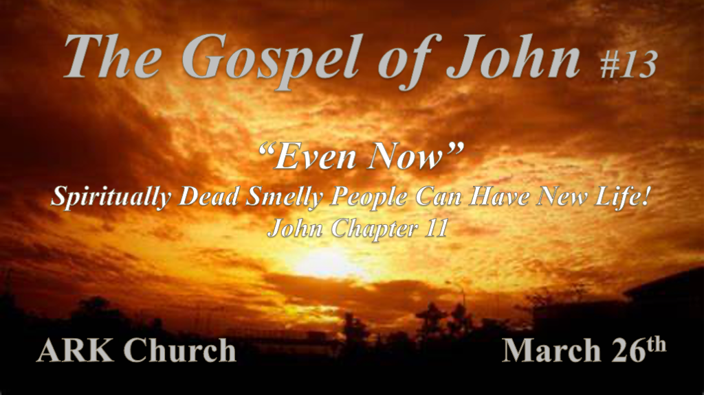

*The Son of God came so we could walk in the light of the day.

*John 11:1 Now a certain man was sick, Lazarus of Bethany, the town of Mary and her sister Martha. 2 It was that Mary who anointed the Lord with fragrant oil and wiped His feet with her hair, whose brother Lazarus was sick. 3 Therefore the sisters sent to Him, saying, “Lord, behold, he whom You love is sick.”
4 When Jesus heard that, He said, “This sickness is not unto death, but for the glory of God, that the Son of God may be glorified through it.”
5 Now Jesus loved Martha and her sister and Lazarus. 6 So, when He heard that he was sick, He stayed two more days in the place where He was. 7 Then after this He said to the disciples, “Let us go to Judea again.”
8 The disciples said to Him, “Rabbi, lately the Jews sought to stone You, and are You going there again?”
9 Jesus answered, “Are there not twelve hours in the day? If anyone walks in the day, he does not stumble, because he sees the light of this world.
10 But if one walks in the night, he stumbles, because the light is not in him.”
11 These things He said, and after that He said to them, “Our friend Lazarus sleeps, but I go that I may wake him up.”
12 Then His disciples said, “Lord, if he sleeps he will get well.”
13 However, Jesus spoke of his death, but they thought that He was speaking about taking rest in sleep.
14 Then Jesus said to them plainly, “Lazarus is dead. 15 And I am glad for your sakes that I was not there, that you may believe. Nevertheless let us go to him.” 16 Then Thomas, who is called the Twin, said to his fellow disciples, “Let us also go, that we may die with Him.”

- V:1-2 The setting: It’s been almost six months since Chapter 10 this puts us weeks before Jesus' death.
Bethany is right outside of Jerusalem about two or three miles.
Mary anointed the Lord’s feet with oil. This implies John believes the reader has read the other Gospels. (Luke 10 Martha is the older sister & Mark 14:3-9 it actually won’t be recorded in the timeline of John’s gospel till Chapter 12
Jesus is going at the girl's request. His agenda is being revealed.

- V:3-7 When there is a God delay. God’s delay in the Bible according to verse 4 is for the glory of God.
This is one of the signs as was the man who was born blind for the glory of God. Lazarus will be in the grave to show something they haven’t seen until the grave and death are robbed! For God’s glory like the man born blind.

- V:8-16 When believers don’t understand Jesus’ metaphor He corrects them. Lazarus wasn’t asleep he was dead. (What a Seventh-Day Adventist doesn’t understand.)
Those who die fall into three categories. The Dead, The Wicked, and The Righteous are the categories. V:8-16 is before Jesus delivered us from Death and the grave. The righteous are in heaven. Those who are not are in the grave or Hades.

Why does Holy Spirit use the word “Sleep”? It’s harmless, a time of relief, and a welcomed rest. We lie down to get back up again. He can awaken us by speaking our name. He did this to activate the I AM The Resurrection and the Life.

*I am the resurrection and the life.

*John 11:17 So when Jesus came, He found that he had already been in the tomb four days. 18 Now Bethany was near Jerusalem, about two miles away. 19 And many of the Jews had joined the women around Martha and Mary, to comfort them concerning their brother.
20 Then Martha, as soon as she heard that Jesus was coming, went and met Him, but Mary was sitting in the house. 21 Now Martha said to Jesus, “Lord, if You had been here, my brother would not have died. 22 But even now I know that whatever You ask of God, God will give You.”
23 Jesus said to her, “Your brother will rise again.” 24 Martha said to Him, “I know that he will rise again in the resurrection at the last day.”
25 Jesus said to her, “I am the resurrection and the life. He who believes in Me, though he may die, he shall live. 26 And whoever lives and believes in Me shall never die. Do you believe this?” 27 She said to Him, “Yes, Lord, I believe that You are the Christ, the Son of God, who is to come into the world.” 28 And when she had said these things, she went her way and secretly called Mary her sister, saying, “The Teacher has come and is calling for you.” 29 As soon as she heard that, she arose quickly and came to Him. 30 Now Jesus had not yet come into the town, but was in the place where Martha met Him. 31 Then the Jews who were with her in the house and comforting her, when they saw that Mary rose up quickly and went out, followed her, saying, “She is going to the tomb to weep there.”
32 Then, when Mary came where Jesus was, and saw Him, she fell down at His feet, saying to Him, “Lord, if You had been here, my brother would not have died.” 33 Therefore, when Jesus saw her weeping, and the Jews who came with her weeping, He groaned in the spirit and was troubled. 34 And He said, “Where have you laid him?” They said to Him, “Lord, come and see.” 35 Jesus wept. 36 Then the Jews said, “See how He loved him!” 37 And some of them said, “Could not this Man, who opened the eyes of the blind, also have kept this man from dying?” 38 Then Jesus, again groaning in Himself, came to the tomb. It was a cave, and a stone lay against it.

- V:17-31 The Certainty of Death and the reality of Jesus being the I am the resurrection and life.
V:19 Many Jews came and will be a witness of the power of God.
V:25 A declaration of two sets of people those who died will be resurrected those who are alive when Jesus comes will never die. The order is a prophetic order and doctrinally correct.

- V:32-37 The Son of God reveals the emotions of the Godman who is “The Resurrection.”
V:33 &38 Jesus groaned. In the Greek translation, it means to snort with anger like a horse.
V:35 Jesus wept. As we too will weep for all those that will die not knowing the resurrection and the life.
Isaiah 53 Prophesied that Jesus would be a man of sorrows.

*Believers will see the glory of God!

*John 11:39 Jesus said, “Take away the stone.” Martha, the sister of him who was dead, said to Him, “Lord, by this time there is a stench, for he has been dead four days.”
40 Jesus said to her, “Did I not say to you that if you would believe you would see the glory of God?” 41 Then they took away the stone from the place where the dead man was lying. And Jesus lifted up His eyes and said, “Father, I thank You that You have heard Me. 42 And I know that You always hear Me, but because of the people who are standing by I said this, that they may believe that You sent Me.” 43 Now when He had said these things, He cried with a loud voice, “Lazarus, come forth!” 44 And he who had died came out bound hand and foot with graveclothes, and his face was wrapped with a cloth. Jesus said to them, “Loose him, and let him go.”

- V:39-40 The action of The God who is the “I AM” is so the Jew and Gentile might believe in God’s glory.
Before the resurrection of Jesus, death had the same result for all humanity “It Stinks”.
- V:41-44 There’s more than being freed from death!
The grave clothes that restricted his ability to go back life to normal must be loosed!
What’s restricting your life? V:41-42 Jesus prays aloud so that those listening might believe.

*Plots against God & The Role Signs should and shouldn’t play.

This next section is in all four gospels. (Matt. 26:1–5; Mark 14:1, 2; Luke 22:1, 2)
45 Then many of the Jews who had come to Mary, and had seen the things Jesus did, believed in Him. 46 But some of them went away to the Pharisees and told them the things Jesus did. 47 Then the chief priests and the Pharisees gathered a council and said, “What shall we do? For this Man works many signs. 48 If we let Him alone like this, everyone will believe in Him, and the Romans will come and take away both our place and nation.”
49 And one of them, Caiaphas, being high priest that year, said to them, “You know nothing at all, 50 nor do you consider that it is expedient for us that one man should die for the people, and not that the whole nation should perish.” 51 Now this he did not say on his own authority; but being high priest that year he prophesied that Jesus would die for the nation, 52 and not for that nation only, but also that He would gather together in one the children of God who were scattered abroad.
53 Then, from that day on, they plotted to put Him to death. 54 Therefore Jesus no longer walked openly among the Jews, but went from there into the country near the wilderness, to a city called Ephraim, and there remained with His disciples.
55 And the Passover of the Jews was near, and many went from the country up to Jerusalem before the Passover, to purify themselves. 56 Then they sought Jesus, and spoke among themselves as they stood in the temple, “What do you think—that He will not come to the feast?” 57 Now both the chief priests and the Pharisees had given a command, that if anyone knew where He was, he should report it, that they might seize Him.

- V:45-48 Jesus works many signs yet; they feared Rome and what they could lose more than what they could gain by believing.
Our world is the same today, we can see the difference Jesus makes but many operate out of fear. No one is ever saved through fear. The path must be by faith for you are saved through grace.

- V:49-52 One man should die for all the people.
The high priest prophesied Jesus would die for the nation, He missed the full heart of God because Jesus died for the world.

- V:53-57 We are weeks away from the crucifixion.
The timing was all God’s and Jesus knew in advance when, how, and why He must die.

