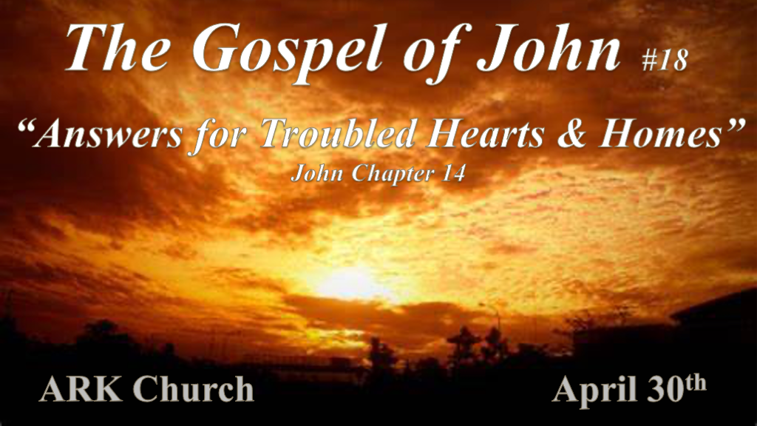
Jesus does comfort the hearts and homes in the 21st that are under attack from every direction. The Gospel of John has the solutions to our daily problems.

Jesus is preparing for our future.

*John 14:1 “Let not your heart be troubled; you believe in God, believe also in Me. 2 In My Father’s house are many mansions; if it were not so, I would have told you. I go to prepare a place for you. 3 And if I go and prepare a place for you, I will come again and receive you to Myself; that where I am, there you may be also. 4 And where I go you know, and the way you know.”
5 Thomas said to Him, “Lord, we do not know where You are going, and how can we know the way?”
6 Jesus said to him, “I am the way, the truth, and the life. No one comes to the Father except through Me.
7 “If you had known Me, you would have known My Father also; and from now on you know Him and have seen Him.”
8 Philip said to Him, “Lord, show us the Father, and it is sufficient for us.”
9 Jesus said to him, “Have I been with you so long, and yet you have not known Me, Philip? He who has seen Me has seen the Father; so how can you say, ‘Show us the Father’? 10 Do you not believe that I am in the Father, and the Father in Me? The words that I speak to you I do not speak on My own authority; but the Father who dwells in Me does the works. 11 Believe Me that I am in the Father and the Father in Me, or else believe Me for the sake of the works themselves.

- V:1 A troubled heart is optional. Have you ever heard this truth?

We have to permit our hearts to be upset.
Placing Faith in Jesus will change your heart in many ways.

- V:2-4 The invitation to live with Jesus. What do you need to know?

*Isaiah 26:19 Your dead shall live; Together with my dead body they shall arise. Awake and sing, you who dwell in dust; For your dew is like the dew of herbs, and the earth shall cast out the dead.20 Come, my people, enter your chambers and shut your doors behind you; Hide yourself, as it were, for a little moment, until the indignation is past. 21 For behold, the LORD comes out of His place to punish the inhabitants of the earth for their iniquity; The earth will also disclose her blood and will no more cover her slain.

- V:5-6 Three truths about Jesus we must never forget.

He is the Way. There is no other way. Before Him, there was no access to heaven or the Father.
He is the Truth. All other religions, philosophies, and cults are false. He is the Word of Truth. You reject His Word. You’ve rejected Him.
He is the Life. The only way to a resurrected life is through the Messiah, who defeated death and the grave.

- V:7-10 Can you be in Church for up to three years and not know Jesus?

Question? Having I’ve been living with you so long, and you don’t know Me?
The false teaching of The God of the O.T. was terrible, and that Jesus is the good God is destroyed. He and the Father are one.
Somewhere or sometimes, you have to either accept or reject. To keep denying what you believe will mark you.

Where does the power to do more wondrous works come from?

*John 14:12 “Most assuredly, I say to you, he who believes in Me, the works that I do he will do also; and greater works than these he will do, because I go to My Father. 13 And whatever you ask in My name, that I will do, that the Father may be glorified in the Son. 14 If you ask anything in My name, I will do it.
15 “If you love Me, keep My commandments. 16 And I will pray the Father, and He will give you another Helper, that He may abide with you forever— 17 the Spirit of truth, whom the world cannot receive, because it neither sees Him nor knows Him; but you know Him, for He dwells with you and will be in you. 18 I will not leave you orphans; I will come to you.

- V:12-14 Are you expecting to see more extraordinary things?
We have an advocate in Jesus.

- The Helper who makes all things possible.
We have the Spirit of truth. Truth is this world’s greatest weapon against evil.

*The coming ruler has nothing to do with Jesus.

*John 14:19 “A little while longer and the world will see Me no more, but you will see Me. Because I live, you will live also. 20 At that day you will know that I am in My Father, and you in Me, and I in you. 21 He who has My commandments and keeps them, it is he who loves Me. And he who loves Me will be loved by My Father, and I will love him and manifest Myself to him.”
22 Judas (not Iscariot) said to Him, “Lord, how is it that You will manifest Yourself to us, and not to the world?”
23 Jesus answered and said to him, “If anyone loves Me, he will keep My word; and My Father will love him, and We will come to him and make Our home with him. 24 He who does not love Me does not keep My words; and the word which you hear is not Mine but the Father’s who sent Me.
25 “These things I have spoken to you while being present with you. 26 But the Helper, the Holy Spirit, whom the Father will send in My name, He will teach you all things, and bring to your remembrance all things that I said to you. 27 Peace I leave with you, My peace I give to you; not as the world gives do I give to you. Let not your heart be troubled, neither let it be afraid. 28 You have heard Me say to you, ‘I am going away and coming back to you.’ If you loved Me, you would rejoice because I said, I am going to the Father,’ for My Father is greater than I.
29 “And now I have told you before it comes, that when it does come to pass, you may believe. 30 I will no longer talk much with you, for the ruler of this world is coming, and he has nothing in Me. 31 But that the world may know that I love the Father, and as the Father gave Me commandment, so I do. Arise, let us go from here.

- V:19-24 Three things Christians must understand to guard against the ruler who is coming.

- *Honoring Jesus and following Him comes with a promise that Jesus will manifest Himself in us.
*Colossians 1:27 Christ in you, the hope of glory.

- *The manifestation of Jesus is His promise that God will live with us on earth again.
The promise is to Israel that Jesus will come and live with them and us on earth for one thousand years. This period is known as the Millennium Reign of Christ.

- *V:23-24 The critical ingredient of Jesus living in you and you reigning with Him is obedience to the Word of God.
*2 Thess. 2:3 Let no one deceive you by any means; for that Day will not come unless the falling away comes first, and the man of sin is revealed, the Son of perdition, 4 who opposes and exalts himself above all that is called God or that is worshiped, so that he sits as God in the temple of God, showing himself that he is God.

- V:25-28 The relationship during the 1st generation is with Jesus.

*The Holy Spirit’s fruits and gifts are the deposit for maturing in the Way, the Truth, and the Life since.

- *V:29-31 Believing Jesus now will protect you from the lies in this world and that is still to come.

