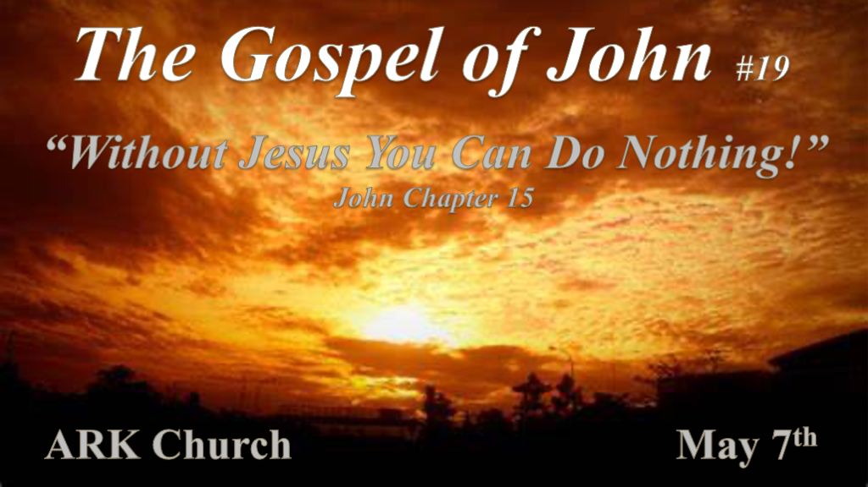
Relationships: The idioms in John 15 are the Vine and branches. This Chapter is not a parable; it is a teaching using these idioms to drive home Biblical insights.

*Jesus is the True Vine and His Relationship with Us.

*John 15:1 “I am the true vine, and My Father is the vinedresser. 2 Every branch in Me that does not bear fruit He takes away; and every branch that bears fruit He prunes, that it may bear more fruit. 3 You are already clean because of the word which I have spoken to you. 4 Abide in Me, and I in you. As the branch cannot bear fruit of itself, unless it abides in the vine, neither can you, unless you abide in Me.
5 “I am the vine, you are the branches. He who abides in Me, and I in him, bears much fruit; for without Me you can do nothing. 6 If anyone does not abide in Me, he is cast out as a branch and is withered; and they gather them and throw them into the fire, and they are burned. 7 If you abide in Me, and My words abide in you, you will ask what you desire, and it shall be done for you. 8 By this My Father is glorified, that you bear much fruit; so you will be My disciples. 9 “As the Father loved Me, I also have loved you; abide in My love. 10 If you keep My commandments, you will abide in My love, just as I have kept My Father’s commandments and abide in His love.
11 “These things I have spoken to you, that My joy may remain in you, and that your joy may be full.

- V:1 The 7th “I AM” Statement is “I am the true vine.” Israel is often called a vine. Psalm 80:8-9, Isaiah 5:1-7 & Hosea 10:1
Since there is a “True Vine,” there must be a false vine.
The action statement of “I AM” points to the results of being part of the True Vine, which is the fruit of the vine.
Psalm 80:8-9 Acknowledges that God took Israel out of Egypt to plant them in the land.

- V:2-4 The Abiding principle. Remaining, Enduring, Steadfast, and Unshakable are the characteristics of a relationship that abides in Jesus.
The deception in this world is that you can bear the last fruit without remaining in Christ.
Apart from Jesus, we can do NOTHING!
V:8 Is the primary fruit from the vine a disciple? It seems to be so.

- V:2-10 Jesus is the Vine, and we are branches according to V:1, and the Father is the pruner.
Non-fruit-bearing branches are taken away and burned to keep the vine healthy.
Fruit-bearing branches are pruned so that they bear much fruit.
The anchor of the Christian faith is the fruit or the evidence of His love.

- V:11 To be full of Joy is to have the Holy Spirit maturing you as a healthy branch of Jesus.
Joy is a fruit of the Holy Spirit. The fruit of Love initiates or activates the maturing process.
The heart filled with the Spirit will bear evidence of maturity by the fruit of the Spirit.

*The more you are drawing from the True Vine. The evidence of a transformed heart, mind, soul, and strength is revealed. His Word commanded us to love God with all of these. The guarantee of the Holy Spirit as the Helper enables this to come to fruition.

*Our relationship with each other when we are in Christ.

*John 15:12 This is My commandment, that you love one another as I have loved you. 13 Greater love has no one than this, than to lay down one’s life for his friends. 14 You are My friends if you do whatever I command you. 15 No longer do I call you servants, for a servant does not know what his master is doing; but I have called you friends, for all things that I heard from My Father I have made known to you. 16 You did not choose Me, but I chose you and appointed you that you should go and bear fruit, and that your fruit should remain, that whatever you ask the Father in My name He may give you. 17 These things I command you, that you love one another.

- V:12-14 The qualifier of true friendship.
The qualifier for friendship must include agape love and evidence of sacrifice.

- V:15-17 Is The evidence of true friendship the ability to share insights that make you vulnerable?
Wisdom is to let Jesus choose them. You should not be selecting people who haven’t shown spiritual maturity so that you can share the treasures and pain of your heart.

The selection of friends should also consider the fruit aspect. Are you adding a person to your confidence birth more excellent fruit? One puts to flight a thousand and two ten thousand. If there’s no multiplication factor, you only have a risk factor.
*Jesus elevates them from servants to friends.

In the intimacy of Prophecy, God called Abraham a friend and showed him what He was about to do.

*The worldly spirit will love, persecute and hate without a cause.

*John 15:18 “If the world hates you, you know that it hated Me before it hated you. 19 If you were of the world, the world would love its own. Yet because you are not of the world, but I chose you out of the world, therefore the world hates you. 20 Remember the word that I said to you, A servant is not greater than his master.’ If they persecuted Me, they will also persecute you. If they kept My word, they will keep yours also. 21 But all these things they will do to you for My name’s sake, because they do not know Him who sent Me. 22 If I had not come and spoken to them, they would have no sin, but now they have no excuse for their sin. 23 He who hates Me hates My Father also. 24 If I had not done among them the works which no one else did, they would have no sin; but now they have seen and also hated both Me and My Father. 25 But this happened that the word might be fulfilled which is written in their law, They hated Me without a cause.’

26 “But when the Helper comes, whom I shall send to you from the Father, the Spirit of truth who proceeds from the Father, He will testify of Me. 27 And you also will bear witness, because you have been with Me from the beginning.

- V:18-19 Our relationship with the world when we are living in Christ.
Hate is a powerful word. You must guard against you becoming hateful when others despise and hate you.
*This world is not my home is a good motto.

- V:20-21 Remember the Word. What they did to Jesus, they will do to you, so remember God’s Word.
The positive is if they listened to Jesus. Then, they will listen to you.
If you change the Word of God to fit your cultural view, you’ve forgotten this command to remember The Word.

- V:22-25 The sin of unbelief and the sin of ignorance are revealed.
Some are ignorant of the Truth of the Word. This is because they remain in the world or cultural way of life.
Others say they are in the Vine, yet their unbelief reveals that they have no part in him.

- V:26-27 Only “The Helper,” the Holy Spirit, can help us deal with so much hate.
*V:18-27 Uses the word hate seven times.
No human being can handle that level of hate without the Holy Spirit.

*The most powerful witness in the last generation is the true power of Love that doesn’t compromise the Word of God to be loved by the World.

