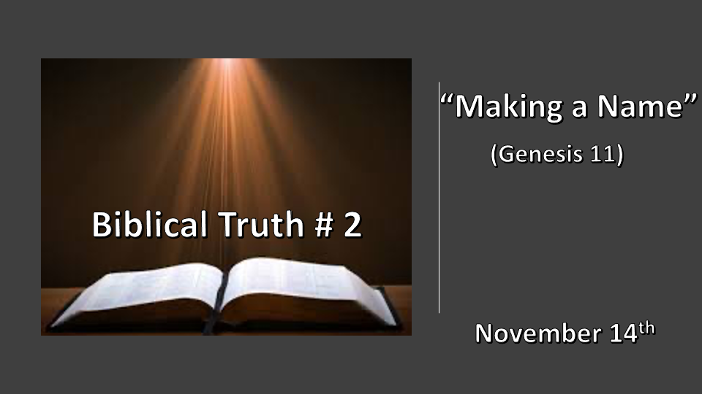

*“Sanctify them by the truth; your word is truth." John 17:17

Five Biblical truths that will determine how you view the Bible, God, and our choices.
- A place of refuge & the wrath of God. Genesis 6 & 7
- Making a name. (Defining deception) Genesis 10 & 11
- The covenants of Abraham and David. Genesis 12, 2 Samuel 7:16 & Luke 1:32
- The Nation of Israel. Genesis 32:48
- The remnant and its role. Genesis 45:7

*Genesis 10:8 Cush was the father of Nimrod, who became a mighty warrior on the earth. 9 He was a mighty hunter before the LORD; that is why it is said, "Like Nimrod, a mighty hunter before the LORD."
*Genesis 11:1 Now the whole world had one language and a common speech. 2 As people moved eastward, they found a plain in Shinar and settled there.

3 They said to each other, "Come, let's make bricks and bake them thoroughly." They used brick instead of stone, and tar for mortar. 4 Then they said, "Come, let us build ourselves a city, with a tower that reaches to the heavens, so that we may make a name for ourselves; otherwise we will be scattered over the face of the whole earth."

*Defining Deception

- *Genesis 10:8 Nimrod will be the 1st world dictator. His symbol is the bow Revelation 6:2
- Son of Cush, grandson of Ham, and the great-grandson of Noah.
- Nimrod means let us rebel. He is the founder of Babylon. (Babel)
- The 1st human organized rebellion against God is by Nimrod.
- A mighty hunter. Nimrod was not a hunter of animals but men. This is not a compliment but a message about the spirit of a warrior who is against God.

- *Self-deception is the greatest form of deception. Isaiah 14:14
- Bricks with tar and mortar was a sign they didn’t trust God or His Word.
- Let us will build a city a dwelling place that does not answer to God
- Building a tower as monuments of one's might. Tower: to be lifted and made great.
- Let’s make a name for ourselves as an identity apart from God.

*Genesis 11:5 But the LORD came down to see the city and the tower the people were building. 6 The LORD said, "If as one people speaking the same language they have begun to do this, then nothing they plan to do will be impossible for them. 7 Come, let us go down and confuse their language so they will not understand each other."

8 So the LORD scattered them from there over all the earth, and they stopped building the city. 9 That is why it was called Babel—because there the LORD confused the language of the whole world. From there the LORD scattered them over the face of the whole earth.

*Why will God send His Son to the earth in the future.

- Genesis 11:5 Total abandonment of God’s will has a direct consequence from God himself.

- Genesis 11:6-7 A united evil will deal with the fullness of the Trinity. V:7 Let us go down and set this straight.

- V:8 God starts once again with humanity. He will always start with a person that does His will, even if that person doesn’t do it perfectly. (The story comes to a nation under God in 2002)

*Genesis 11:10 Two years after the flood, when Shem was 100 years old, he became the father of Arphaxad.

*Genesis 11:26 After Terah had lived 70 years, he became the father of Abram, Nahor, and Haran.

*Genesis 11:31 Terah took his son Abram, his grandson Lot son of Haran, and his daughter-in-law Sarai, the wife of his son Abram, and together they set out from Ur of the Chaldeans to go to Canaan. But when they came to Harran, they settled there.

God gives a righteous path for the outcome that our soul desires.

- V:10 & 26 It’s found in the righteous of Noah’s son name Shem and Abram’s name together.
Shem means, “Name or reputation” and Abram means, “the exalted father”. Together their generation is the reputation of the exalted father.

- “Doing God’s will” releases to us what Nimrod wanted but could not obtain outside of God.
- Abram becomes Abraham. Father of multitudes.
- Sarai becomes Sarah. A noblewoman.
- Saul becomes Paul and writes one-half of the New Testament.
- Levi becomes Matthew and the writer of the 1st Gospel in the New Testament.
- You become a child of God.

