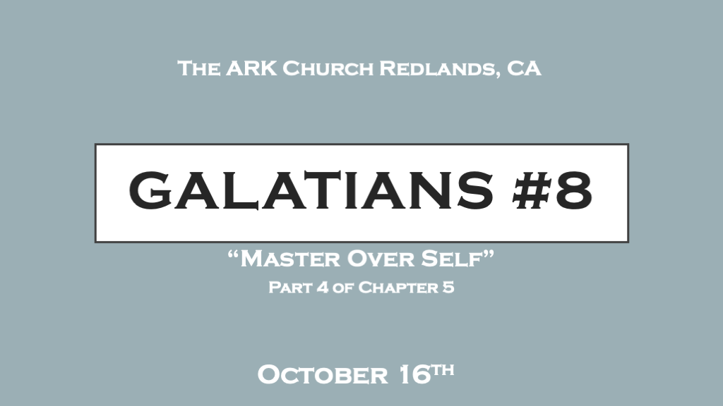

*We must never confuse reformation with transformation.
*Galatians 5:16 I say then: Walk in the Spirit, and you shall not fulfill the lust of the flesh. 17 For the flesh lusts against the Spirit, and the Spirit against the flesh; and these are contrary to one another, so that you do not do the things that you wish. 18 But if you are led by the Spirit, you are not under the law.

- Walking in the Spirit: It is the surrendered life. Surrendering to the Holy Spirit's transforming power.
A promise is attached to our walking in the Spirit. You won’t satisfy (fulfill) the lust of the flesh. You will still be human and your flesh will have yearnings against the Spirit.
*James 4:6 God resists the proud but, gives grace to the humble.

- Led by the Spirit: It’s a life led by the Holy Scriptures and indwelling of the Holy Spirit.

To be guided or led by the Spirit is a maturation process of the Holy Spirit’s sanctifying process.
It is the work of transformation.
*2 Corinthians 12:9 My grace is sufficient for you. For my power is made perfect in weakness.

*Being led by the Holy Spirit is a fully transformative process of the whole person.

*Galatians 5:22 But the fruit of the Spirit is love, joy, peace, longsuffering, kindness, goodness, faithfulness, 23 gentleness, self-control. Against such there is no law. 24 And those who are Christ’s have crucified the flesh with its passions and desires. 25 If we live in the Spirit, let us also walk in the Spirit. 26 Let us not become conceited, provoking one another, envying one another.

- *Love, and joy starts the transformation of our heart. While peace continues the process but now initiates the transformation of the mind.

Isaiah 26: 3 You will keep him in perfect peace, Whose mind is stayed on You, Because he trusts in You.

- *Longsuffering and kindness will begin the transformation of our emotions. While goodness continues the process but adds another element to the transformation of the mind.

Romans 12:2 (NIV) Do not conform to the pattern of this world but be transformed by the renewing of your mind. Then you will be able to test and approve what God's will is—his good, pleasing and perfect will.

- Faithfulness and gentleness launches the transformation of our soul/spirit. While self-control anchors the transformation of the Soul with renewed thinking. (The Mind)

Faithfulness

*Deuteronomy 7:9 Therefore know that the Lord your God, He is God, the faithful God who keeps covenant and mercy for a thousand generations with those who love Him and keep His commandments;

- Faithfulness: Starts with believing that God does what He promises. Because God is faithful.

- *The reasoning behind it. The Holy Spirit is the seal of God’s guarantee of faithfulness to a believer.

*2 Corinthians 1:22 who also has sealed us and given us the Spirit in our hearts as a guarantee.

2 Corinthians 5:5 the guarantee, Ephesians 1:13 you were sealed with the Holy Spirit of promise
Matthew 5:21 Well done though good and faithful servant, enter into the joy of the master.

- *The Promise: 2 Timothy 2:13 If we are faithless, He remains faithful; He cannot deny Himself.

Gentleness

*James 1:21 Therefore lay aside all filthiness and overflow of wickedness, and receive with meekness (gentleness) the implanted word, which is able to save your souls.

- Gentleness: Strength under control. Jesus revealed meekness does not mean weakness.
Will you surrender to the Holy Spirit enough that you could have a teachable spirit?

- *The reason behind it: Philippians 4:5 5 Let your gentleness be known to all men. The Lord is at hand.

- The relational aspect: Matthew 11:29 Take My yoke upon you and learn from Me, for I am gentle and lowly in heart, and you will find rest for your souls.
Surrendering to the Holy Spirit is being tethered to Jesus and this is the only path for your soul to find real rest in this world.

Self-Control

*Titus 2:11-12 For the grace of God has appeared that offers salvation to all people. 12 It teaches us to say "No" to ungodliness and worldly passions, and to live self-controlled, upright and godly lives in this present age,

- *Self-Control: The master over self. Grace introduced us to the Holy Spirit who is the master of our transformation.

- *The reason behind it. This is the greatest witness of a changed life. It is especially needed in the last days. 2 Timothy 3:1-5

- *The Warning: Proverbs 25:28 Whoever has no rule over his own spirit is like a city broken down, without walls.

