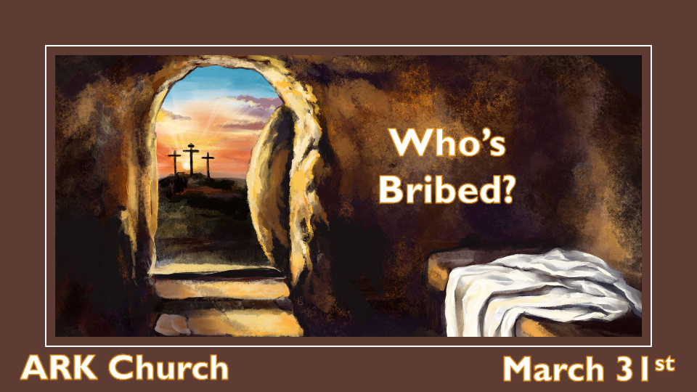

*Could you be bribed concerning resurrection day and not know it?

*The Prophecies Around Jesus Taking on The Curse.

- *Deuteronomy 21:22 "If a man has committed a sin deserving of death, and he is put to death, and you hang him on a tree, 23 his body shall not remain overnight on the tree, but you shall surely bury him that day, so that you do not defile the land which the LORD your God is giving you as an inheritance; for he who is hanged is accursed of God.
It was the tree that Adam and Eve ate from, and this brought the curse of death into the world.
It would be a tree that the innocent God/man would be placed on to take away the curse.

- *Zechariah 12:10 Then they will look on Me whom they pierced.
Adam and Eve gave up the crown of eternal life. Jesus wore the crown of thorns to redeem it in full.
It was their feet that carried them to the place of disobedience, and It would be His feet of obedience to take Him to the cross, and His feet nailed to it removes this portion of the curse.

It was their hands in disobedience picking from the forbidden tree. Therefore, It would be Jesus' hands that are nailed to the tree.
It was the woman who was taken out of the man's side who was first to be deceived. Jesus is pierced in His side, redeeming every aspect of humanity.

*Who was Involved in Jesus' Resurrection?

*Matthew 28:1 Now after the Sabbath, as the first day of the week began to dawn, Mary Magdalene and the other Mary came to see the tomb. 2 And behold, there was a great earthquake; for an angel of the Lord descended from heaven, and came and rolled back the stone from the door, and sat on it. 3 His countenance was like lightning, and his clothing as white as snow. 4 And the guards shook for fear of him, and became like dead men.
5 But the angel answered and said to the women, "Do not be afraid, for I know that you seek Jesus who was crucified. 6 He is not here; for He is risen, as He said. Come, see the place where the Lord lay. 7 And go quickly and tell His disciples that He is risen from the dead, and indeed He is going before you into Galilee; there you will see Him. Behold, I have told you."
8 So they went out quickly from the tomb with fear and great joy, and ran to bring His disciples word.
9 And as they went to tell His disciples, behold, Jesus met them, saying, "Rejoice!" So they came and held Him by the feet and worshiped Him. 10 Then Jesus said to them, "Do not be afraid. Go and tell My brethren to go to Galilee, and there they will see Me."

- The angel of the Lord rolled back the stone from the door.
The angel gets an assist.
Important: The guards saw the angel and shook for fear of him. They were scared to death
The narrative comes into play at the end of Matthew's Gospel on the resurrection.

- *Romans 6:4 Therefore we were buried with Him through baptism into death, that just as Christ was raised from the dead by the glory of the Father, even so we also should walk in newness of life.
1 Peter 1:20-21 agrees with Romans 6; God raised Jesus from the dead and that there is a faith that is ready to be revealed in the last time.
We are in the last time.

- *Romans 8:11 But if the Spirit of Him who raised Jesus from the dead dwells in you, He who raised Christ from the dead will also give life to your mortal bodies through His Spirit who dwells in you.
The mystery of the Triune God is showcasing the wonders of the Almighty.

- *John 10:17-18 "Therefore My Father loves Me, because I lay down My life that I may take it again. 18 No one takes it from Me, but I lay it down of Myself. I have power to lay it down, and I have power to take it again. This command I have received from My Father."
The willing Savior gave his life. No one took it from Him; it was the gift of love to all humanity.

- Matt. 28:1-8 Fear and great joy were the emotions on the day of resurrection. Our generation is experiencing those two emotions at extreme levels.
The emotion of the enemy and those who rejected Christ is not fear but terror.
Their time is coming to an end, and our victory is here. (Important mindset)

*Are You Worshipping the Resurrected Christ, or Are You Being Bribed?

*Matthew 28:11 Now while they were going, behold, some of the guard came into the city and reported to the chief priests all the things that had happened. 12 When they had assembled with the elders and consulted together, they gave a large sum of money to the soldiers, 13 saying, "Tell them, 'His disciples came at night and stole Him away while we slept.' 14 And if this comes to the governor's ears, we will appease him and make you secure." 15 So they took the money and did as they were instructed; and this saying is commonly reported among the Jews until this day.
16 Then the eleven disciples went away into Galilee, to the mountain which Jesus had appointed for them. 17 When they saw Him, they worshiped Him; but some doubted.

- The Roman Soldiers are bribed.

Roman Soldiers are highly trained. If they were to fall asleep during a watch, it would be punishable by imprisonment or even death.

Apostles fighting the soldiers and winning is not a likely scenario.
- The chief priest and religious leaders are compromised.

They had seen Jesus' miracles.
They witness His beatings and crucifixion.
Why wouldn't Jesus' resurrection make them rethink all that they knew about the Messiah coming to Israel?

- Could we be bribed to compromise our beliefs about Jesus?

You might not accept money to be quiet about who Jesus is, but it is our silence to fit in and be part of the more sophisticated, educated, or progressive thinkers. Even if it is an excuse not to push our faith in public, isn't that a compromise?

