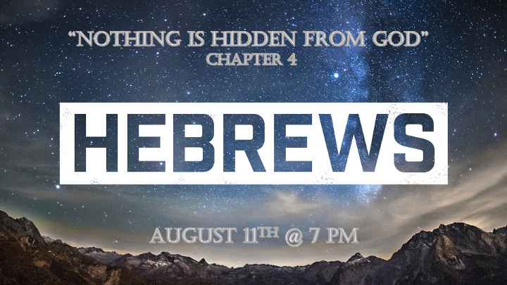

*A Prophetic Update for 2021

*The upheaval: I Thess. 5:3-4 While people are saying, "Peace and safety," destruction will come on them suddenly, as labor pains on a pregnant woman, and they will not escape.
The world is promising if you “Do” these actions then we will all have safety.
The beginning of labor pains: This sign reveals the later stages of the last days. Labor happens in the third wave. We see this pattern in the three waves of judgement in Ezekiel. There are three Woes in Revelation Chapters 9 – 11 with the 5th, 6th, and 7th trumpets we see the pattern of three.

*Hebrews4:1 Therefore, since the promise of entering his rest still stands, let us be careful that none of you be found to have fallen short of it. 2 For we also have had the good news proclaimed to us, just as they did; but the message they heard was of no value to them, because they did not share the faith of those who obeyed. 3 Now we who have believed enter that rest, just as God has said, "So I declared on oath in my anger, 'They shall never enter my rest.' " And yet his works have been finished since the creation of the world. 4 For somewhere he has spoken about the seventh day in these words: "On the seventh day God rested from all his works." 5 And again in the passage above he says, "They shall never enter my rest."
6 Therefore since it still remains for some to enter that rest, and since those who formerly had the good news proclaimed to them did not go in because of their disobedience, 7 God again set a certain day, calling it "Today." This he did when a long time later he spoke through David, as in the passage already quoted: "Today, if you hear his voice, do not harden your hearts."
8 For if Joshua had given them rest, God would not have spoken later about another day. 9 There remains, then, a Sabbath-rest for the people of God; 10 for anyone who enters God's rest also rests from their works, just as God did from his. 11 Let us, therefore, make every effort to enter that rest, so that no one will perish by following their example of disobedience.

*The Many Dimensions of God’s Rest.

- Hebrews 4:1-11 God’s rest has a past, present, and future aspect to it.
- God commands us to cease and desist from busyness. Rest is different from peace but you will feel the benefit.
- Stop depending on your efforts to get saved. Rituals have merit but not saving power.
- God’s rest has a temporal aspect as well as an eternal one.
- The main emphasis of rest is to celebrate, but what?

- How do we apply God’s rest to our life?
- Rest in what God has done for you. __________________.

- Rest in what God is doing in you. ____________________.

- Rest in what God promises to do. ____________________________________________.

*Hebrews4:12 For the word of God is alive and active. Sharper than any double-edged sword, it penetrates even to dividing soul and spirit, joints and marrow; it judges the thoughts and attitudes of the heart. 13 Nothing in all creation is hidden from God's sight. Everything is uncovered and laid bare before the eyes of him to whom we must give account.

*Nothing is hidden from God.

- His Word reveals unique powers concerning our lives.
- It is alive but it is more than that. It is active.
- It is precise with a purpose to help us judge between our thoughts (our reasoning) and our attitudes of the heart. (our spirit of surrender)
- It penetrates every area of life, society, and culture. It is timeless.

- God wants us to search in the Bible to find the connection between His omniscient power and His Word.
- As the Holy Spirit was writing the Word of God through the prophets, God saw everything. Past, Present, and Future situations and people.
- Everything is seen by God unless it is erased.

Hebrews 4:14 Therefore, since we have a great high priest who has ascended into heaven, Jesus the Son of God, let us hold firmly to the faith we profess. 15 For we do not have a high priest who is unable to empathize with our weaknesses, but we have one who has been tempted in every way, just as we are—yet he did not sin. 16 Let us then approach God's throne of grace with confidence, so that we may receive mercy and find grace to help us in our time of need.

*Confidence about the one who sits on the Throne of God.

- V:14 Our Savior _____________________________________.

- V:15 Our Savior _______________________________________.

- V:16 Our Savior _______________________________________.

- Two key ingredients: ________________________with the promise that during our time of need both are available.

