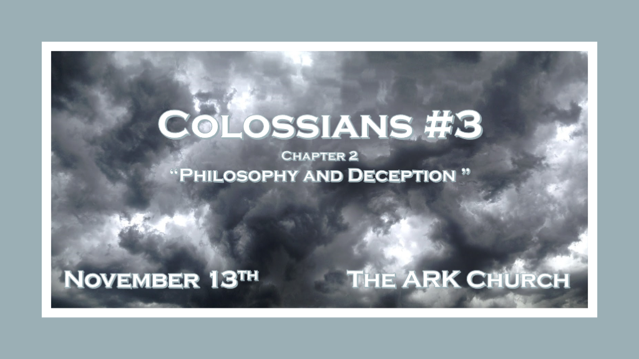

The role of the Christian to others and in this world.

*Colossians2:1 For I want you to know what a great conflict I have for you and those in Laodicea, and for as many as have not seen my face in the flesh, 2 that their hearts may be encouraged, being knit together in love, and attaining to all riches of the full assurance of understanding, to the knowledge of the mystery of God, both of the Father and of Christ, 3 in whom are hidden all the treasures of wisdom and knowledge.
4 Now this I say lest anyone should deceive you with persuasive words. 5 For though I am absent in the flesh, yet I am with you in spirit, rejoicing to see your good order and the steadfastness of your faith in Christ. 6 As you therefore have received Christ Jesus the Lord, so walk in Him, 7 rooted and built up in Him and established in the faith, as you have been taught, abounding in it with thanksgiving.
8 Beware lest anyone cheat you through philosophy and empty deceit, according to the tradition of men, according to the basic principles of the world, and not according to Christ. 9 For in Him dwells all the fullness of the Godhead bodily; 10 and you are complete in Him, who is the head of all principality and power.

- V:1-3 Do you anguish over those who are deceived?

- We must be encouraging with our common bond of God’s love.
Laodicea means: People rule or the people’s intelligence is where their faith is placed. (Gnostics)

- The knowledge of the Mystery of God is about both the Father and Jesus Christ.
There are mysteries about God we cannot answer. Why? God is infinite: Limitless without beginning or end.
Because Jesus took on humanity, we think mistakenly we can understand all the mysteries of the Son of God.

- Don’t be selfish by keeping hidden treasures of the wisdom and knowledge of God’s Word to yourself.
Sharing the Word of God must challenge others’ intellect, and spirit, as it reveals Jesus.

- V:4-7 Who is responsible to protect and establishing others in their faith?

What does walking in the faith of Jesus look like? Answer: It’s rooting, building, and establishing others in their faith through Biblical teaching and being an example of a thankful Christian.

- V:8-10 Philosophy is the study of the fundamental nature of human knowledge.

Beware lest someone cheat you and deceives you by the traditions of men. Who uses the basic principles from this world and philosophies to anchor you to something other than Jesus.

The great cheat is anyone who convinces you Jesus is anything less than God.

*The Bible is not filled with philosophy. It’s filled with design.
*The Word of God teaches Epistemology, the investigation of what distinguishes justified belief from opinion.

*(John 3:12-15) 12 If I have told you earthly things and you do not believe, how will you believe if I tell you heavenly things? 13 No one has ascended to heaven but He who came down from heaven, that is, the Son of Man who is in heaven. 14 And as Moses lifted up the serpent in the wilderness, even so must the Son of Man be lifted up, 15 that whoever believes in Him should not perish but have eternal life. (John 3:16)
*The Ultimate design is found in foolishness. I Corinthians 1:18 For the message of the cross is foolishness to those who are perishing, but to us who are being saved it is the power of God.

*Triumphant Christianity has sin debt wiped out & has nailed down certain truths.
*Colossians 2:11 In Him you were also circumcised with the circumcision made without hands, by putting off the body of the sins of the flesh, by the circumcision of Christ, 12 buried with Him in baptism, in which you also were raised with Him through faith in the working of God, who raised Him from the dead. 13 And you, being dead in your trespasses and the uncircumcision of your flesh, He has made alive together with Him, having forgiven you all trespasses, 14 having wiped out the handwriting of requirements that was against us, which was contrary to us. And He has taken it out of the way, having nailed it to the cross. 15 Having disarmed principalities and powers, He made a public spectacle of them, triumphing over them in it.

- V:11-12 Christ did the work! Jesus cuts away our sins.
To my Catholic friends. No sacrament can save you. They only point to the one who can.

Sacraments cannot be the requirement to have Jesus. If you believe they are you are trying to earn heaven by what you do instead of what was done.

- V:13-14 Dismantling the way we used to act. We no longer sin and hide from God like Adam & Eve.
*We run to Jesus and boldly proclaim His love, grace, forgiveness, and all He has paid in full for us.

Jesus died once and for all is the truth of the Gospel.

- V:15 Having disarmed the enemy from his ultimate goal.
The truth the devil is a powerful enemy. The devil’s goal was to corrupt God’s creation, humanity.

*Let your standard for truth be found in the Word of God.

*Colossians 2:16 So let no one judge you in food or in drink, or regarding a festival or a new moon or sabbaths, 17 which are a shadow of things to come, but the substance is of Christ. 18 Let no one cheat you of your reward, taking delight in false humility and worship of angels, intruding into those things which he has not seen, vainly puffed up by his fleshly mind, 19 and not holding fast to the Head, from whom all the body, nourished and knit together by joints and ligaments, grows with the increase that is from God.
20 Therefore, if you died with Christ from the basic principles of the world, why, as though living in the world, do you subject yourselves to regulations— 21 “Do not touch, do not taste, do not handle,” 22 which all concern things which perish with the using—according to the commandments and doctrines of men? 23 These things indeed have an appearance of wisdom in self-imposed religion, false humility, and neglect of the body, but are of no value against the indulgence of the flesh.

- V:16-19 The shadow of things to come pointed to Jesus.
Don’t worship the shadow, the things that are created the moon, sabbaths, or even angels, worship Jesus.

The Bible from Genesis to Revelation continues to point to and exalt Jesus.

- V:20-23 Be a Christ-centered Biblical worldview follower of Jesus Christ.

Plato at his death hungered for a divine word. Epistemology is NOT worth taking today in college. They focus on human thoughts and words. They don’t even attempt to justify their belief any longer.

The Divine Word came into the World His name is Jesus.

