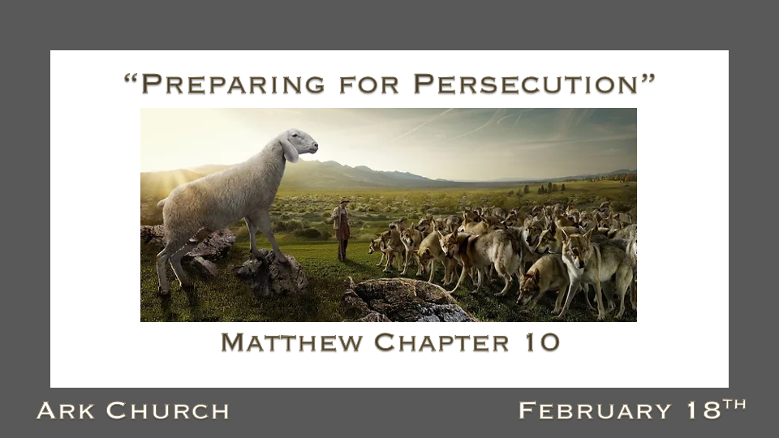

*The Transformed Life Prepares You For Real Life.

Last week, we learned about the power of transformation.
Matthew 9:9 As Jesus passed on from there, He saw a man named Matthew sitting at the tax office. And He said to him, "Follow Me." So he arose and followed Him.

Interview with Al Spigner (Prison Ministry Pastor)

- Question: Al, you grew up in Oklahoma in a time when life was very segregated. Your Christian Grandma gave you some advice about the persecution you would face. What did she tell you?

- Question: At 19, you are a Marine in Okinawa, Japan. Grandma was not there. How did her training help you with the persecution you faced during that time of your life?

- Question: What advice do you have for Christians, as persecution is a part of life?

*God Equips Us To Change Our World.

*Matthew 10:1 And when He had called His twelve disciples to Him, He gave them power over unclean spirits, to cast them out, and to heal all kinds of sickness and all kinds of disease.
*Matthew 10:5 These twelve Jesus sent out and commanded them, saying: "Do not go into the way of the Gentiles, and do not enter a city of the Samaritans. 6 But go rather to the lost sheep of the house of Israel. 7 And as you go, preach, saying, The kingdom of heaven is at hand.'

- Our power comes from God. We are to heal people from all kinds of sickness, and racism is a terrible societal sickness.

- Did Jesus ask the Jewish disciples to isolate themselves from the world?

- V:7 Jesus told to tell them how close the kingdom of heaven is.

*Is Jesus Sending Us Out As Lambs To Be Among Wolves Today? YES!

*Matthew 10:16 "Behold, I send you out as sheep in the midst of wolves. Therefore be wise as serpents and harmless as doves. 17 But beware of men, for they will deliver you up to councils and scourge you in their synagogues. 18 You will be brought before governors and kings for My sake, as a testimony to them and to the Gentiles. 19 But when they deliver you up, do not worry about how or what you should speak. For it will be given to you in that hour what you should speak; 20 for it is not you who speak, but the Spirit of your Father who speaks in you.
21 "Now brother will deliver up brother to death, and a father his child; and children will rise up against parents and cause them to be put to death. 22 And you will be hated by all for My name's sake. But he who endures to the end will be saved. 23 When they persecute you in this city, flee to another. For assuredly, I say to you, you will not have gone through the cities of Israel before the Son of Man comes.

- *V:16 Be wise and harmless at the same time. How?

- *V:17-20 You will be and are being persecuted for being a follower of Jesus.

- *V:21 Hatred will deceive everyone in your family who doesn't follow Jesus.

- *V:22 You will be hated by all, but you will not be filled with hate. (Al Spigner's Grandma knew the truth)

- *V:23 When they persecute you in this city, flee to another. You will not go through all the cities or towns of the inland Empire before Jesus returns.

