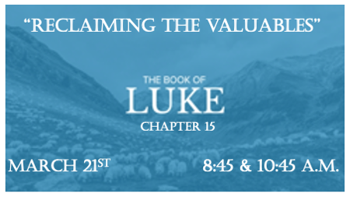

Have you ever misjudged God’s heart?

*Luke 15:1 Now the tax collectors and sinners were all gathering around to hear Jesus. 2 But the Pharisees and the teachers of the law muttered, "This man welcomes sinners and eats with them."

3 Then Jesus told them this parable: 4 "Suppose one of you has a hundred sheep and loses one of them. Doesn't he leave the ninety-nine in the open country and go after the lost sheep until he finds it? 5 And when he finds it, he joyfully puts it on his shoulders 6 and goes home. Then he calls his friends and neighbors together and says, 'Rejoice with me; I have found my lost sheep.' 7 I tell you that in the same way there will be more rejoicing in heaven over one sinner who repents than over ninety-nine righteous persons who do not need to repent.

A Biblical Look at Who Needs Jesus.

- Luke 15 Has four common threads. One is something or someone of worth is lost. Two an effort is given to retrieve that which is lost. Three a party is thrown on earth when the lost is found. Four how heaven reacts about the recoveries.

- V:1-2 Why religious people misjudge Jesus.

- The purpose of these parables is to show the different reasons for lost people in the world. The Sheep = Foolishness, The coin = Carelessness, and the Son = Willfulness.

*Luke 15:8 "Or suppose a woman has ten silver coins and loses one. Doesn't she light a lamp, sweep the house and search carefully until she finds it? 9 And when she finds it, she calls her friends and neighbors together and says, 'Rejoice with me; I have found my lost coin.' 10 In the same way, I tell you, there is rejoicing in the presence of the angels of God over one sinner who repents."

God’s Effort for Humanity

- The first two parables are different in that an all-out search is done for what was lost. John 10:16 I have other sheep not of this fold.

- Romans 5:8 God proves His love for us in that while we were still sinners...

*Luke 15:11 Jesus continued: "There was a man who had two sons. 12 The younger one said to his father, 'Father, give me my share of the estate.' So, he divided his property between them. 13 "Not long after that, the younger son got together all he had, set off for a distant country and there squandered his wealth in wild living. 14 After he had spent everything, there was a severe famine in that whole country, and he began to be in need. 15 So he went and hired himself out to a citizen of that country, who sent him to his fields to feed pigs. 16 He longed to fill his stomach with the pods that the pigs were eating, but no one gave him anything.

17 "When he came to his senses, he said, 'How many of my father's hired servants have food to spare, and here I am starving to death!

Why are Believers Separated from God’s Kingdom?

- V:11-16 Beware, manipulating the Kingdom for gain has dangerous consequences.

- V:17 Coming back to our senses. This is prophetic in that many believers who have experienced God forgiveness will lose their way.

*Luke 15:25 "Meanwhile, the older son was in the field. When he came near the house, he heard music and dancing. 26 So he called one of the servants and asked him what was going on. 27 'Your brother has come,' he replied, 'and your father has killed the fattened calf because he has him back safe and sound.'
28 "The older brother became angry and refused to go in. So, his father went out and pleaded with him. 29 But he answered his father, 'Look! All these years I've been slaving for you and never disobeyed your orders. Yet you never gave me even a young goat so I could celebrate with my friends. 30 But when this son of yours who has squandered your property with prostitutes comes home, you kill the fattened calf for him!'
31 " 'My son,' the father said, 'you are always with me, and everything I have is yours. 32 But we had to celebrate and be glad because this brother of yours was dead and is alive again; he was lost and is found.' "

The Heart of God and the Heart of the Apostate

- V:28 The Word of God reveals that our God pleads with his children to understand all of His heart.

- V:32 The Father has the last Word in this matter.

- Is it too harsh to call the older brother an apostate? What is the older brother’s sin? Put all three parables together.

