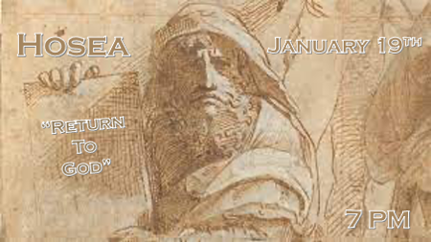

*Israel and the Church have different origins, different roles, and destinies, but we can draw parallels in God’s judgment and His love for His people.

*Hosea 3:1 The LORD said to me, "Go, show your love to your wife again, though she is loved by another man and is an adulteress. Love her as the LORD loves the Israelites, though they turn to other gods and love the sacred raisin cakes."
2 So I bought her for fifteen shekels of silver and about a homer and a lethek of barley. 3 Then I told her, "You are to live with me many days; you must not be a prostitute or be intimate with any man, and I will behave the same way toward you."

*God purchases us from our bondage.

- V:1 God is consistent he shows love when we don’t deserve it.
- There are three ways a person can become a slave.
- V:2 By conquest as a more powerful entity (Satan) conquered them and they become his slave.

- By birth, because of the fall of humanity through Adam and Eve's sin. All of humanity is now born in a sinful state.

- By debt, we all have debt because of sin that we cannot repay. Jesus paid the debt for all our sins and this is the reason humanity has hope.
- *Titus 2:13-14 while we wait for the blessed hope—the appearing of the glory of our great God and Savior, Jesus Christ, 14 who gave himself for us to redeem us from all wickedness and to purify for himself a people that are his very own, eager to do what is good.
- *Ephesians 2:7 in order that in the coming ages he might show the incomparable riches of his grace, expressed in his kindness to us in Christ Jesus.

- V:2 The average price of a slave was sold for 30 shekels of silver. In this story, the price was achieved half in silver and half in grain.

- V:3 The bride is purchased and the bridegroom’s request is not to just stay out of prostitution but to engage in a real relationship with the groom.

*Hosea chapter 3 parallels with Romans chapters 9, 10, and 11

- Israel’s unfaithful and idolatrous past. (Romans 9)

- Present prophecy of a people restored to their homeland. (Romans 10)

- Future Restoration was completed by being bought by God through Jesus the Messiah. (Romans 11)

*Hosea 3:4 For the Israelites will live many days without king or prince, without sacrifice or sacred stones, without ephod or household gods. 5 Afterward the Israelites will return and seek the LORD their God and David their king. They will come trembling to the LORD and to his blessings in the last days.

*The future with…

- V:4 This describes Israel since 70 A.D. Does this describe the Church of today? All of Israel’s past judgments had specific times. 430 years in Egypt and 70 years in Babylon, but this is an open-ended time period.
- Without a king or prince. Israel will not have the national leadership it needs.

- Without a sacrifice, they will live an undetermined time without a temple.

- Without an ephod, they will be without any spiritual guidance.

- V:5 Israel will return to God. They will also return to honoring the Davidic royalty that Jeroboam 1 rejected when he split the nation.
- These events have no set date. It is not the when will it happen, but why will it.

- The last days will be marked by a great return to God. If this is true for Israel the people of God? Then will it also be true for the Church the Bride of Christ?

