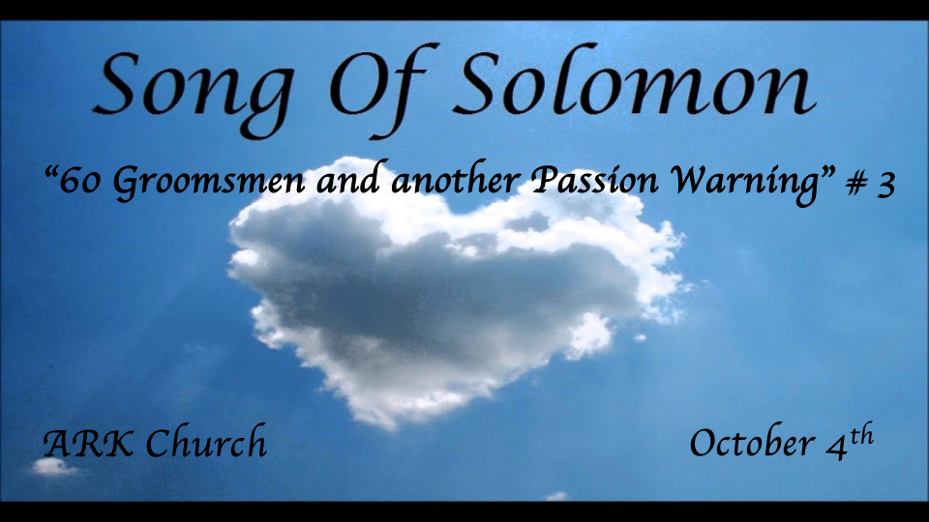
Review Four reflections:
- Preparing for the Wedding feast
- At the Wedding banquet
- In the Bridal chambers
- Courtship & the pain of separation

The Shulamite’s Words are 50% of the Song of Songs.

*A troubled night and a repeated warning with a twist.
*Song of Solomon 3:1-5

The Shulamite
1 By night on my bed I sought the one I love;
I sought him, but I did not find him.
2 “I will rise now,” I said,
“And go about the city;
In the streets and in the squares
I will seek the one I love.”
I sought him, but I did not find him.
3 The watchmen who go about the city found me;
I said,
“Have you seen the one I love?”
4 Scarcely had I passed by them,
When I found the one I love.
I held him and would not let him go,
Until I had brought him to the house of my mother,
And into the chamber of her who conceived me.
5 I charge you, O daughters of Jerusalem,
By the gazelles or by the does of the field,
Do not stir up nor awaken love
Until it pleases.

Insights V:1-2: (Allegory) The word “Night” is in the Hebrew plural. This is still reflection #4 and is one of the reoccurring dream during the courtship.

Nothing is more troubling than feeling as if you’ve lost the Lord’s presence.

*Psalm 30:7 LORD, by Your favor You have made my mountain stand strong; You hid Your face, and I was troubled.

The testing of our faith often comes by seeing if we can trust God in times of darkness and doubt as well as in times of light.

These insights are true in our spiritual walk and within our marriages.

Insights V3-4: I don’t believe Jesus ever plays the game of being hard to get. It is possible there are times when God wants to make sure we don’t take Him for granted.

V:3 This, too, is an essential lesson within marriage. Don’t take your spouse for granted.

V:4 Others, even those who spiritual, the spiritual Watchmen, cannot find Jesus for us.

The Lesson is we must find Jesus ourselves. Though others can tell us about Jesus, we must see Him ourselves.

*Jeremiah 29:13 And you will seek Me and find Me, when you search for Me with all your heart.

Insights V:5 The repeated warning. (Literal) It is possible that this warning is about our passions and lust that take us away from our love for our spouse. (Allegory) The things that take us away from our Savior and God.

*A Fifth Reflection: The Wedding Procession and more
*Song of Solomon 3:6-11

The Shulamite

6 Who is this coming out of the wilderness
Like pillars of smoke,
Perfumed with myrrh and frankincense,
With all the merchant’s fragrant powders?
7 Behold, it is Solomon’s couch,
With sixty valiant men around it,
Of the valiant of Israel.
8 They all hold swords,
Being expert in war.
Every man has his sword on his thigh
Because of fear in the night.
9 Of the wood of Lebanon
Solomon the King
Made himself a palanquin:
10 He made its pillars of silver,
Its support of gold,
Its seat of purple,
Its interior paved with love
By the daughters of Jerusalem.
11 Go forth, O daughters of Zion,
And see King Solomon with the crown
With which his mother crowned him
On the day of his wedding,
The day of the gladness of his heart.

Understanding the Five Things within a Jewish Wedding

The Betrothal: This is the covenant that takes before marriage, and a divorce is the only way to dissolve it.

The Wedding Procession: The groom goes away and builds a room on his parent’s house or a house on the parent’s property. The procession can only start when the house is complete. Then the groom goes to get his bride.

The Wedding Ceremony: This is the legal fulfillment of a marriage and the acknowledgments of the guest.

The Wedding Feast: This is the dinner feast with singing and dancing and the exchange of gifts.

The Wedding Night: The consummation of the marriage. The two become one flesh.

Insight V:6 Spices and fragrances are throughout this song.
The environment is life. This book of the Bible is about the fragrance of life.

Insights V:7-8 Sixty groomsmen for what purpose?
The royal guards are a great truth within their purpose and presence at a royal wedding.

The Wedding processional was a vulnerable time.

The guards were there to protect the Wedding. Why? Because there was fear in the night. Does not our Bridegroom parable in Matthew 25 tell us He comes at night?

V:9-11 Special furniture and the groom is crowned by his mother.
Furniture is like a couch, yet it’s mobile. Adorned with silver (symbol of redemption), Gold (symbol of purity), The color purple (symbol of priesthood and royalty)

The crown is the marriage crown. Signifying joy and completeness, it’s a wreath crown.

This practice stopped in 70 A.D. when the temple was destroyed. They now smash a wine glass as the symbol of destruction. The happiest day is marked with the reminder of their disconnected time from God.

