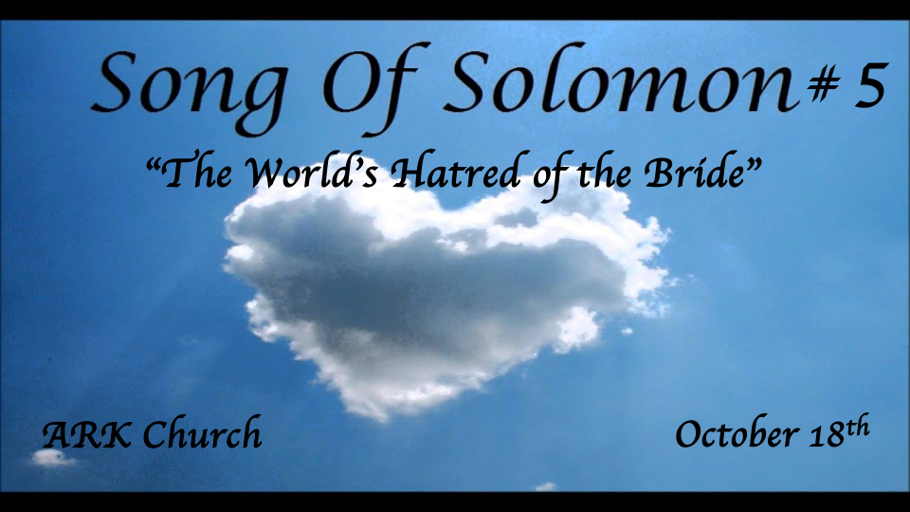
Reflections:
- Preparing for the Wedding feast
- At the Wedding banquet
- In the Bridal chambers (Shulamite)
- Courtship & the pain of separation
- The Wedding Procession (Shulamite)
- The Wedding Night (The Beloved)
- The Dream of Rejecting the Bridegroom

*Song of Songs 4:16 – 5:1 Is by design to give us the message of oneness with 111 verses before these two verses and 111 after them.

*The Seventh Reflection Not responding to the Bridegroom.
*Song of Solomon 5:1-8

The Beloved
1 I have come to my garden, my sister, my spouse;
I have gathered my myrrh with my spice;
I have eaten my honeycomb with my honey;
I have drunk my wine with my milk.
(To His Friends)
Eat, O friends!
Drink, yes, drink deeply,
O beloved ones!

The Shulamite
2 I sleep, but my heart is awake;
It is the voice of my beloved!
He knocks, saying,
“Open for me, my sister, my love,
My dove, my perfect one;
For my head is covered with dew,
My locks with the drops of the night.”
3 I have taken off my robe;
How can I put it on again?
I have washed my feet;
How can I defile them?
4 My beloved put his hand
By the latch of the door,
And my heart yearned for him.
5 I arose to open for my beloved,
And my hands dripped with myrrh,
My fingers with liquid myrrh,
On the handles of the lock.
6 I opened for my beloved,
But my beloved had turned away and was gone.
My heart leaped up when he spoke.
I sought him, but I could not find him;
I called him, but he gave me no answer.
7 The watchmen who went about the city found me.
They struck me, they wounded me;
The keepers of the walls
Took my veil away from me.
8 I charge you, O daughters of Jerusalem,
If you find my beloved,
That you tell him I am lovesick!

Insights V:1 The consummation of marriage. The King (God) is telling humanity the path of sexual fulfillment.
Review: The wedding night was all that God intended it to be.
The potential for sexual fulfillment in its abundance and its blessing is in the marriage bed.

Insights V:2-5 The Bridegroom came home after midnight. How do we know this?
The Bride is asleep. They are no longer newlyweds.
Allegory: Christ in your heart is a commitment of Salvation. Will you be ready for His return? Matt. 25:13

The dew is heavy on the bridegroom. The dew in Israel is heaviest after midnight.
She was not prepared for his late arrival.

Worse, her excuses for not opening the door show a heart that has grown cold toward her husband.
Apathy in a Christian life is more dangerous than we know.

Myrrh was on the handles of the lock door. Allegory, the one who died for us, came, and we locked Him out? John 19:39 Myrrh was one of the spices/oils used in burying Jesus.

Insights V:6-7 Is this treatment of the Bride before the bridegroom's return or because she missed His return?
It’s not an either-or but a both-and situation.

*Comparisons with the previous dream.
- *In the 1st dream, the watchmen helped her. In this one, they beat her. Matthew 25
- *The keepers of the wall removed her veil. This is a symbol of the removal of her position of protection.

*The Seventh Reflection: Missing the return of the bridegroom
*Song of Solomon 5:9-14

The Daughters of Jerusalem
9 What is your beloved
More than another beloved,
O fairest among women?
What is your beloved
More than another beloved,
That you so charge us?
The Shulamite
10 My beloved is white and ruddy,
Chief among ten thousand.
11 His head is like the finest gold;
His locks are wavy,
And black as a raven.
12 His eyes are like doves
By the rivers of waters,
Washed with milk,
And fitly set.
13 His cheeks are like a bed of spices,
Banks of scented herbs.
His lips are lilies,
Dripping liquid myrrh.
14 His hands are rods of gold
Set with beryl.
His body is carved ivory
Inlaid with sapphires.
15 His legs are pillars of marble
Set on bases of fine gold.
His countenance is like Lebanon,
Excellent as the cedars.
16 His mouth is most sweet,
Yes, he is altogether lovely.
This is my beloved,
And this is my friend,
O daughters of Jerusalem!
The Daughters of Jerusalem
6:1 Where has your beloved gone,
O fairest among women?
Where has your beloved turned aside,
That we may seek him with you?

Insight V:8-9: *Matthew 25:5 But while the bridegroom was delayed, they all slumbered and slept.
6 “And at midnight a cry was heard: ‘Behold, the bridegroom is coming; go out to meet him!’ 7 Then all those virgins arose and trimmed their lamps. 8 And the foolish said to the wise, ‘Give us some of your oil, for our lamps are going out.’ 9 But the wise answered, saying, ‘No, lest there should not be enough for us and you; but go rather to those who sell, and buy for yourselves.’ 10 And while they went to buy, the bridegroom came, and those who were ready went in with him to the wedding; and the door was shut.
11 “Afterward the other virgins came also, saying, Lord, Lord, open to us!’ 12 But he answered and said, ‘Assuredly, I say to you, I do not know you.’
13 “Watch therefore, for you know neither the day nor the hour in which the Son of Man is coming.

The daughters of Jerusalem couldn’t separate one Beloved from another. Can you?

Insights V:10-16 All that made her “Beloved” stand out to her.

Does Jesus stand out in your life for all the right reasons?

- V:10 My beloved stands out beyond others. Is this why we follow Jesus?
- V:11-13 The physical things of our beloved can reveal shallowness when choosing a Messiah.
- V:14 The beauty or wow factor of his hands. The miracles of Jesus had impressed the Pharisees.
- V:15 His dignity/wisdom standards are to be admired.
- V:16 His love and friendship. They are wonderful qualities, but none of them will get you into heaven.

Insight for Song of Solomon 6:1 Yes, others will want to follow the charismatic, good-looking, loving leader who can do miracles with his hands. That leader will be the antichrist.

