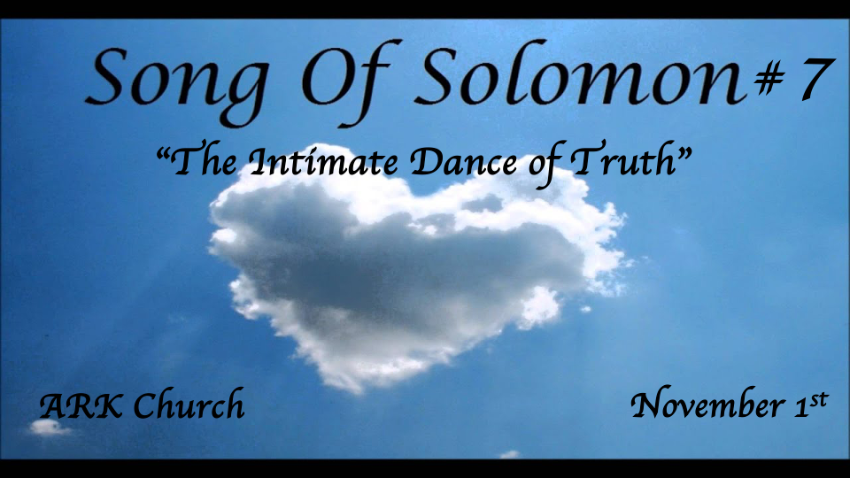
Reflections:
- Preparing for the Wedding feast
- At the Wedding banquet
- In the Bridal chambers (Shulamite)
- Courtship & the pain of separation
- The Wedding Procession (Shulamite)
- The Wedding Night (The Beloved)
- The Dream of Rejecting the Bridegroom
- The Return of the King
- The Dance of the Two Camps
- The Stability of the Beloved's Love

*The Ninth Reflection The Dance of the Two Camps Continues Literally.
*Song of Solomon 7:1-3

The Beloved
1 How beautiful are your feet in sandals,
O prince's daughter!
The curves of your thighs are like jewels,
The work of the hands of a skillful workman.
2 Your navel is a rounded goblet;
It lacks no blended beverage.
Your waist is a heap of wheat
Set about with lilies.
3 Your two breasts are like two fawns,
Twins of a gazelle.
4 Your neck is like an ivory tower,
Your eyes like the pools in Heshbon
By the gate of Bath Rabbim.
Your nose is like the tower of Lebanon
Which looks toward Damascus.
5 Your head crowns you like Mount Carmel,
And the hair of your head is like purple;
A king is held captive by your tresses.
6 How fair and how pleasant you are,
O love, with your delights!
7 This stature of yours is like a palm tree,
And your breasts like its clusters.
8 I said, "I will go up to the palm tree,
I will take hold of its branches."
Let now your breasts be like clusters of the vine,
The fragrance of your breath like apples,
9 And the roof of your mouth like the best wine.

Insights V:1 The Beloved, for the 3rd time, describes his bride. For the 1st time, the description of his wife starts at her feet.

- Song of Solomon 4:1-5: The 1st description was before she yielded her virginity to him in marriage.

- Song of Solomon 6:4-9: The 2nd time was after the dream of rejection as a part of reconciliation.

- The third description suggests both literal and symbolic insights.

- Literally, men often consider their wife's beauty more incredible than the woman herself.
- The Allegory is for us to consider whether God finds us more beautiful than we may see Him.

- The feet are telling a story in the dance. Because of the sensuality of the dance, it is believed to be private. The Shulamite's sandals suggest royalty. People with low incomes would dance barefooted.

Insights V:2-3 The theme is love for the whole person. A picture of intimacy shared between a husband and wife.
Learn to capture the level of enjoyment with each other. The totality of this time implies much more than a physical romp in bed.

Yes, it is physical oneness, but the emotions are there; the spirit of innocence is being recaptured with the reiterating that her breasts are like two fawns.

The dance of the two camps, implied in chapter six, reveals two different hearts toward the bridegroom.

This dance details a total captivation with each other. The message is to avoid ruts of intimacy and be creative in reigniting your love for each other and your love for your returning King.

Insights V:4-6 Love is supposed to be a neck-up kind of love, too.
The Head is crowned with the color purple, again speaking to the royalty of the bride.

Insights V:7-9a These verses express the power of sexual attachment in marriage and the power of kisses.
At the height of the description of intimacy, the focus moves to kissing and the mouth.

The power of the kiss is where the Beloved voice ends, and the Shulamite begins.

*The 10 Reflection: I am my Beloved's, and His desire is toward me.
*Song of Solomon 7: 9b,10-13

The Shulamite
The wine goes down smoothly for my beloved,
Moving gently the lips of sleepers.
10 I am my beloved's,
And his desire is toward me.
11 Come, my beloved,
Let us go forth to the field;
Let us lodge in the villages.
12 Let us get up early to the vineyards;
Let us see if the vine has budded,
Whether the grape blossoms are open,
And the pomegranates are in bloom.
There I will give you my love.
13 The mandrakes give off a fragrance,
And at our gates are pleasant fruits,
All manner, new and old,
Which I have laid up for you, my beloved.

Insight V:9b The gentleness of lips.
It's a reminder of our words and the power of our lips.

Insights V:10 The 3rd time we hear. I am my beloved's, and His desire is toward me.

- Song of Solomon 2:16 Was during the courtship: "My beloved is mine, and I am his.
The statement is one of security.

- Song of Solomon 6:3 Was written after the marriage and her understanding of the King's role. "I am my beloved's, and my beloved is mine.
The statement is one of submission.

- Song of Solomon 7:10 As their relationship shows longevity. "I am my beloved's,
and his desire is toward me."
The statement reveals Stability.

Insights V:11-13 Seeing the evidence of new fruit. (The Shulamite and King went to a new environment for renewal.)

Literally: The couple will not let anything create a rut in any area of the marriage.

Allegory: Don't allow times of low or no intimacy to happen between you and Jesus.

