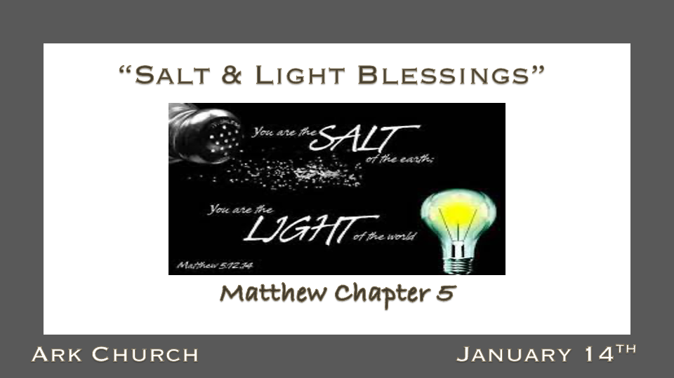

*Are you tempted to worship and serve something other than God?

*Matthew 4:10 Then Jesus said to him, "Away with you, Satan! For it is written, You shall worship the LORD your God, and Him only you shall serve.'"
11 Then the devil left Him, and behold, angels came and ministered to Him.

The devil leaves when he is convinced you won't worship him.

- *Worship is the key to the Christian's vitality. Worship reveals your heart, your mind, and strength.
We are introducing you to a greater level of Worshipping God in 2024. We must, or you will worship something else.

- *Isaiah 2:8 Their land is also full of idols; They worship the work of their own hands,
that which their own fingers have made.
Isaiah 2:8 Is A Prophecy about self-worship that has come to reality in the 21st century.

- *We will serve that which we worship.
Technology has come from our hands and the world; many Christians worship and serve it.

*The Salt Covenant is to Preserve the Ways of God.

*Matthew 5:13 "You are the salt of the earth; but if the salt loses its flavor, how shall it be seasoned? It is then good for nothing but to be thrown out and trampled underfoot by men.

*Leviticus 2:13 And every offering of your grain offering you shall season with salt; you shall not allow the salt of the covenant of your God to be lacking from your grain offering. With all your offerings you shall offer salt.

- How shall our salt covenant season the Earth?
- *Numbers 18:19, A covenant to preserve Israel. 2 Chronicles 13:5, a covenant to preserve David and his sons over Israel. 2 Kings 2: 19-21, Elisha cleanses the waters and land with salt.
- *The Persian word for traitor is translated in English as "faithless to salt."

*The Light of the World Must Reveal the Deeds of Darkness.

*Matthew 5:14 "You are the light of the world. A city that is set on a hill cannot be hidden. 15 Nor do they light a lamp and put it under a basket, but on a lampstand, and it gives light to all who are in the house. 16 Let your light so shine before men, that they may see your good works and glorify your Father in heaven.

- Biblical Declarations are used when something is a fact. You are the light of the world and should not be used as a suggestion.

- You are light; it can be a tiny light or a spotlight, indirect light, accent lightening, high beam light, low beam light, or you can son light or moonlight. But every Christ is light.

*The Fulfillment of Righteousness (Salt & Light) or False Worship?

*Matthew 5:17 "Do not think that I came to destroy the Law or the Prophets. I did not come to destroy but to fulfill. 18 For assuredly, I say to you, till heaven and earth pass away, one jot or one tittle will by no means pass from the law till all is fulfilled. 19 Whoever therefore breaks one of the least of these commandments, and teaches men so, shall be called least in the kingdom of heaven; but whoever does and teaches them, he shall be called great in the kingdom of heaven. 20 For I say to you, that unless your righteousness exceeds the righteousness of the scribes and Pharisees, you will by no means enter the kingdom of heaven.

- A righteousness beyond religion. It is a right standing with God as you worship Him and establish a salt and light covenant with humanity.

Religion is powerless to save. The great falling away, according to 2 Thessalonians, is a discarding of truth and worship to worship lawlessness.

- *2 Thess. 2:3 Let no one deceive you by any means; for that Day will not come unless the falling away comes first, and the man of sin is revealed, the son of perdition, 4 who opposes and exalts himself above all that is called God or that is worshiped, so that he sits as God in the temple of God, showing himself that he is God.

Worship comes before service! Matthew 4:10

- *When the Church doesn't preserve (Salt) covenant. The church will try to survive by maintaining attendance, money, or an image instead of honoring God.

The church will double its serving effort while shrinking the worship of God.

- *When the Church ceases being the light. The church will argue over what is a good light, a healthy light, or what subjects are appropriate subjects to bring light to.

Our high school-age students go from 1% Identifying as some confusion of gender to 25% identifying with gender confusion.

A nation that was once under God becomes a nation that is attacking the right to be led by a Biblical Worldview.

- When Worship is reduced to singing, you will see the evidence of barrenness. Prayer, seeking God's voice/direction, singing, and meditating on His Word are all forms of worship. When freedom of worship comes, there are dancing, silence, and holy awe moments before the Lord.

We invite you in 2024 to journey to the new of worship. Don't let the awkwardness of Worship intimidate you. You will find some forms of worship are your chocolate. At the same time, Other forms of Worship are the vegetables and meat of your worship before the Lord.

