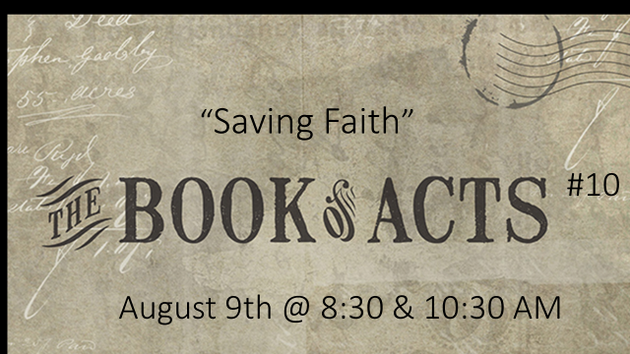

Introduction: Concerning Philip from chapter 6:

- “Leadership is not about titles, positions or flow charts. It is about one life influencing another” ~ John Maxwell
- “Titles may give someone authority, but not influence.” Influence comes from the person; it must be earned. King David had earned it and King Saul had not. ” ~ John Maxwell
- As a judge, Samson squandered his anointing and his authority, and as such, had no influence.

Here are a few examples from the OT of those commissioned in important positions but squandered that authority and were grossly ineffective because their heart was not right!!!

- Aaron’s sons: In Leviticus 10 we read about Nadab and Abihu when they offered “strange (profane) fire” before the Lord and the Lord killed them.

- Eli’s sons: In I Samuel 2 we read about Hophni and Phineas; The Bible designates them as “sons of Belial” and “thoroughly worthless individuals”, and describes in detail the ways in which they abused their priestly privileges.

- Samuel’s sons: In I Samuel 8, we read about Joel and Abijah; they were not like their father, for they were greedy for money. They accepted bribes and perverted justice.

The Proper Preparation

Genuine saving faith demands the proper preparation. In the parable of the sower, only the good, properly prepared soil brought forth the fruits of salvation. The text indicates four features which prepared the soil of the eunuch’s heart. They are as follows…

- The Sovereign WORK of the Spirit (vss. 25-26)
- The Submissive WILL of the hearer (vs. 27a)
- The Searching WORSHIP of the hearer (vs. 27b)
- The Scriptural WORD of truth (vs. 28)

- The Sovereign WORK of the Spirit (vss. 25-26)

Vs. 26: Gaza – One of five cities of the Philistines. The original city was destroyed in the first century B.C. and a new city was built near the coast.

So when they had testified and preached the word of the Lord, they returned to Jerusalem, preaching the gospel in many villages of the Samaritans. Now an angel of the Lord spoke to Philip, saying, “Arise and go toward the south along the road which goes down from Jerusalem to Gaza.” This is desert. (Acts 8:25-26)

Salvation, both in its eternal planning and its temporal outworking, is totally God’s Sovereign work!!! The Apostle Paul tells us that there are two insurmountable barriers keeping man from grasping God’s salvation by his own efforts.

First, men are spiritually DEAD and therefore unable to respond to God.

Secondly, as if man’s deadness wasn’t enough, you also then have Satan and his demon hosts actively involved in keeping men from finding God’s truth. In light of those truths, it is ludicrous to assume that anyone apart from the sovereign work of the Holy Spirit in his or her lifeless soul, could ever come to a saving faith in Christ!!!!

In our story today, the Spirit began his preparatory work by maneuvering Philip into a strategic position. After Peter and John solemnly testified and spoken the word of the Lord, they started back to Jerusalem. On their return trip, they were preaching the gospel to many villages of the Samaritans, carrying on the evangelistic work begun by Philip. But an angel of the Lord spoke to Philip saying, “Arise and go south to the road that descends from Jerusalem to Gaza”.
The circumstances that were to lead to the eunuch‘s salvation were sovereignly and specifically arranged by the Spirit.

- The Submissive WILL of Philip (vs. 27a)

“So he arose and went.”

God often accomplishes His sovereign work through human instruments. Like a master sculptor He takes otherwise useless and inconsequential tools and uses them to create a masterpiece.

- The Searching WORSHIP of the eunuch (vs. 27b)

“And behold, a man of Ethiopia, a eunuch of great authority under Candace the queen of the Ethiopians, who had charge of all her treasury, and had come to Jerusalem to worship,...”

The Lord Jesus Christ said in John 7:17, “If any man is willing to do His will, he shall know of the teaching, whether it is of God, or whether I speak from Myself.”

The eunuch is a classic example of one who lived up to the light he had. God then gave him the full revelation of Jesus Christ through Philip’s ministry.

- The Scriptural WORD of truth (vs. 28)

“…was returning. And sitting in his chariot, he was reading Isaiah the prophet.”

While returning to his own country, the eunuch was sitting in his chariot, and was reading the prophet Isaiah, He had a desire to know God and was aware that He was to be known through the Scripture. He was indeed an eager seeker, He had no doubt paid a great price in Jerusalem for that scroll, which would have been difficult for a Gentile to acquire. He knew the importance of seeking God through the Scripture.

One of the casualties of this increasingly “wicked and adulterous generation”, in spite of all the “lightning speed” access to information, (bible apps, e-books, online search engines to vast databases of information, etc.) is the continuous deterioration of Biblical knowledge among so-called Bible-believing, church-attending, and spirit-filled Christians!!!!

  - The Proper Presentation (vss. 29-35)

- Centers on Scripture (vss. 30-34)

“But sanctify the Lord God in your hearts, and always be ready to give a defense (answer - KJV) to everyone who asks you a reason for the hope that is in you, with meekness and fear;” (I Peter 3:15 – NKJV)

An effective presentation of the gospel MUST be based solidly on Scripture. Even though they may add some value, use of personal testimonies, stories, tracts, and other tools is no substitute for a truly Biblical presentation of the Gospel. For Scripture alone is “the power of God for salvation to everyone who believes, to the Jew first and also to the Greek (Romans 1:16). The power is in God’s Word!!!!

- Centers on Christ (Cristo-centric) (vs. 35)

“And Philip opened his mouth, and beginning from this scripture he preached Jesus to him (v. 35)

- The Proper Response (vss. 36-40)

    - Faith (vs. 36)
    - Confession (vss. 37-38)
    - Rejoicing (vss. 39-40)

Luke does not give us the subsequent history of the Ethiopian eunuch. According to the church Father Irenaeus (Greek Bishop; 130 – 202 A.D.), he became a missionary to the Ethiopians. What is clear in this account is that the Spirit’s preparation, coupled with Philip’s presentation, produced in this eunuch the faith that does save!!!!

