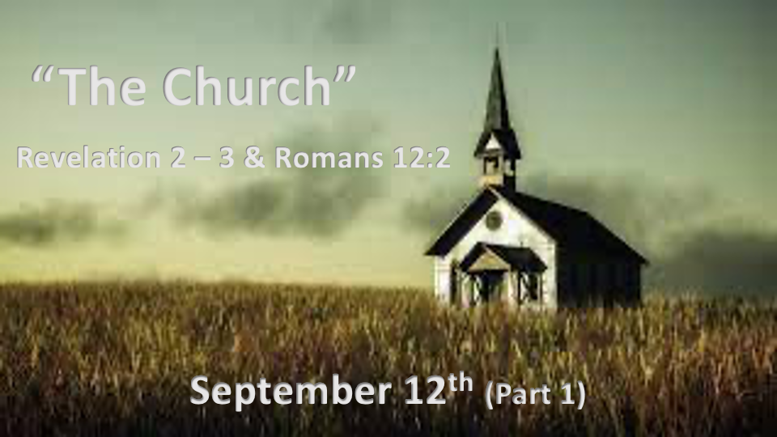

*Within every church, there are families revealing Jesus to the world.

*It may seem like the pieces are falling apart, when they are falling into place. ~ Jan Markell olivetreeviews.org

*Romans 12:2 Do not conform to the pattern of this world, but be transformed by the renewing of your mind. Then you will be able to test and approve what God's will is—his good, pleasing and perfect will.

*God’s earthly families (Churches) that conformed to the world

- *Revelation 2:4 The Ephesus family they’ve forsaken the love they had at first.

- *Revelation 2:14-15 The Pergamum family entices each other to sin. They also want to be served as their family’s main privilege.

- *Revelation 2:20 The Thyatira family tolerate and embrace sexual immorality as their household code.

- *Revelation 3:1-3 The Sardis family think they’re the best liveliest family, yet the truth is this is the most dead and apostate family.

- *Revelation 3:15-16 The Laodicea family are proud of their middle of the road non-confronting mindset.

*God gives each family a message of hope & transformation.

- Rev. 2:1 Follow the God of light who walks among you. (Ephesus family)

- Rev. 2:12 The God of the Word is willing to cut away from your sins. (Pergamum family)

- Rev. 2:18 Let the words of Jesus purify and burn away your lust. (Thyatira family)

- Rev. 3:1 Hear what the Spirit is saying and receive real-life and wholeness. (Sardis family)

- Rev. 3:14 Follow Jesus and become awaken to real Kingdom passion and your witness will be complete. (Laodicea family)

*In all of the families (Churches) there are remnants. (Revelation 2 & 3)

- Those in the family who have stayed true to the narrow way, hate what God hates and reject false teachings. They won’t accept any substitute for Jesus and His Word.

- Those in the family who have found the power to NOT soiled their clothes with unrighteous and stay victorious.

Did you know?

- It took Noah 100 years to build the ARK. The Redlands Church of the Nazarene became the ARK Church in its 100th year in Redlands.
- Noah’s Ark was a place of refuge for all who were wise enough to get on board before God’s wrath.

