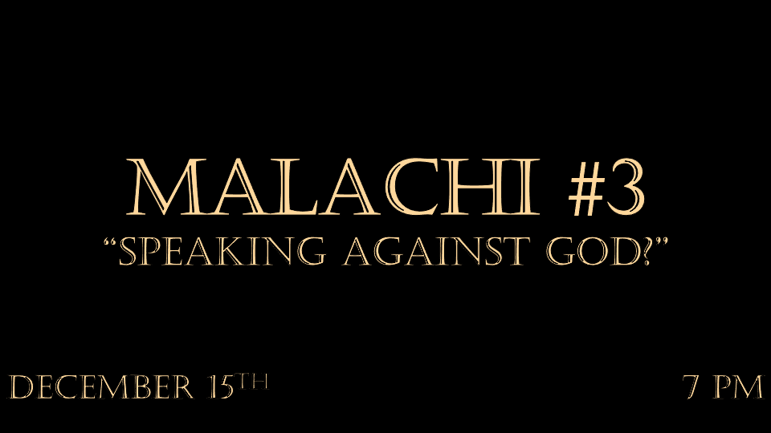

*Seven questions from those who are distant from God.
These kinds of questions often reveal our doubting, discouraged, and sinful hearts.
- In what way have You loved us? (Malachi 1:2)
- In what way have we despised Your name? (Malachi 1:6)
- In what way have we defiled You? (Malachi 1:7)
- In what way have we wearied Him? (Malachi 2:17)
- In what way shall we return? (Malachi 3:7)
- In what way have we robbed You? (Malachi 3:8)
- In what way have we spoken against You? (Malachi 3:13)

*Malachi 3:6 "I the LORD do not change. So you, the descendants of Jacob, are not destroyed. 7 Ever since the time of your ancestors you have turned away from my decrees and have not kept them. Return to me, and I will return to you," says the LORD Almighty. "But you ask, 'How are we to return?'

8 "Will a mere mortal rob God? Yet you rob me. "But you ask, 'How are we robbing you?' "In tithes and offerings. 9 You are under a curse—your whole nation—because you are robbing me. 10 Bring the whole tithe into the storehouse, that there may be food in my house. Test me in this," says the LORD Almighty, "and see if I will not throw open the floodgates of heaven and pour out so much blessing that there will not be room enough to store it. 11 I will prevent pests from devouring your crops, and the vines in your fields will not drop their fruit before it is ripe, " says the LORD Almighty. 12 "Then all the nations will call you blessed, for yours will be a delightful land," says the LORD Almighty.

*God wants us to be called blessed, not thieves.

- *V:6-8 How are we to return to God? It’s different for the believer we start by acknowledging that everything belongs to him.

- V:9-10 Curses or blessings we choose which we will be under.
- The promise is you can test God’s faithfulness in the area of finances. Luke 11:42
- The blessing the windows of heaven will be thrown open.
- Nations will call you blessed. The witness of God’s faithfulness is a testimony to the world.

*Malachi 3:13 "You have spoken arrogantly against me," says the LORD. "Yet you ask, 'What have we said against you?”
14 "You have said, 'It is futile to serve God. What do we gain by carrying out his requirements and going about like mourners before the LORD Almighty? 15 But now we call the arrogant blessed. Certainly, evildoers prosper, and even when they put God to the test, they get away with it.' "
16 Then those who feared the LORD talked with each other, and the LORD listened and heard. A scroll of remembrance was written in his presence concerning those who feared the LORD and honored his name.
17 "On the day when I act," says the LORD Almighty, "they will be my treasured possession. I will spare them, just as a father has compassion and spares his son who serves him. 18 And you will again see the distinction between the righteous and the wicked, between those who serve God and those who do not.

*How does a person speak arrogantly against God?

- V:16-17 Is it useless to serve God? It often looks like the wicked and the arrogant get away with evil. The truth is this is only deception in part by the evil one.

- There is a day of action. When God does bring justice there are several things He wants you to know.
- God writes your name in a scroll of remembrance. Daniel 12:1, Psalm 87:6
- You are God’s treasure and the KJV says, you are my jewels.

- You will see the distinction between the righteous and the wicked.

*Malachi 4:1 "Surely the day is coming; it will burn like a furnace. All the arrogant and every evildoer will be stubble, and the day that is coming will set them on fire, " says the LORD Almighty. "Not a root or a branch will be left to them. 2 But for you who revere my name, the sun of righteousness will rise with healing in its rays. And you will go out and frolic like well-fed calves. 3 Then you will trample on the wicked; they will be ashes under the soles of your feet on the day when I act," says the LORD Almighty.

4 "Remember the law of my servant Moses, the decrees and laws I gave him at Horeb for all Israel.

5 "See, I will send the prophet Elijah to you before that great and dreadful day of the LORD comes. 6 He will turn the hearts of the parents to their children, and the hearts of the children to their parents; or else I will come and strike the land with total destruction."

*The Day is Coming!

- Malachi 4:1-3 Judgement day is coming. This is his second coming judgment and the White Throne Judgement won’t happen for another thousand years.
- Evil will be purged from this world. Matthew 25
- Their influence will be removed from its foundations.
- A reminder that this is the Lord Almighty who is returning.

- V:4-6 Several time periods are suggested. The time of law is one time period, the coming of John the Baptist is another, and the great tribulation is a third.

