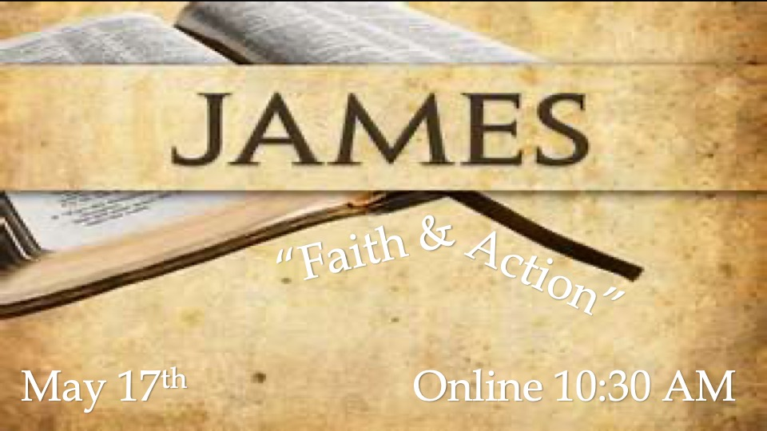

- EMPTY CONFESSION” (Faith and Works - Verses 12-14)
- “FALSE COMPASSION” (Profession and Practice - Verses 15-17)
- “SHALLOW CONVICTION” (Not “Either Or, BUT “Both And…- Verses 18-20)
- “AUTHENTIC CONFIRMATION” (The Proof of Faith: Verses 21-26)

- “EMPTY CONFESSION” (Faith and Works - Verses 12-14)

So speak and so act as those who are to be judged by the law of liberty: for judgment will be merciless to one who has shown no mercy; mercy triumphs over judgment. What use is it, my brethren, if someone says he has faith but he has nor works? Can that faith save him? (2:12-14; NASB)

Some of the righteous and godly works that James has enumerates in this epistle are as follows….

- Endurance
- Perseverance under trial
- Purity of life,
- Obedience to scriptures
- Compassion for the needy
- Impartiality
- Acts of compassion
- Control of the tongue
- Humility
- Truthfulness
- Patience.

- “FALSE COMPASSION” (Profession and Practice - Verses 15-17)

If a brother or sister is without clothing and in need of daily food, and one of you says to them, “Go in peace, be warmed and be filled,” and yet you do not give them what is necessary for their body, what use it that? Even so faith, if it has not works, is dead, being by itself (2:15-17; NASB)

- To a Jew, almsgiving was of paramount importance. In fact, almsgiving and righteousness were indistinguishable traits to a Jew.

- The middle/passive voice of the Greek verbs rendered here as “be warmed and be filled” suggest an even more indifferent, cruel, and sarcastic attitude which says, in effect, “warm and feed yourself”, as if such a needy person would not already have done so if they were able!!!

- “SHALLOW CONVICTION” (Not “Either Or, BUT “Both And…- Verses 18-20)

But someone may well say, You have faith and I have works; show me your faith without the works, and I will show you my faith by my works.” You believe that God is one, you do well; the demons also believe, and shudder. But are you willing to recognize, you foolish fellow, that faith without works is useless” (2:18-20; NASB)

A third characteristic of dead faith is shallow conviction, a recognition of certain facts about God and His Word without submission to either.

“Foolish” fellow – empty or defective…

“Useless” (Grk. – argos) useless, fruitlessness, lack of productivity.

- “AUTHENTIC CONFIRMATION” (The Proof of Faith: Verses 21-26)

Was not Abraham our father justified by works when he offered up Isaac his some on the altar? You see that faith was working with his works, and as a result of the works, faith was perfected; and the scripture was fulfilled which says, “and Abraham believed God, and it was reckoned (accounted) to him as righteousness, and he was call the friend of God. You see that a man is justified by works and not by faith alone. In the same way was not Rahab the harlot also justified by works when she received the messengers and sent them out by another way? For just as the body without the spirit is dead, so also faith without works is dead. (2:21-26: NASB)

“The just shall live by faith”
- Belief = behavior
- Position = practice
- Doctrine = duty

Not saved by deeds, but save FOR deeds!! (Ephesians 2:10)

