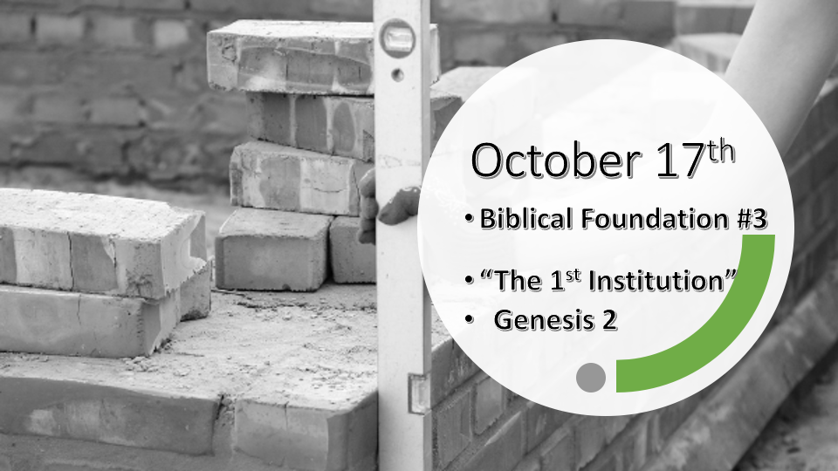

*Psalm 11: 3 When the foundations are being destroyed, what can the righteous do?"

Things we’ve learned about God’s foundations.

- He set the foundations and He won’t leave them to chance or change. (Job 38:4)
- He set the universe with the sky, the stars, sun, and moon to mark what is sacred. (Genesis 1:14)
- He set the appointed times of the end and His coming Kingdom. (Acts 1:6-7)
- *He set the timing of the world with a seven-day week.
(Exodus 20:11) For in six days the LORD made the heavens and the earth, the sea, and all that is in them, but he rested on the seventh day. Therefore the LORD blessed the Sabbath day and made it holy.

*Genesis 2:7 Then the LORD God formed a man from the dust of the ground and breathed into his nostrils the breath of life, and the man became a living being.

8 Now the LORD God had planted a garden in the east, in Eden; and there he put the man he had formed. 9 The LORD God made all kinds of trees grow out of the ground—trees that were pleasing to the eye and good for food. In the middle of the garden were the tree of life and the tree of the knowledge of good and evil.

*In the beginning, two trees reveal humanity's two choices.

*Genesis 2:15 The LORD God took the man and put him in the Garden of Eden to work it and take care of it. 16 And the LORD God commanded the man, "You are free to eat from any tree in the garden; 17 but you must not eat from the tree of the knowledge of good and evil, for when you eat from it you will certainly die."

18 The LORD God said, "It is not good for the man to be alone. I will make a helper suitable for him."

19 Now the LORD God had formed out of the ground all the wild animals and all the birds in the sky. He brought them to the man to see what he would name them; and whatever the man called each living creature, that was its name. 20 So the man gave names to all the livestock, the birds in the sky, and all the wild animals. But for Adam no suitable helper was found. 21 So the LORD God caused the man to fall into a deep sleep; and while he was sleeping, he took one of the man's ribs and then closed up the place with flesh. 22 Then the LORD God made a woman from the rib he had taken out of the man, and he brought her to the man.

*Relational foundations are set from the beginning.

- Genesis 2:15-18 It’s not good for what man to be alone?

- V:15 The man who has a work ethic, and can take care of things.

- V:16-17 The man who is willing to receive spiritual instructions from God about how life works.

- V:18- 22 A suitable mate, the idea of the appropriate person for you comes from God.

*Genesis 2:23 The man said, "This is now bone of my bones and flesh of my flesh; she shall be called 'woman,' for she was taken out of man."
24 That is why a man leaves his father and mother and is united to his wife, and they become one flesh.

25 Adam and his wife were both naked, and they felt no shame.

Genesis 3:1 Now the serpent was more crafty than any of the wild animals the LORD God had made. He said to the woman, "Did God really say, 'You must not eat from any tree in the garden'?"

*The gift of marriage is from God. The foundation for all of society.

- *V:23-24 The gift of oneness is a key ingredient to the foundation of marriage.

- *V:25 Shame is the enemy to an intimate relationship.

- *Genesis 3:1 The deception trusting anyone or thing more than you do God.

