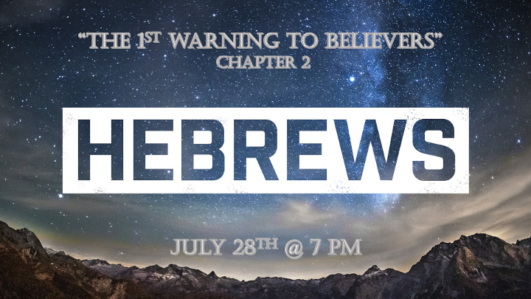

The Overview of Hebrews

5 Major warnings as prophetic warnings to believers.
3 Key Pillars of Judaism are replaced with the Messiah.
3 Crucial teachings about Salvation, The Messiah, and End-time Prophetic Warnings.

*Hebrews 2:1 We must pay the most careful attention, therefore, to what we have heard, so that we do not drift away. 2 For since the message spoken through angels was binding, and every violation and disobedience received its just punishment, 3 how shall we escape if we ignore (KJV neglect) so great a salvation? This salvation, which was first announced by the Lord, was confirmed to us by those who heard him. 4 God also testified to it by signs, wonders and various miracles, and by gifts of the Holy Spirit distributed according to his will.

*Drifting away from God is the evidence of a long-term spiritual draught.

- V:1 The first warning is to pay attention to our salvation. This is the call to be a holy people in the know, like the tribe of Issachar.

- V:2-3 How to escape death? Salvation is the only path it happens through repentance, surrender and the acceptance of the gift. *To neglect this salvation is to develop apathy or the spirit of indifference. *Prophecy keeps me from boredom or from being lethargic.

- The transformed life will have signs, wonders and miracles as a testimony to what God does when Jesus saves us.

*Hebrews 2:5 It is not to angels that he has subjected the world to come, about which we are speaking. 6 But there is a place where someone has testified: "What is mankind that you are mindful of them, a son of man that you care for him?
7 You made them a little lower than the angels; you crowned them with glory and honor
8 and put everything under their feet.", In putting everything under them, God left nothing that is not subject to them. Yet at present, we do not see everything subject to them. (KJV) 8 Thou hast put all things in subjection under his feet. For in that he put all in subjection under him, he left nothing that is not put under him. But now we see not yet all things put under him. 9 But we do see Jesus, who was made lower than the angels for a little while, now crowned with glory and honor because he suffered death, so that by the grace of God he might taste death for everyone.

*Everything Jesus did was to prepare us for what was yet to come.

- The World to come. It’s more than a new cosmos, or the age to come, in Greek the word is pronounced *“Oikoumene” Greek meaning: The “inhabitable place” meaning earth.

- V:6-9 The Paradox: Jesus is made a little lower than the angels, yet everything is put under his feet including the angels. (Psalm 8:4-6)
*His humanity gave him the ability to die, making him less than the angels. His deity and humility made him sovereign over all created beings. He tasted death for everyone.

Hebrews 2:10 In bringing many sons and daughters to glory, it was fitting that God, for whom and through whom everything exists, should make the pioneer of their salvation perfect through what he suffered. 11 Both the one who makes people holy and those who are made holy are of the same family. So Jesus is not ashamed to call them brothers and sisters. (KJV) 11 For both he that sanctifieth and they who are sanctified are all of one: for which cause he is not ashamed to call them brethren, 12 He says, "I will declare your name to my brothers and sisters; in the assembly I will sing your praises."
13 And again, "I will put my trust in him." And again he says, "Here am I, and the children God has given me."
14 Since the children have flesh and blood, he too shared in their humanity so that by his death he might break the power of him who holds the power of death—that is, the devil— 15 and free those who all their lives were held in slavery by their fear of death. 16 For surely it is not angels he helps, but Abraham's descendants. 17 For this reason he had to be made like them, fully human in every way, in order that he might become a merciful and faithful high priest in service to God, and that he might make atonement for the sins of the people. 18 Because he himself suffered when he was tempted, he is able to help those who are being tempted.

*Full Salvation does this mean there is more than one salvation?

- V:10-12 Sanctification is both a condition and position. People filled with God’s Spirit often testify to this growing truth in their lives.

- V:13-15 Have you put your trust in Jesus? What’s your trust level is the question God asks of us every day in so many different ways.

- V:16 Jesus is the foundation that supports our faith journey. Any other foundation breaks the 1st Commandment. (Exodus 20:1-2)

- V:17-18 Jesus being fully human, suffered physically and with temptation (Emotionally). This positions Jesus to be one we can turn to when we need help.

