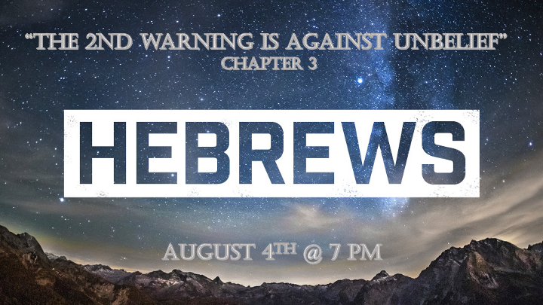

*A Prophetic Update for 2021

A convergence of signs is happening. Prophecy reveals why an event is happening, more so than when it will be fulfilled.
The beginning of the sevens. 7 represents a total completion, so don’t harden your heart.
*3 Critical warnings about “the church”, “the time of plenty has run out”, and “the time of a radical release” have all converged this fall.
- *April 2014 the first of four blood-red moons (Church) appeared and continued in the sequence of Passover and Tabernacles for two straight years.
- *September 2014 Two cows were born with the number 7 on their heads. The first was a black cow and the second was a red cow. Both were born on the Feast of Trumpets
- *The “Shemitah” Exodus 23:10-11 After six years the ground was to remain unplowed during the 7th. 1st Shemitah of 21st century on the Hebrew calendar Elu 29, this was Monday the 18th 7 days after 9/11/2001. (7%)
The 2nd Shemitah (Elu 29) Sept. 29, 2008, was also a Monday and the stock market fell 777 points.

*The final 7 years? May 14, 2021, marks the final seven years before Israel turns 80 in 2028

*Hebrews3:1 Therefore, holy brothers and sisters, who share in the heavenly calling, fix your thoughts on Jesus, whom we acknowledge as our apostle and high priest. 2 He was faithful to the one who appointed him, just as Moses was faithful in all God's house. 3 Jesus has been found worthy of greater honor than Moses, just as the builder of a house has greater honor than the house itself. 4 For every house is built by someone, but God is the builder of everything. 5 "Moses was faithful as a servant in all God's house," bearing witness to what would be spoken by God in the future. 6 But Christ is faithful as the Son over God's house. And we are his house, if indeed we hold firmly to our confidence and the hope in which we glory.

*The Second Pillar of Judaism is pulldown.

- Hebrews 2:1 The first warning was to not drift away from Jesus. If you exalt angels or a person even if that person is Moses (The law) to a status of worship, you are building a wrong foundation.

- Hebrews 3:1-3 Jesus is above all. He is the sent one (Apostle) to the Jews.

- V:4-6 The 1st Warning is revisited and the call to us is to hold firm to our confidence in Jesus.

*Hebrews3:7 So, as the Holy Spirit says: "Today, if you hear his voice,
8 do not harden your hearts as you did in the rebellion, during the time of testing in the wilderness,
9 where your ancestors tested and tried me, though for forty years they saw what I did.
10 That is why I was angry with that generation; I said, 'Their hearts are always going astray, and they have not known my ways.'
11 So I declared on oath in my anger, 'They shall never enter my rest.' "

*If you hear the Holy Spirit’s voice don’t rebel during your time of testing.

- Psalm 95:7-10 and Hebrews 3:7 confirms who is the writer of these words.

- V:8-11 Three times in this chapter V:8,15,16 the people rebelled. (Provoked God)
- It was a heart rebellion.
- It was a rebellion against God’s ways.

Hebrews 3:12 See to it, brothers and sisters, that none of you has a sinful, unbelieving heart that turns away from the living God. 13 But encourage one another daily, as long as it is called "Today," so that none of you may be hardened by sin's deceitfulness. 14 We have come to share in Christ, if indeed we hold our original conviction firmly to the very end. 15 As has just been said: "Today, if you hear his voice, do not harden your hearts as you did in the rebellion."

16 Who were they who heard and rebelled? Were they not all those Moses led out of Egypt? 17 And with whom was he angry for forty years? Was it not with those who sinned, whose bodies perished in the wilderness? 18 And to whom did God swear that they would never enter his rest if not to those who disobeyed? 19 So we see that they were not able to enter, because of their unbelief.

*The 2nd Warning is against unbelief.

- V:12 The condition of the heart. We are to encourage one another to a level of purity and belief. The condition of unbelieving and hardening of the heart is sin.

- V:13-15 Today, implies urgency, but what day is it referring to? 2 Cor. 6:2 says; “Today is the day of salvation and now is the time for God’s favor.”

- V:16-18 They wandered in the wilderness, never seizing their potential or purpose.

- V:19 A dreadful outcome! They couldn’t enter into God’s rest nor the promised land.

