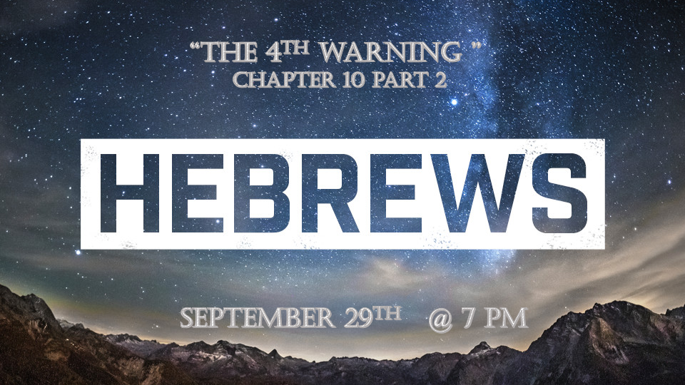

*Hebrews 10:22 let us draw near to God with a sincere heart and with the full assurance that faith brings, having our hearts sprinkled to cleanse us from a guilty conscience and having our bodies washed with pure water. 23 Let us hold unswervingly to the hope we profess, for he who promised is faithful. 24 And let us consider how we may spur one another on toward love and good deeds, 25 not giving up meeting together, as some are in the habit of doing, but encouraging one another—and all the more as you see the Day approaching.

Three times it says; “Let us.”

- *Draw near to God in our faith. (V:22)

- *Hold on to the hope we have. Don’t be moved by circumstances because Jesus is faithful. (V:23)

- *Spur each other toward love, good deeds, and not giving up meeting together. (V:24-25)

*Hebrews10:26 If we deliberately keep on sinning after we have received the knowledge of the truth, no sacrifice for sins is left, 27 but only a fearful expectation of judgment and of raging fire that will consume the enemies of God. 28 Anyone who rejected the law of Moses died without mercy on the testimony of two or three witnesses. 29 How much more severely do you think someone deserves to be punished who has trampled the Son of God underfoot, who has treated as an unholy thing the blood of the covenant that sanctified them, and who has insulted the Spirit of grace? 30 For we know him who said, "It is mine to avenge; I will repay," and again, "The Lord will judge his people." 31 It is a dreadful thing to fall into the hands of the living God.

*The 4th Warning to believers is to stop intentionally sinning.

- V:26-28 Severity of a choice to continue to sin. No sacrifice for sin is left for them. (Numbers 15:29-31 three sins had no sacrifice for them, sexual sin, murder, and blasphemy)

- V:29 Rejecting the Messiah’s sacrifice was to turn away from the Trinity. (It was the gift from God the father, it was the sacrifice of the Son, and it insults the grace from the Spirit.)

- V:30-31 God is sovereign over vengeance and He is the supreme judge.

*Hebrews10:32 Remember those earlier days after you had received the light, when you endured in a great conflict full of suffering. 33 Sometimes you were publicly exposed to insult and persecution; at other times you stood side by side with those who were so treated. 34 You suffered along with those in prison and joyfully accepted the confiscation of your property, because you knew that you yourselves had better and lasting possessions. 35 So do not throw away your confidence; it will be richly rewarded.

36 You need to persevere so that when you have done the will of God, you will receive what he has promised. 37 For, "In just a little while, he who is coming will come and will not delay."

38 And, "But my righteous one will live by faith. And I take no pleasure in the one who shrinks back."

39 But we do not belong to those who shrink back and are destroyed, but to those who have faith and are saved.

*Insights into deliverance from apostasy.

- *V:32 Remembering It is the exact same thing Jesus letter to the Church of Ephesus says to do. (Revelation Chapter2)

- *V:33-35 The power of suffering for some the loss of health, wealth, and what we consider the normalcy of life is more than devastating. (Those things came before our relationship with God and when they were removed many may choose to abandon their faith.

- V:36 The will of God is the crucial ingredient in persevering times of trouble. (Nothing can come to me unless it passes through the sovereignty of God.)

- V:37 Our focus is his coming and deliverance. (Even if it doesn’t happen in our lifetime.)

- V:38 Faith is the deeper level of God’s will that says I want to please my God even when I can’t understand life.

- V:38-39 We don’t shrink back. It doesn’t mean we aren’t disappointed or even dismayed. (Our faith enables us to spring back to I am blessed that God would trust me with these things that I could reveal He is Lord over and above all things in my life.)

