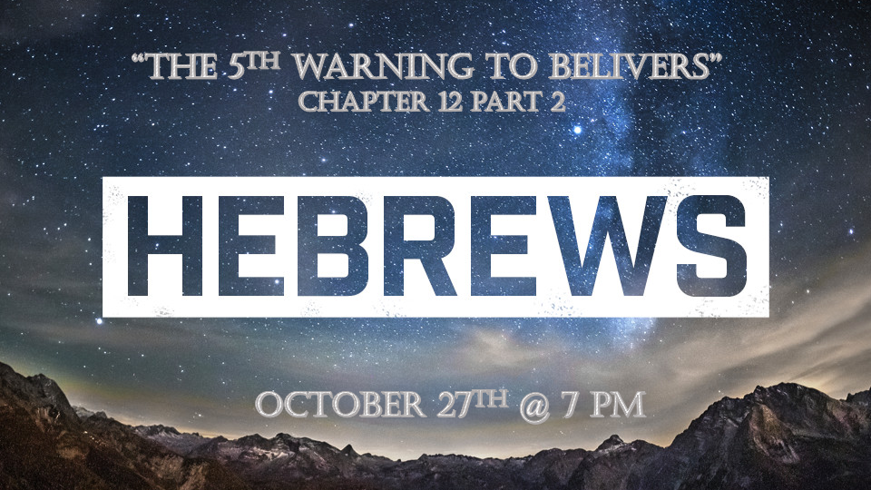

*The world has become like a James Bond movie, shaken and not stirred.

*Hebrews 12:14 Make every effort to live in peace with everyone and to be holy; without holiness no one will see the Lord. 15 See to it that no one falls short of the grace of God and that no bitter root grows up to cause trouble and defile many. 16 See that no one is sexually immoral, or is godless like Esau, who for a single meal sold his inheritance rights as the oldest son. 17 Afterward, as you know, when he wanted to inherit this blessing, he was rejected. Even though he sought the blessing with tears, he could not change what he had done.

*A warning to all believers, who give away what should have been kept.

- *Hebrews 12:14-15 Peace is the goal but not at the cost of truth. Why is it that the holy people give in to the unholy decisions of others? The value of peace has become greater than holiness.

- Hebrews 12:16-17 Irreversible damage when you give away yourself sexually outside of marriage?

*Hebrews 12:18 You have not come to a mountain that can be touched and that is burning with fire; to darkness, gloom and storm; 19 to a trumpet blast or to such a voice speaking words that those who heard it begged that no further word be spoken to them, 20 because they could not bear what was commanded: "If even an animal touches the mountain, it must be stoned to death." 21 The sight was so terrifying that Moses said, "I am trembling with fear." 22 But you have come to Mount Zion, to the city of the living God, the heavenly Jerusalem. You have come to thousands upon thousands of angels in joyful assembly, 23 to the church of the firstborn, whose names are written in heaven. You have come to God, the Judge of all, to the spirits of the righteous made perfect, 24 to Jesus the mediator of a new covenant, and to the sprinkled blood that speaks a better word than the blood of Abel.

*The contrast of the old of Mount Sinai and the new of Mount Zion.

- Mount Sinai was marked by fear and terror. Mount Zion is a place of love and forgiveness.
- Mount Sinai is in the desert of Israel. Mount Zion is part of the city of the Living God in the New Jerusalem.
- Mount Sinai spoke of earthly things. Mount Zion speaks of heavenly things.
- At Mount Sinai, the people were hesitant to go near it. Because of the promise of Mount Zion, we put away our hesitation and we become bold for God.

- Mount Sinai was characterized by the guilty in fear of the law. Mount Zion features the just made perfect through Grace.

- At Mount Sinai, Moses (A Man) becomes the mediator of the blood sacrifice of animals. Mount Zion exalts, Jesus (The son of God) is both the mediator and the sacrifice.

- V:22 Mount Sinai shook with God’s presence. Mount Zion will one day shake with the praise of the saints, Church, and angels! (Exodus 19:18-19, Judges 5:4-5)

*Hebrews 12:25 See to it that you do not refuse him who speaks. If they did not escape when they refused him who warned them on earth, how much less will we, if we turn away from him who warns us from heaven? 26 At that time his voice shook the earth, but now he has promised, "Once more I will shake not only the earth but also the heavens." 27 The words "once more" indicate the removing of what can be shaken—that is, created things—so that what cannot be shaken may remain.

28 Therefore, since we are receiving a kingdom that cannot be shaken, let us be thankful, and so worship God acceptably with reverence and awe, 29 for our "God is a consuming fire."

*Warning a shaking of heaven, earth, and of the coming of the Kingdom of God.

- V:25 The Warning includes a command to don’t refuse God who is speaking to you.
- His Word: All 66 books are from God.

- His Voice: You can hear God in your heart, visions, dreams, and in your spirit.

- *V:26-27 The heavens and earth will tremble, is it already happening? This shaking can be used literally, figuratively, economically, and spiritually. (Joel 3:16)

- V:28-29 The Kingdom of God is unshakeable! Therefore, we worship God with awe and passion.

