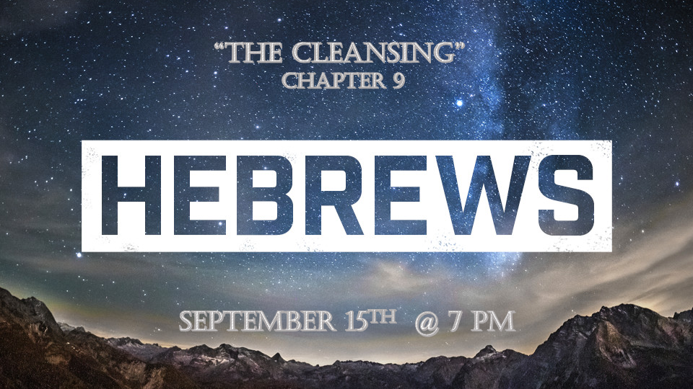

Prophetic Update:

*Hebrews9:1:1 Now the first covenant had regulations for worship and also an earthly sanctuary. 2 A tabernacle was set up. In its first room were the lampstand and the table with its consecrated bread; this was called the Holy Place. 3 Behind the second curtain was a room called the Most Holy Place, 4 which had the golden altar of incense and the gold-covered ark of the covenant. This ark contained the gold jar of manna, Aaron's staff that had budded, and the stone tablets of the covenant. 5 Above the ark were the cherubim of the Glory, overshadowing the atonement cover. But we cannot discuss these things in detail now. 6 When everything had been arranged like this, the priests entered regularly into the outer room to carry on their ministry. 7 But only the high priest entered the inner room, and that only once a year, and never without blood, which he offered for himself and for the sins the people had committed in ignorance. 8 The Holy Spirit was showing by this that the way into the Most Holy Place had not yet been disclosed as long as the first tabernacle was still functioning. 9 This is an illustration for the present time, indicating that the gifts and sacrifices being offered were not able to clear the conscience of the worshiper. 10 They are only a matter of food and drink and various ceremonial washings—external regulations applying until the time of the new order.

*God’s Tabernacle tells a story.

- V:1-2 There is a place to worship a location, and that place has memories and signs pointing to God’s faithfulness.

- V:2-6 Tabernacle Material symbolisms:
- Brass: fire and judgement
- Gold: Deity, the Holy of Holies was made of wood covered in gold, the ark of the covenant made in wood cover in gold, and the Mercy Seat was pure gold.
- Silver: Is the symbol for blood. The redemption shekel. Judas betrays Jesus for 30 pieces of silver.

- V:7-10 The “Way” to the holy place is through the blood. The symbol of what was to come by the Lamb of God.

*Hebrews9:11 But when Christ came as high priest of the good things that are now already here, he went through the greater and more perfect tabernacle that is not made with human hands, that is to say, is not a part of this creation.
12 He did not enter by means of the blood of goats and calves; but he entered the Most Holy Place once for all by his own blood, thus obtaining eternal redemption. 13 The blood of goats and bulls and the ashes of a heifer sprinkled on those who are ceremonially unclean sanctify them so that they are outwardly clean. 14 How much more, then, will the blood of Christ, who through the eternal Spirit offered himself unblemished to God, cleanse our consciences from acts that lead to death, so that we may serve the living God!

*15 For this reason Christ is the mediator of a new covenant, that those who are called may receive the promised eternal inheritance—now that he has died as a ransom to set them free from the sins committed under the first covenant.

*Insights into the sacrifice of our Messiah.

- V:11 Jesus enters the tabernacle of heaven that’s not created by human hands to cleanse it.

- V:12 Access was granted through his own blood cleansing it. It was once and for all and was the result of him obtaining eternal redemption.

- V:13-14 The blood of Jesus is a greater cleansing than the blood of bulls used to purify the priest, the blood of goats to purify unclean people. The ashes of the red heifer used to cleanse those who came in contact with dead things.

*Hebrews 9:16 In the case of a will, it is necessary to prove the death of the one who made it, 17 because a will is in force only when somebody has died; it never takes effect while the one who made it is living. 18 This is why even the first covenant was not put into effect without blood. 19 When Moses had proclaimed every command of the law to all the people, he took the blood of calves, together with water, scarlet wool and branches of hyssop, and sprinkled the scroll and all the people. 20 He said, "This is the blood of the covenant, which God has commanded you to keep." 21 In the same way, he sprinkled with the blood both the tabernacle and everything used in its ceremonies. 22 In fact, the law requires that nearly everything be cleansed with blood, and without the shedding of blood, there is no forgiveness.

23 It was necessary, then, for the copies of the heavenly things to be purified with these sacrifices, but the heavenly things themselves with better sacrifices than these. 24 For Christ did not enter a sanctuary made with human hands that was only a copy of the true one; he entered heaven itself, now to appear for us in God's presence. 25 Nor did he enter heaven to offer himself again and again, the way the high priest enters the Most Holy Place every year with blood that is not his own. 26 Otherwise Christ would have had to suffer many times since the creation of the world. But he has appeared once for all at the culmination of the ages to do away with sin by the sacrifice of himself. 27 Just as people are destined to die once, and after that to face judgment, 28 so Christ was sacrificed once to take away the sins of many; and he will appear a second time, not to bear sin, but to bring salvation to those who are waiting for him.

*The One Sacrifice that Changed Eternity.

- V:16-22 The Cleansing that came through his blood broke the system of the penalty of the Mosaic law.

- V:23-28 The single Cleansing is powerful enough to cleanse the past, the present, and the future.

- *Jesus blood cleansed humanity of _______________ of sin. The Holy Spirit cleanses us from _______________ of sin. God our Father cleanses creation from _____________ of sin.

