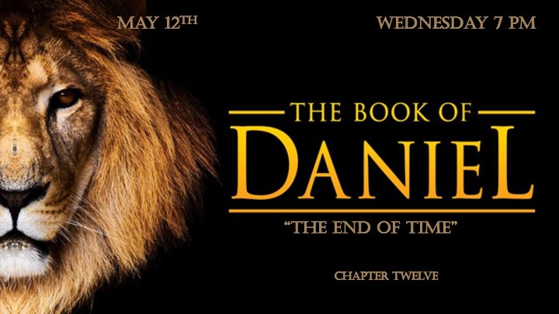

Signs, what do they say?

*Daniel12:1 "At that time Michael, the great prince who protects your people, will arise. There will be a time of distress such as has not happened from the beginning of nations until then. But at that time your people—everyone whose name is found written in the book—will be delivered. 2 Multitudes who sleep in the dust of the earth will awake: some to everlasting life, others to shame and everlasting contempt. 3 Those who are wise will shine like the brightness of the heavens, and those who lead many to righteousness, like the stars for ever and ever. 4 But you, Daniel, roll up and seal the words of the scroll until the time of the end. Many will go here and there to increase knowledge."

At That Time…

- V:1 Michael the archangel’s assignment is the protection of Israel. Is he the reason Jordan is a place of refuge for the nation of Israel?

- V:2-3 The truth about judgement day.

- V:4 Sealed! Until the time of the end. This time is marked by three things.

*Daniel 12:5 Then I, Daniel, looked, and there before me stood two others, one on this bank of the river and one on the opposite bank. 6 One of them said to the man clothed in linen, who was above the waters of the river, "How long will it be before these astonishing things are fulfilled?"
7 The man clothed in linen, who was above the waters of the river, lifted his right hand and his left hand toward heaven, and I heard him swear by him who lives forever, saying, "It will be for a time, times and half a time. When the power of the holy people has been finally broken, all these things will be completed."

The 3 ½ Years of the Great Tribulation (1260 days)

- V:5-6 Two what, one on each side of the bank of the river? Who or what are they? Some believe they are angels. But could they be? Luke 24:3

- V:6-7 Who is the man above the waters of the river. Why does he hold the answers about the times?
- The Time of Jacob’s Trouble. This prophecy is in Jeremiah 30:7, Daniel 7:25, Revelation 12:14. Their hope is in these prophecies Daniel 11:41, & Revelation 12:6.

*Daniel 12:8 I heard, but I did not understand. So, I asked, "My lord, what will the outcome of all this be?" (The outcome is found in Zechariah 13:8-9)
9 He replied, "Go your way, Daniel because the words are rolled up and sealed until the time of the end. 10 Many will be purified, made spotless and refined, but the wicked will continue to be wicked. None of the wicked will understand, but those who are wise will understand.

The wise will know what the wicked won’t understand.

- V:8 A faulty rule of interpreting scripture is looking at them and explaining them through the eyes of the author & how he would reason them through that time period. Ezekiel, Isaiah, Zechariah, Micah, and many other prophets often wrote what the Spirit led them to write without full understanding of the future event.

*Zechariah 13:8-9 In the whole land," declares the LORD, "two-thirds will be struck down and perish, yet one-third will be left in it. 9 This third I will put into the fire; I will refine them like silver and test them like gold. They will call on my name and I will answer them; I will say, 'They are my people,' and they will say, “The LORD is our God.")

- V:9 The Seal: Two great passages on “The End of Time” Daniel’s is sealed. Revelation is not sealed. *Revelation 22:10, NIV: "Then he told me, 'Do not seal up the words of the prophecy of this scroll, because the time is near."

*Daniel12:11 "From the time that the daily sacrifice is abolished and the abomination that causes desolation is set up, there will be 1,290 days. 12 Blessed is the one who waits for and reaches the end of the 1,335 days.

13 "As for you, go your way till the end. You will rest, and then at the end of the days you will rise to receive your allotted inheritance."

Understanding the times

- The precision around the time of the end. The 1260 days are known also as 42 months or 3 ½ years of the great tribulation. The 1290 days are known as the countdown from the day the anti-Christ places his image in the temple until Jesus is installed on his throne. The 1335 days are believed to be the resurrection of the Old Testament Saints and the judgement period of the sheep and goats in Matthew 25:31-46. Use Acts 17:11.

- Daniel is the prophetic book of precision. At the end of the days, Daniel is promised to receive his reward. I believe He will reign with Christ in the millennium.

