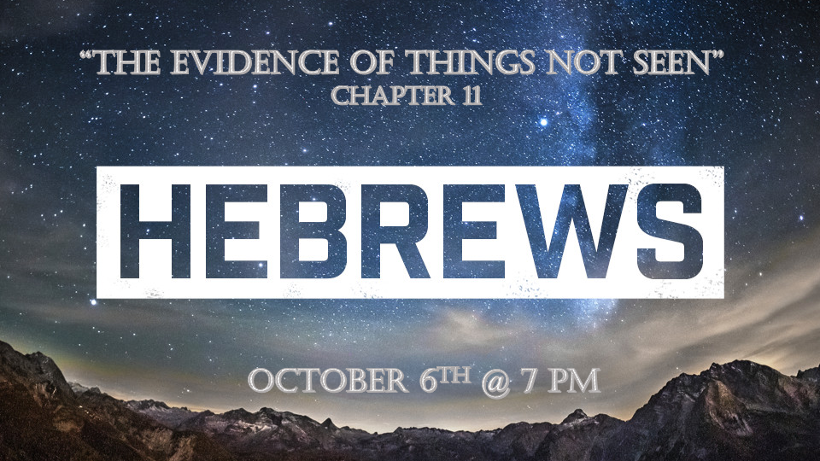

*Faithful Christians don’t shrink back”

*Hebrews 11:1 Now faith is confidence in what we hope for and assurance about what we do not see. (KJV) 1 Now faith is the substance of things hoped for, the evidence of things not seen. 2 This is what the ancients were commended for.

3 By faith we understand that the universe was formed at God's command, so that what is seen was not made out of what was visible.

4 By faith Abel brought God a better offering than Cain did. By faith, he was commended as righteous, when God spoke well of his offerings. And by faith Abel still speaks, even though he is dead.

*The substance that makes something better.

- V:1-2 Faith or believing God’s Word is the ingredient that rewards those in Hebrews 11

- V:3 Faith is the doorway for us to understand how God creates.

- V:4 Faith made Abel’s offering better than Cain’s. (How do we know it was better?) The fire took the offering. ( Moses Leviticus 9:24, Gideon Judges 6:24, Samson’s parents Judges 13:20, Elijah 1st Kings 18:38, David’s Threshing floor I Chron. 21:26, and Solomon’s dedication of the temple 2 Chron. 7:1)

*Hebrews11:5 By faith Enoch was translated that he should not see death; and was not found, because God had translated him: for before his translation he had this testimony, that he pleased God.
6 But without faith it is impossible to please him: for he that cometh to God must believe that he is and that he is a rewarder of them that diligently seek him.
7 By faith Noah, being warned of God of things not seen as yet, moved with fear, prepared an ark to the saving of his house; by the which he condemned the world, and became heir of the righteousness which is by faith.

*The rapture and protection from God’s wrath.

- *V:5-6 Two special ingredients to be prepared for the rapture. (Genesis 5:21-24) We must believe in God to what level? Believing God will reward you for diligently seeking Him.

- *V:7 God warns the faithful. Being moved by a righteous fear for his household as the world was coming under judgement.

*Hebrews 11:8( KJV) By faith Abraham, when he was called to go out into a place which he should after receiving for an inheritance, obeyed; and he went out, not knowing whither he went.
9 By faith he sojourned in the land of promise, as in a strange country, dwelling in tabernacles with Isaac and Jacob, the heirs with him of the same promise:
10 For he looked for a city which hath foundations, whose builder and maker is God.

11 And by faith even Sarah, who was past childbearing age, was enabled to bear children because she considered him faithful who had made the promise. 12 And so from this one man, and he as good as dead, came descendants as numerous as the stars in the sky and as countless as the sand on the seashore.
13 All these people were still living by faith when they died. They did not receive the things promised; they only saw them and welcomed them from a distance, admitting that they were foreigners and strangers on earth. 14 People who say such things show that they are looking for a country of their own. 15 If they had been thinking of the country they had left, they would have had opportunity to return. 16 Instead, they were longing for a better country—a heavenly one. Therefore God is not ashamed to be called their God, for he has prepared a city for them.
17 By faith Abraham, when God tested him, offered Isaac as a sacrifice. He who had embraced the promises was about to sacrifice his one and only son, 18 even though God had said to him, "It is through Isaac that your offspring will be reckoned." 19 Abraham reasoned that God could even raise the dead, and so in a manner of speaking he did receive Isaac back from death.
20 By faith Isaac blessed Jacob and Esau in regard to their future.

*Immediate obedience is the sign of extraordinary faith.

- V:8-10 Abraham went not knowing where he was going. (They are looking for a heavenly city most scholars believe it is the New Jerusalem.)

- V:11-12 Sarah by faith has a baby when she passes the bearing children age. (Note the name change of both Abram and Sari to Abraham and Sarah)

- V:13-16 All the men and women of faith died not seeing the city (New Jerusalem) that was prepared for them. (They understood God’s promises are good forever.)

- V:17-19 A burnt sacrifice was going to happen. Isaac was going to be turned to ashes. At what level of faith is Abraham trusting God?

- V:20 By faith Isaac blesses his sons.

