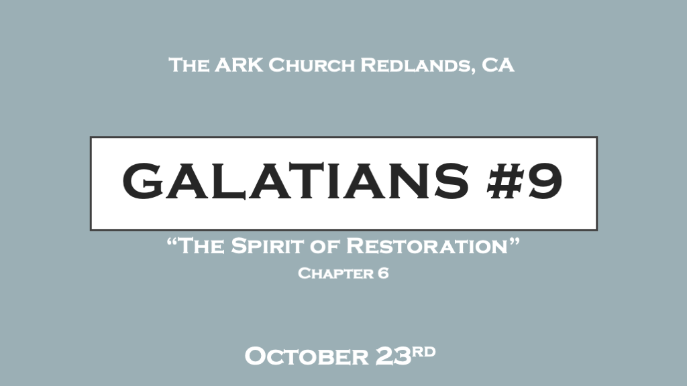

*The Holy Spirit is the renovator of life.

*Galatians 6:1 Brethren, if a man is overtaken in any trespass, you who are spiritual restore such a one in a spirit of gentleness, considering yourself lest you also be tempted. 2 Bear one another’s burdens, and so fulfill the law of Christ. 3 For if anyone thinks himself to be something, when he is nothing, he deceives himself. 4 But let each one examine his own work, and then he will have rejoicing in himself alone, and not in another. 5 For each one shall bear his own load.

- V:1 Restoration through the fruit of gentleness: The Holy Spirit opens our eyes to the contrasts between A) Bondage and Liberty, B) The Flesh and the Spirit, C) Self-focus or others, D) Man’s approval or God’s Glory.

- *We must be able to spiritually discern, where the person’s need is and what’s overtaken them.
What caught them (overtaken) A bondage, their flesh, self-centeredness, or wanting human approval?

- Restore with gentleness. The Greek term for restore is “Katartizo” a medical term like setting a broken bone.
The procedure: Once a bone is set it must be protected with a cast and time to heal.
The fruit Gentleness is used implying humility and that no one is immune from these situations.

- Violating the rules of restoration sets a trap for you into a dilemma.
None of us are free from temptation, shortcomings, and our flesh.

- V:2 Bearing one another's burden is the law of Christ.
We are to love one another and as a part of that love we help with the heavy lifting of another’s life.

- V:3 Self-deception is the worse deception of all.
A judgmental spirit is closely tied to a critical spirit. Both, want to discourage the believer under a false deception of help.

- V:4-5 Inward examination will reveal your need for the Holy Spirit.
When we examine our lives with honesty we cry out to the Holy Spirit to help us.
*V:4 The word “prove” is saying to us we are to own our works or test our works.

We will then rejoice in what God is doing in us and not be so focused on others' success or failure. Carrying our own burden is taking responsibility for our actions. This word is different than verse 2

*Sowing to the Spirit and the opportunity to change our world.

*Galatians 6:6 Let him who is taught the word share in all good things with him who teaches.
7 Do not be deceived, God is not mocked; for whatever a man sows, that he will also reap. 8 For he who sows to his flesh will of the flesh reap corruption, but he who sows to the Spirit will of the Spirit reap everlasting life. 9 And let us not grow weary while doing good, for in due season we shall reap if we do not lose heart. 10 Therefore, as we have opportunity, let us do good to all, especially to those who are of the household of faith.

- V:6-7 God is not mocked it will boomerang to the mocker.
Sow mercy and you will reap mercy.

- V:8 Corruption is a result of humanity living without God. Sow to the Holy Spirit how?
We Surrender our hearts first, emotions, minds, and spirits to be filled by the Holy Spirit.

- V:9-10 There is a spirit of weariness but don’t surrender to it.
Surrender to the Holy Spirit and you will not lose heart. The Holy Spirit will guide you to do good.

*Faithfulness to the message of the crucified life and transformed life.

*Galatians 6:11 See with what large letters I have written to you with my own hand! 12 As many as desire to make a good showing in the flesh, these would compel you to be circumcised, only that they may not suffer persecution for the cross of Christ. 13 For not even those who are circumcised keep the law, but they desire to have you circumcised that they may boast in your flesh. 14 But God forbid that I should boast except in the cross of our Lord Jesus Christ, by whom the world has been crucified to me, and I to the world. 15 For in Christ Jesus neither circumcision nor uncircumcision avails anything, but a new creation. 16 And as many as walk according to this rule, peace and mercy be upon them, and upon the Israel of God.
17 From now on let no one trouble me, for I bear in my body the marks of the Lord Jesus. 18 Brethren, the grace of our Lord Jesus Christ be with your spirit. Amen.

- V:11-12 We must be willing to suffer for the sake of the cross.
Often Christians go along with others just to not have to deal with disagreement.
This is a spirit of fear or not wanting to deal with Jesus' radical message of the cross. This epistle is about the death of the law, the death of works, and the death of self.

- V:13-14 If I desire to showcase my effort it could reveal I want the world to see me.
When what my world needs is to see what Jesus has done. We don’t need another hero.
This will puff us up and pride will seduce us away from what Christ has done and humility.
The real effort on our part is always in surrendering to the Holy Spirit.

- V:15-16 The evidence is a new creation (Transformation).
The fruit in our lives will be peace and mercy. The awe is in the changed life because it couldn’t come from our doing.

- V:17-18 The mark of Jesus is Grace.
*Grace became the anchor in our spirit.

