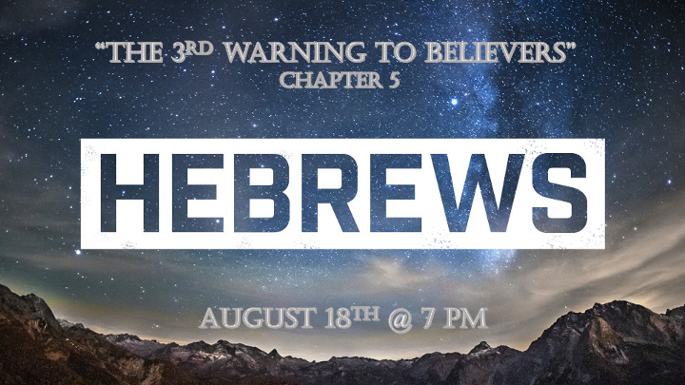

*Overview of Hebrews

*Three Pillars of Judaism are put in their proper perspective for the believer.
* Five prophetic warnings for the believer.
* Insights into the New Covenant and how it is complete.

*Hebrews5:1 Every high priest is selected from among the people and is appointed to represent the people in matters related to God, to offer gifts and sacrifices for sins. 2 He is able to deal gently with those who are ignorant and are going astray, since he himself is subject to weakness. 3 This is why he has to offer sacrifices for his own sins, as well as for the sins of the people. 4 And no one takes this honor on himself, but he receives it when called by God, just as Aaron was.

5 In the same way, Christ did not take on himself the glory of becoming a high priest. But God said to him, "You are my Son; today I have become your Father."

6 And he says in another place, "You are a priest forever, in the order of Melchizedek."
*Hebrews 7:7 During the days of Jesus' life on earth, he offered up prayers and petitions with fervent cries and tears to the one who could save him from death, and he was heard because of his reverent submission. 8 Son though he was, he learned obedience from what he suffered 9 and, once made perfect, he became the source of eternal salvation for all who obey him 10 and was designated by God to be high priest in the order of Melchizedek.

*The Difference between the Prophet and the High Priest.

- *V:1 The High priest present the people to God. The prophet presents God and His Word to the people.

- *V:2 The High priest deals gently with the people. The prophet deals firmly and often with warnings/rebukes to the people. Ephesians 4:11-12 does not have a priest in its list.

- V:3-5 The ultimate offering did not come from the tribe of Levi (Aaron). It came from the tribe of Judah the royal tribe. Priests are not selected they were born into that tribe. Prophets are selected by God. Psalm 110

- V:6 A King & a priest in the order of Melchizedek. When King Saul acted as a priest he lost favor with God. When King Uzziah burnt incense he got leprosy for doing a priest’s job.
- *Melchizedek was the king of Salem (Jerusalem) and as a High priest, he ministered to Abraham with bread and wine. Genesis 14:18
- *King of Salem (Peace) and King of Righteousness Hebrews 7:2
- *There are Biblical types or foreshadows of the bride of Christ (Ruth) and there are types and foreshadows of Christ. (Melchizedek) In these two instances neither has a recorded time or place of death in the scriptures. Does this complete their foreshadow stories?

*Hebrews5:11 We have much to say about this, but it is hard to make it clear to you because you no longer try to understand. 12 In fact, though by this time you ought to be teachers, you need someone to teach you the elementary truths of God's word all over again. You need milk, not solid food! 13 Anyone who lives on milk, being still an infant, is not acquainted with the teaching about righteousness. 14 But solid food is for the mature, who by constant use have trained themselves to distinguish good from evil.

*A Warning about a deficient understanding of God’s Word and only relying on what the priest or others can do for you.

- V:11 Failure to advance in a Biblical worldview. Christians lacking Biblical understanding condemns a world to ignorance.

- V:12 You’ve replaced the Word of God’s agenda with a superficial pseudo-good agenda.
- We must be striving to go deeper in the Word of God while not abusing the elementary truth.

- Responsible to teach or share the good news with others, especially the next generation.

- An unwillingness to learn anything outside of basic gospel truth and many are perverting the gospel at the same time.

- V:13 Living on milk makes you an infant in righteousness. The deeper things of God’s Word keeps you from being deceived, the truth about Infants they are often tricked. They never see the bigger picture within the elementary truths of God.

- V:14 Maturity has traits. The 1st quality is constant use of God’s Word in their daily decisions and life. The 2nd quality is they distinguish themselves by avoiding evil and championing truth and goodness.

